# Task 1: Description of Business

Giga Pet is one of the successful businesses in Vietnam, which designed to provide services for pets, including: spa, manicure, mating… They maintain an elite team of well-trained and always care about customers, with a large community. The company also brings customers some tips and tools to improve their pet’s quality of life.

The manager will recruit staff for working in different jobs: supporter, caretaker, and cashier. He/she has to re-aggregate the revenue to plan for the upcoming strategy.

The customers choose one of the services provided by the company, then they need to provide their pets to the caretaker after booking services. After that the caretaker will give the client commitment board to ensure that there is an exchange and commitment between the two partners.

The supporters will bring customers’ pets to the caretaker with the service that they have to do with them. The caretaker will create a form to follow the progress and summarize after completing progress. Then, the caretaker will bring the pets back to the supporters.

The cashier will calculate the cost for taking care of customers’ pets, the clients have to pay the money in order to end the progress.

If customers use mating service, first they need to upload their pets’ pictures to make sure that other owners recognize. After that, they need to agree the time with other customers to breed with other pets with the same species.

## The following is the booking services information

|  |  |  |  |  |  |  |  |
| --- | --- | --- | --- | --- | --- | --- | --- |
| **ClientID** | **Client Full Name** | **Client Phone Number** | **Pet name** | **Service** | **Price** | **Payment status** | **DateTime finish** |
| 785 | Phong Tran | 0123456789 | Cathy | Spa | 3.35 | Not yet |  |
| 786 | Duy Pham | 0987654321 | Shellie | manicure | 4.25 | OK | 6pm 13/10/2022 |
| 788 | Kien Le | 0383736722 | Alo | manicure | 4.25 | OK | 4pm 23/10/2022 |
| 790 | Minh Nguyen | 0573762644 | Pip | vaccinations | 3 | Not yet |  |
| 791 | Minh Vu | 0374646536 | Tit | vaccinations | 3 | OK | 7pm 3/11/2022 |
| 792 | Duc Tran | 0938746644 | Tut | vaccinations | 3 | Not yet |  |
| 793 | Hoang Lam | 0887564663 | Tot | teeth cleaning | 7 | Not yet |  |

|  |  |  |  |  |  |  |  |  |
| --- | --- | --- | --- | --- | --- | --- | --- | --- |
| **Service** | **Client Name** | **Client Address** | **Client Phone Number** | **Staff name** | **Exchange status** | **Pet name** | **Pet species** | **DateTime implementation** |
| Spa | Phong Tran | A99 area, Nam Trung Yen, Ha Noi | 0123456789 | Huy Tran | OK | Cathy | Dog | 2pm 3/10/2022 |
| manicure | Duy Pham | 123 Yen Hoa road, Ha Noi | 0987654321 | Duc Tran | OK | Shellie | Dog | 2pm 13/10/2022 |
| manicure | Kien Le | 88 Ho Chi Minh road, Hanoi | 0383736722 | Minh Tran | OK | Alo | Parrot | 1pm 23/11/2022 |
| vaccinations | Minh Vu | 123 Banh Chung road, Hanoi | 0947627283 | Hoang Tran | OK | Pip | Dog | 8am 10/11/2022 |
| vaccinations | Minh Nguyen | 99 Ta Hien street, Hanoi | 0573762644 | Anh Tran | OK | Tit | Cat | 10am 11/11/2022 |
| vaccinations | Duc Tran | 803 Khuat Duy Tien road, Hanoi | 0938746644 |  |  | Tut | Cat | 1h30pm 12/11/2022 |
| teeth cleaning | Hoang Lam | 150 Banh Chung road, Hanoi | 0887564663 |  |  | Tot | Dog | 3pm 19/11/2022 |

|  |  |  |  |  |  |  |  |  |  |  |  |
| --- | --- | --- | --- | --- | --- | --- | --- | --- | --- | --- | --- |
| **Client Name One** | **Client Address** | **Client Phone Number** | **Pet client two name** | **Pet client two species** | **Client Name Two** | **Client Address** | **Client two phone number** | **Pet client two name** | **Pet client two species** | **DateTime started** | **DateTime finish** |
| Huy Nguyen | 77 Quyet Thang street, Hanoi | 0283767736 | Micro | Cat | Tung Tran | 823 Khuat Duy Tien road, Hanoi | 0374646536 | Tabu | Cat | 12pm 30/10/2022 | 2pm 30/10/2022 |

## Data requirements

|  |  |
| --- | --- |
| Entity | Attribute |
| department | department_id, department_name, department_description, department_date_started |
| Staff | staff_id, staff_name, staff_type |
| Client | client_id, client_name, client_address, client_phone |
| User | User_id, user_name, user_email, user_password |
| Service | Service_id, service_name, service_description, service_duaration, service_price |
| Pet | Pet_id, pet_name, pet_born_year |
| Species | Species_id, species_name |
| Booking | Booking_id, booking_date |
| Booking_detail | Booking_detail_id, booking_id, service_id, exchange_status |
| Progress | Progress_id, progress_end_date |
| Receipt | Receipt_id, payment_term, status_payment |
| Image | Image_id, image_name, image_description, image_url |
| Request | Request_id, request_message |

# Task 2: ER and Data Dictionary

## ER Diagram

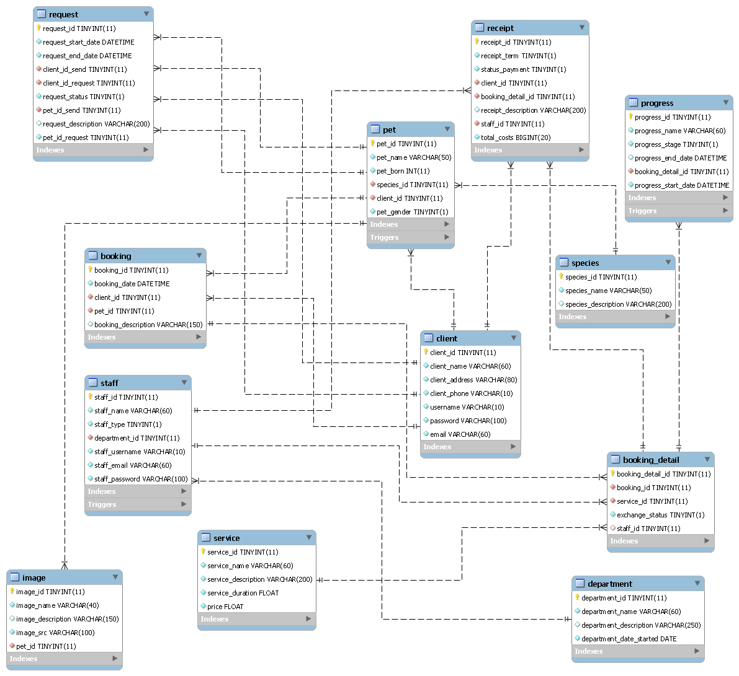

## Data dictionary

|  |  |  |  |  |  |
| --- | --- | --- | --- | --- | --- |
| **Table name** | **sequential** | **Constraints** | **column** | **data_typ** | **nullable** |
| **booking** | 1 | PK | booking_id | tinyint(11) | NOT NULL |
|  | 2 |  | booking_date | datetime(8) | NOT NULL |
|  | 3 | FK | client_id | tinyint(11) | NOT NULL |
|  | 4 | FK | pet_id | tinyint(11) | NOT NULL |
|  | 5 |  | booking_description | varchar(150) | NULL |
| **booking_detail** | 1 | PK | booking_detail_id | tinyint(11) | NOT NULL |
|  | 2 | FK | booking_id | tinyint(11) | NOT NULL |
|  | 3 | FK | service_id | tinyint(11) | NOT NULL |
|  | 4 |  | exchange_status | tinyint(1) | NOT NULL |
|  | 5 | FK | staff_id | tinyint(11) | NULL |
| **client** | 1 | PK | client_id | tinyint(11) | NOT NULL |
|  | 2 |  | client_name | varchar(60) | NOT NULL |
|  | 3 |  | client_address | varchar(80) | NOT NULL |
|  | 4 |  | client_phone | varchar(10) | NOT NULL |
|  | 5 |  | username | varchar(10) | NOT NULL |
|  | 6 |  | password | varchar(100) | NOT NULL |
|  | 7 |  | email | varchar(60) | NOT NULL |
| **department** | 1 | PK | department_id | tinyint(11) | NOT NULL |
|  | 1 |  | id_department | tinyint(11) | NOT NULL |
|  | 2 |  | department_name | varchar(60) | NOT NULL |
|  | 2 |  | name | varchar(50) | NOT NULL |
|  | 3 |  | department_description | varchar(250) | NULL |
|  | 3 |  | money_department | float | NOT NULL |
|  | 4 |  | department_date_started | date | NOT NULL |
| **image** | 1 | PK | image_id | tinyint(11) | NOT NULL |
|  | 2 |  | image_name | varchar(40) | NOT NULL |
|  | 3 |  | image_description | varchar(150) | NULL |
|  | 4 |  | url | varchar(50) | NOT NULL |
|  | 5 |  | image_src | varchar(100) | NOT NULL |
|  | 6 | FK | pet_id | tinyint(11) | NOT NULL |
| **pet** | 1 | PK | pet_id | tinyint(11) | NOT NULL |
|  | 2 |  | pet_name | varchar(50) | NOT NULL |
|  | 3 |  | pet_born | int(10) | NOT NULL |
|  | 4 | FK | species_id | tinyint(11) | NOT NULL |
|  | 5 | FK | client_id | tinyint(11) | NOT NULL |
|  | 6 |  | pet_gender | tinyint(1) | NOT NULL |
| **progress** | 1 | PK | progress_id | tinyint(11) | NOT NULL |
|  | 2 |  | progress_name | varchar(60) | NOT NULL |
|  | 3 |  | progress_stage | tinyint(1) | NOT NULL |
|  | 4 |  | progress_end_date | datetime(8) | NULL |
|  | 5 | FK,UK | booking_detail_id | tinyint(11) | NOT NULL |
|  | 6 |  | progress_start_date | datetime(8) | NOT NULL |
| **receipt** | 1 | PK | receipt_id | tinyint(11) | NOT NULL |
|  | 2 |  | receipt_term | tinyint(11) | NOT NULL |
|  | 3 |  | status_payment | tinyint(1) | NOT NULL |
|  | 4 | FK | client_id | tinyint(11) | NOT NULL |
|  | 5 | FK | booking_detail_id | tinyint(11) | NOT NULL |
|  | 6 |  | receipt_description | varchar(200) | NULL |
|  | 7 | FK | staff_id | tinyint(11) | NOT NULL |
|  | 8 |  | total_costs | Bigint(20) | NOT NULL |
| **request** | 1 | PK | request_id | tinyint(11) | NOT NULL |
|  | 2 |  | request_start_date | datetime(8) | NOT NULL |
|  | 3 |  | request_end_date | datetime(8) | NOT NULL |
|  | 4 | FK | client_id_send | tinyint(11) | NOT NULL |
|  | 5 | FK | client_id_request | tinyint(11) | NOT NULL |
|  | 6 |  | request_status | tinyint(1) | NOT NULL |
|  | 7 | FK | pet_id_send | tinyint(11) | NOT NULL |
|  | 8 |  | request_description | varchar(200) | NULL |
|  | 9 |  | pet_id_request | tinyint(11) | NOT NULL |
| **service** | 1 | PK | service_id | tinyint(11) | NOT NULL |
|  | 2 |  | service_name | varchar(60) | NOT NULL |
|  | 3 |  | service_description | varchar(200) | NOT NULL |
|  | 4 |  | service_duration | float | NOT NULL |
|  | 1 | PK | species_id | tinyint(11) | NOT NULL |
|  | 2 |  | species_name | varchar(50) | NOT NULL |
|  | 3 |  | species_description | varchar(200) | NULL |
| **staff** | 1 | PK | staff_id | tinyint(11) | NOT NULL |
|  | 2 |  | staff_name | varchar(60) | NOT NULL |
|  | 3 |  | staff_type | tinyint(1) | NOT NULL |
|  | 4 | FK | department_id | tinyint(11) | NOT NULL |
|  | 5 |  | staff_username | varchar(10) | NOT NULL |
|  | 6 |  | staff_email | varchar(60) | NOT NULL |
|  | 7 |  | staff_password | varchar(100) | NOT NULL |

## Update Anomalies

Take the following case as an example, if we need to change the address of Aptech center, we have to update all rows referring to that client. It’s difficult to update data in the table. An error occurs during the update process

|  |  |  |  |  |  |  |  |
| --- | --- | --- | --- | --- | --- | --- | --- |
| **ClientID** | **Client Full Name** | **Client Phone Number** | **Pet name** | **Service** | **Price** | **Payment status** | **DateTime finish** |
| 785 | Phong Tran | 0123456789 | Cathy | Spa | 3.35 | Not yet |  |
| 786 | Duy Pham | 0987654321 | Shellie | manicure | 4.25 | OK | 6pm 13/10/2022 |
| 788 | Kien Le | 0383736722 | Alo | manicure | 4.25 | OK | 4pm 23/10/2022 |
| 790 | Minh Nguyen | 0573762644 | Pip | vaccinations | 3 | Not yet |  |
| 791 | Minh Vu | 0374646536 | Tit | vaccinations | 3 | OK | 7pm 3/11/2022 |
| 792 | Duc Tran | 0938746644 | Tut | vaccinations | 3 | Not yet |  |
| 793 | Hoang Lam | 0887564663 | Tot | teeth cleaning | 7 | Not yet |  |

To prevent these problems, we can normalize the database structure. Normalization generally entails splitting one database into two tables. This can prevent errors from occurring during update.

|  |  |  |
| --- | --- | --- |
| **ClientID** | **Client Full Name** | **Client Phone Number** |
| 785 | Phong Tran | 0123456789 |
| 786 | Duy Pham | 0987654321 |
| 788 | Kien Le | 0383736722 |
| 790 | Minh Nguyen | 0573762644 |
| 791 | Minh Vu | 0374646536 |
| 792 | Duc Tran | 0938746644 |
| 793 | Hoang Lam | 0887564663 |

|  |  |  |  |  |
| --- | --- | --- | --- | --- |
| **ClientID** | **Pet name** | **Service** | **Price** | **Payment status** |
| 785 | Cathy | Spa | 3.35 | Not yet |
| 786 | Shellie | manicure | 4.25 | OK |
| 788 | Alo | manicure | 4.25 | OK |
| 790 | Pip | vaccinations | 3 | Not yet |
| 791 | Tit | vaccinations | 3 | OK |
| 792 | Tut | vaccinations | 3 | Not yet |
| 793 | Tot | teeth cleaning | 7 | Not yet |

## Normalization

Normalization is a database design technique that reduces the data redundancy and eliminates insertion, deletion and update anomalies. Normalization divides larger tables into many smaller tables and link them with relationships

There are three normalization steps should follow to get a fully normalized database

1. First Normal Form (1NF)
2. Second Normal Form (2NF)
3. Third Normal Form (3NF)

### First Normal Form

To convert the table into the first normal form there should not have any repeating data values in table which means that intersection of each row and column contains only one value. When an entity completes its first normal form, the most vital component is the primary key. A primary key is used to ensure data in the specific column is unique

Considering the client table and booking table in this database, client_id is included in the booking table as a foreign key. If we do this opposite way by including client_id in the booking as a foreign key. But it will be a reason for data repeating in client table because one client can be any number of booking.

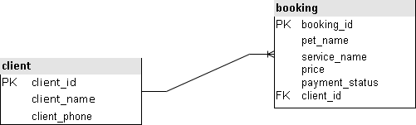

### Second Normal Form

This normal form based on full functional dependency. All the entities are completed second normal form in this database. There are no partial dependencies in any table, only full dependency remains. Client can booking as many as they want and booking can have more than one client. The relationship between these two entites are many to many. These two entites are connected to booking_detail table as many to many relationship will be the reason of caused data redundancy. Client can access his/her booking through booking_detail table, and booking can get the details of client through booking_detail table. This explained that how the transitive dependies are removed in the second normal form.

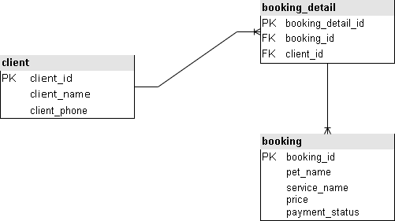

### Third Normal Form

It is in the third normal form and no non-primary key attribute is transitively dependent on any candidate key. To complete third normal form, we need to make sure that the table satisfies the requirements from second normal form, and the table cannot have dependent columns inside them.

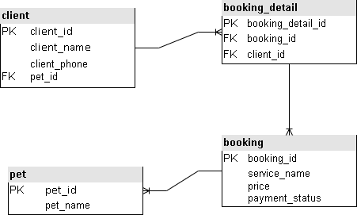

# Task 3 – Scripts to create table structures

## Create `petcare_db` databases

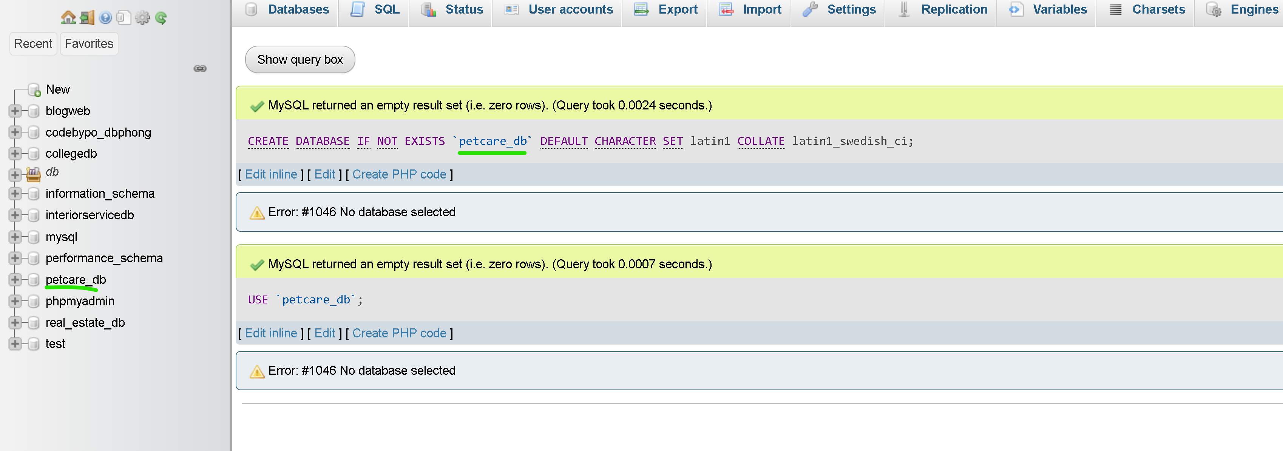

## Create `department` table

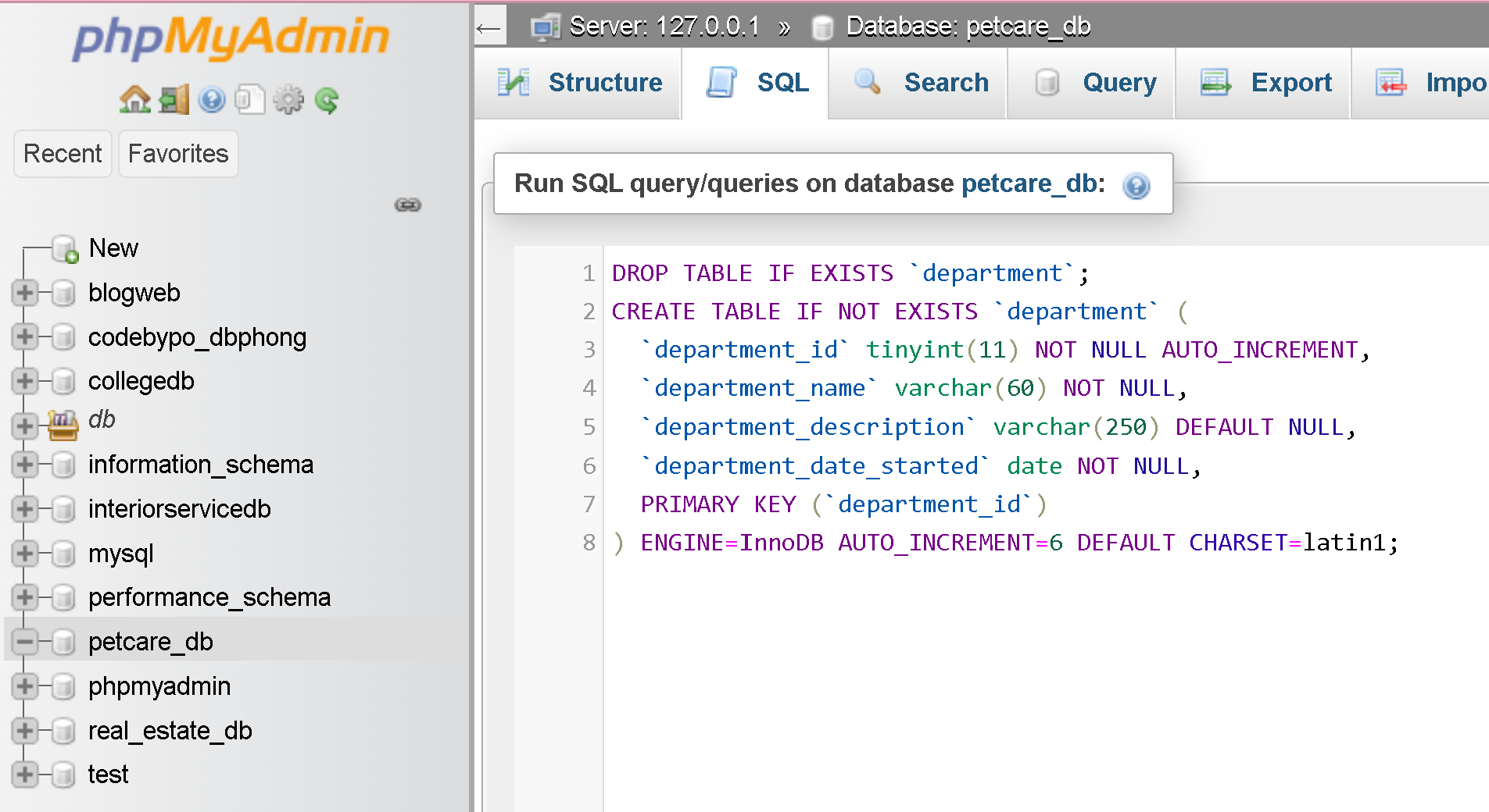

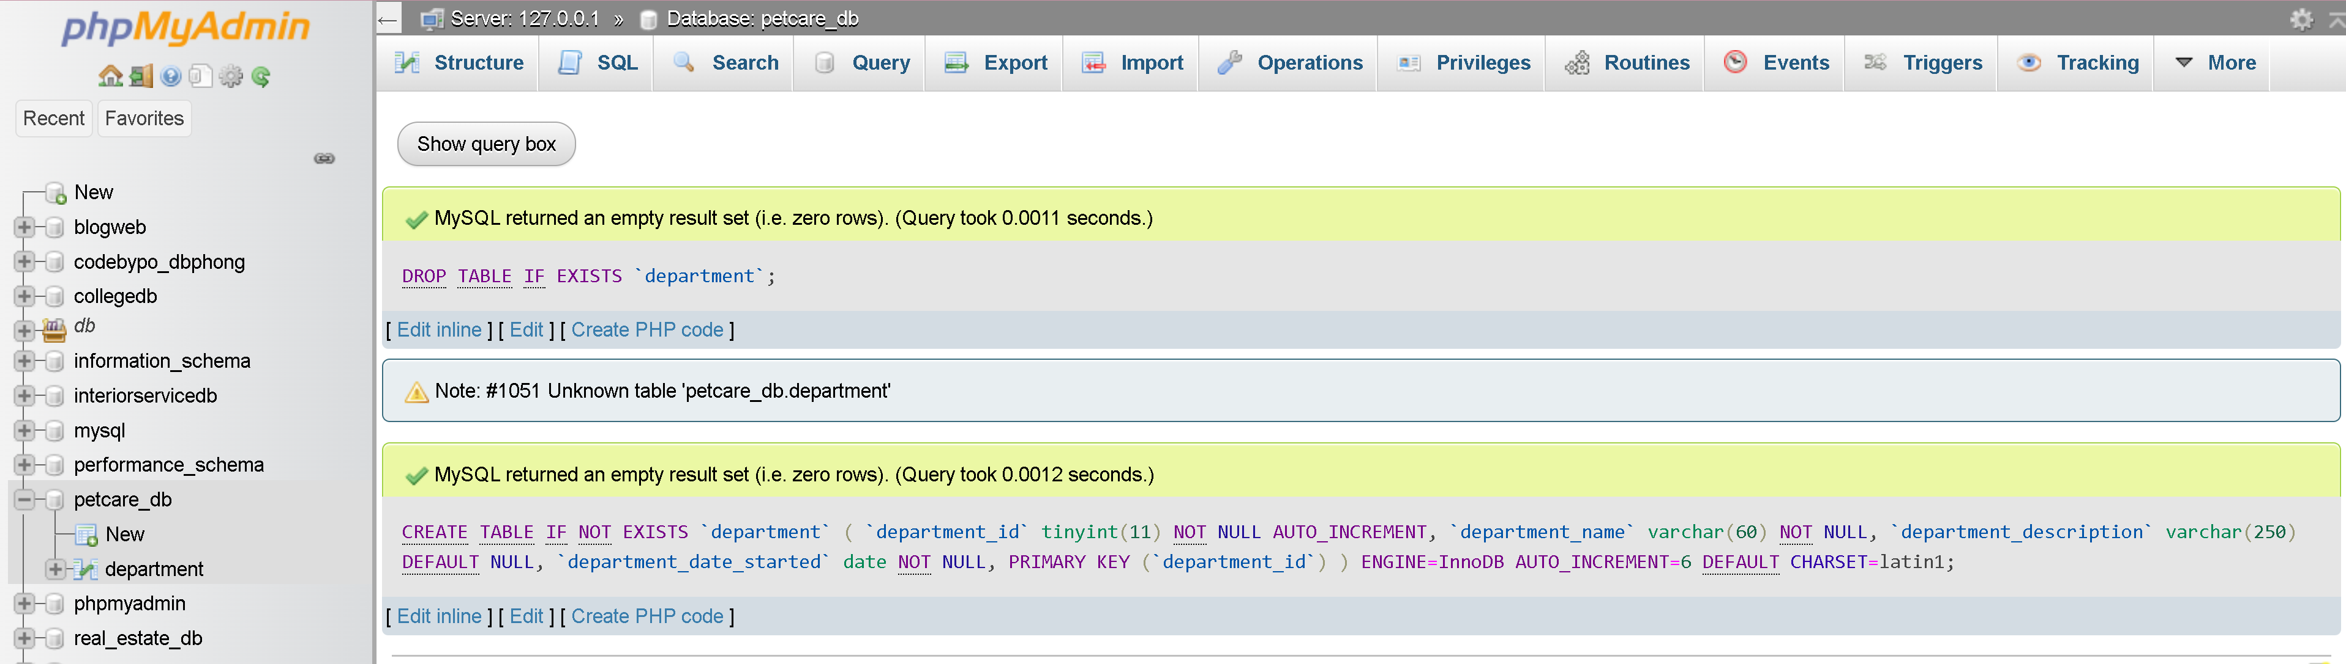

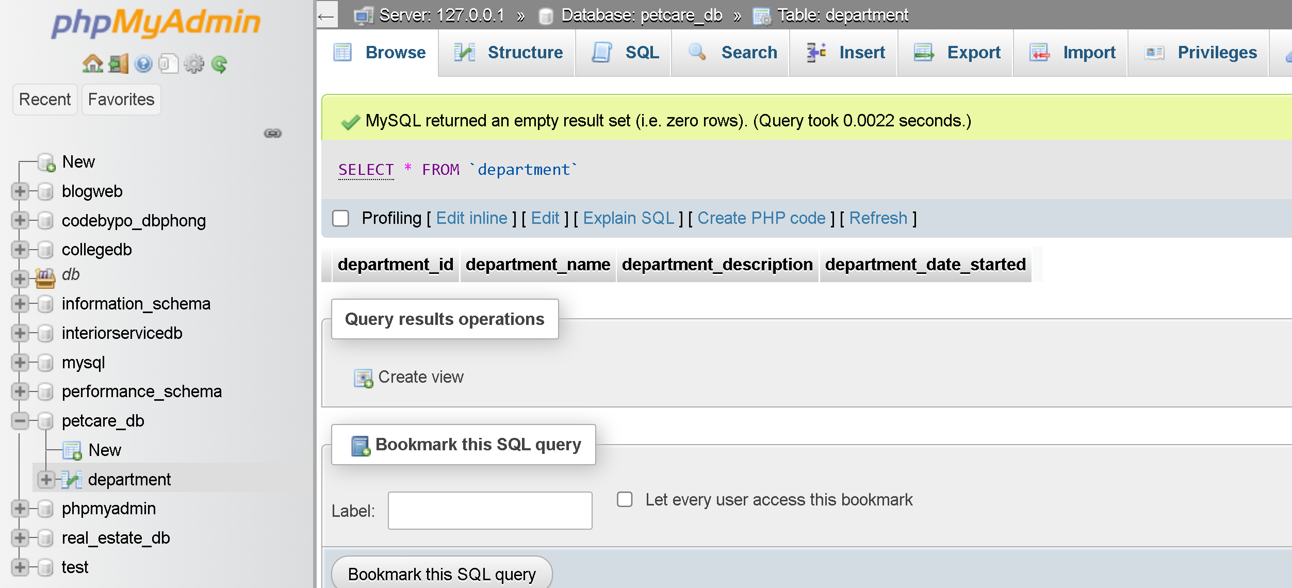

## Create `staff` table

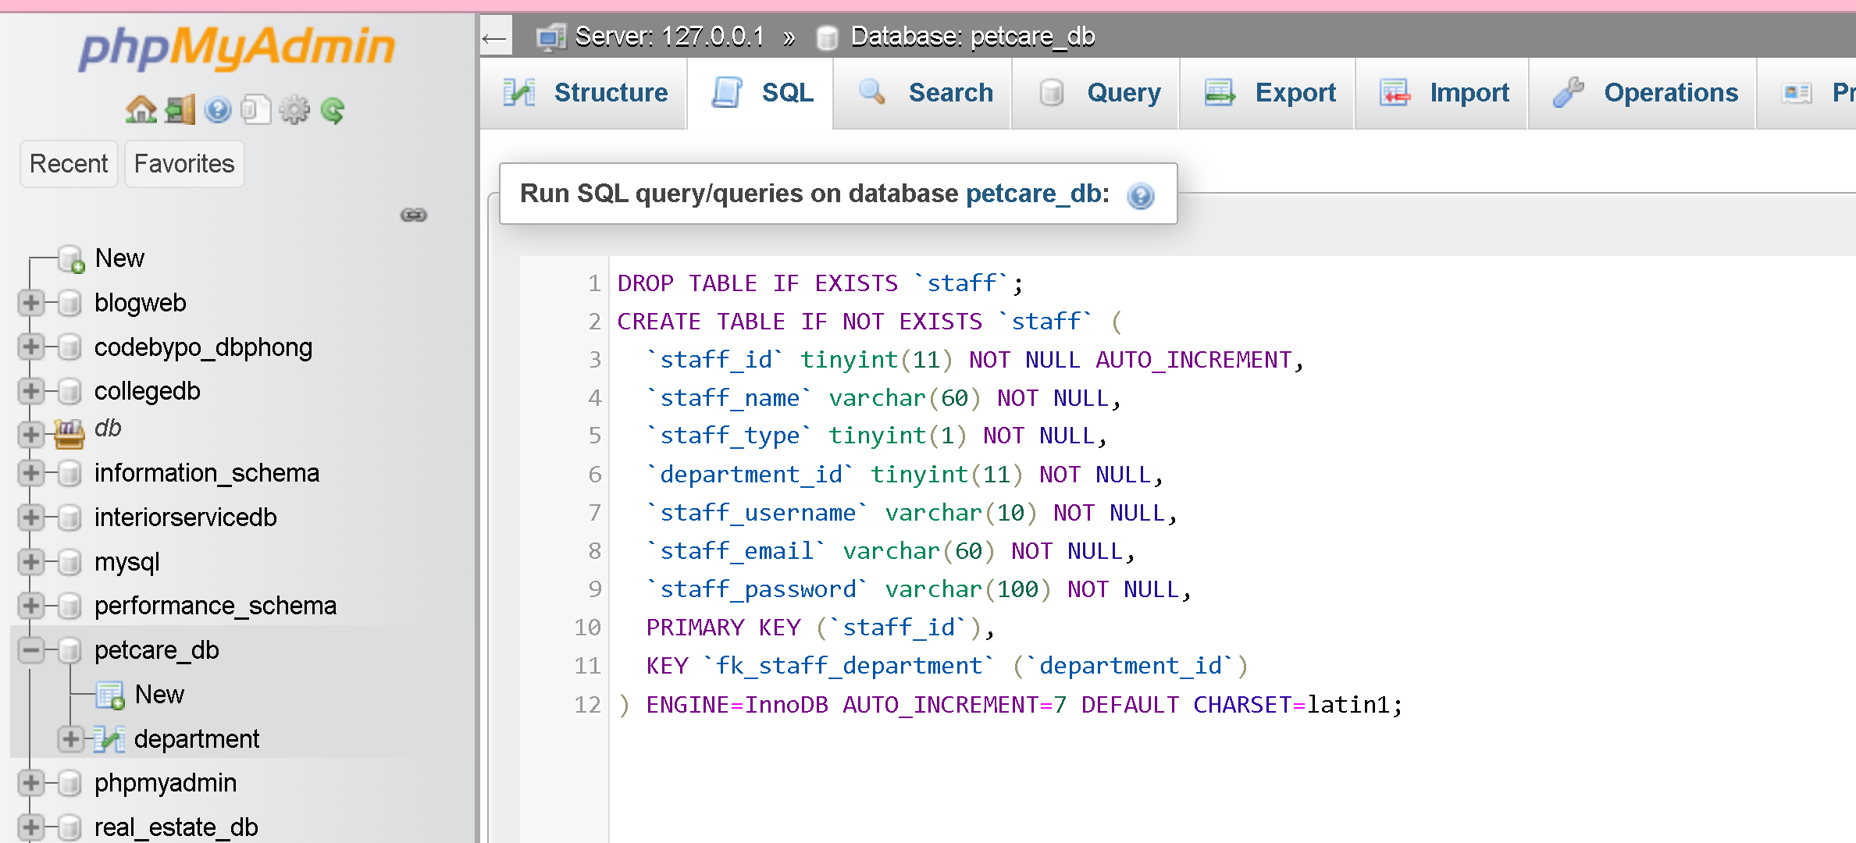

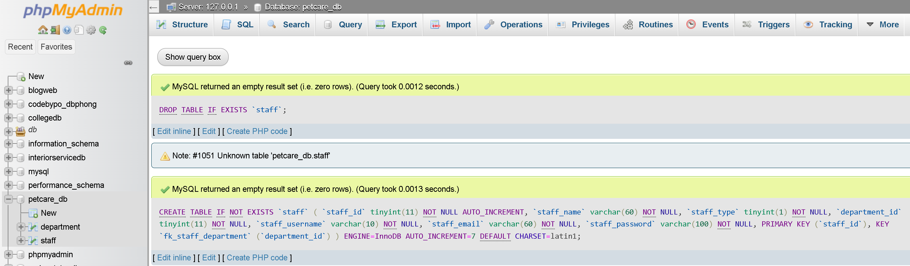

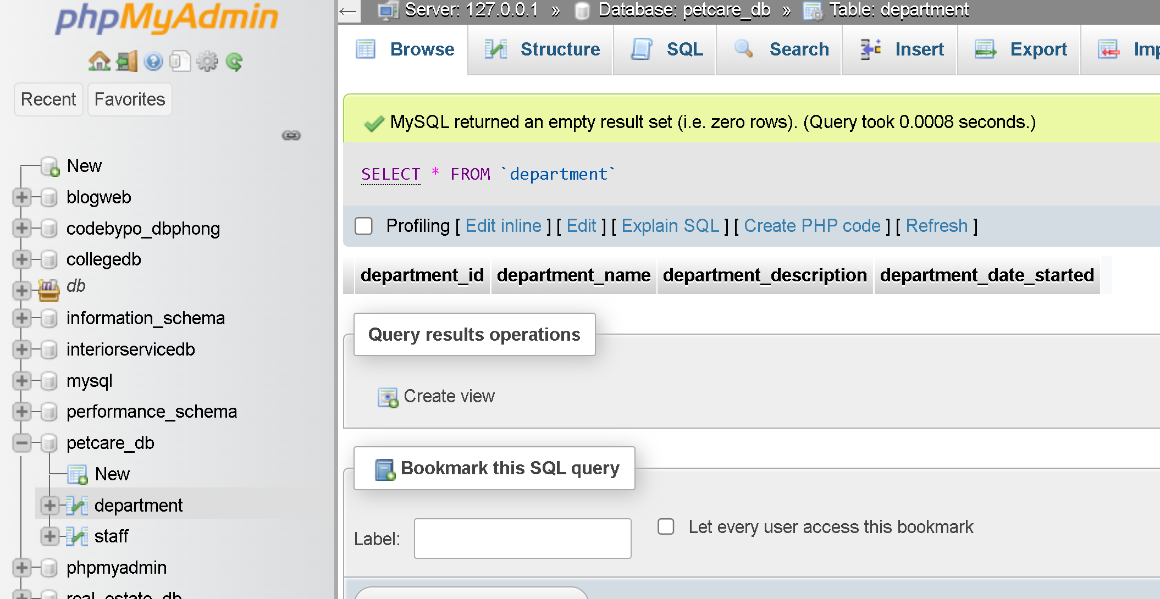

## Create `client` table

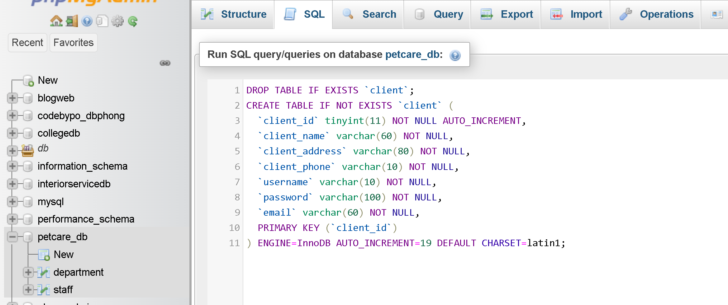

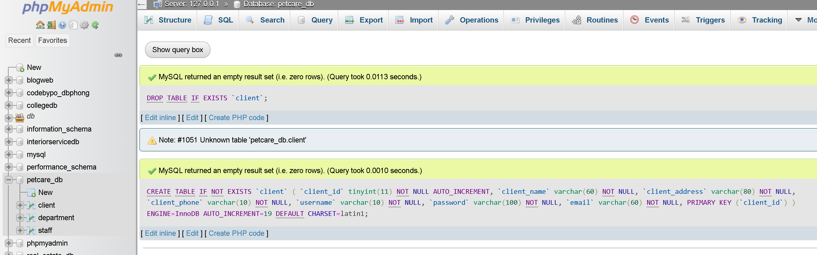

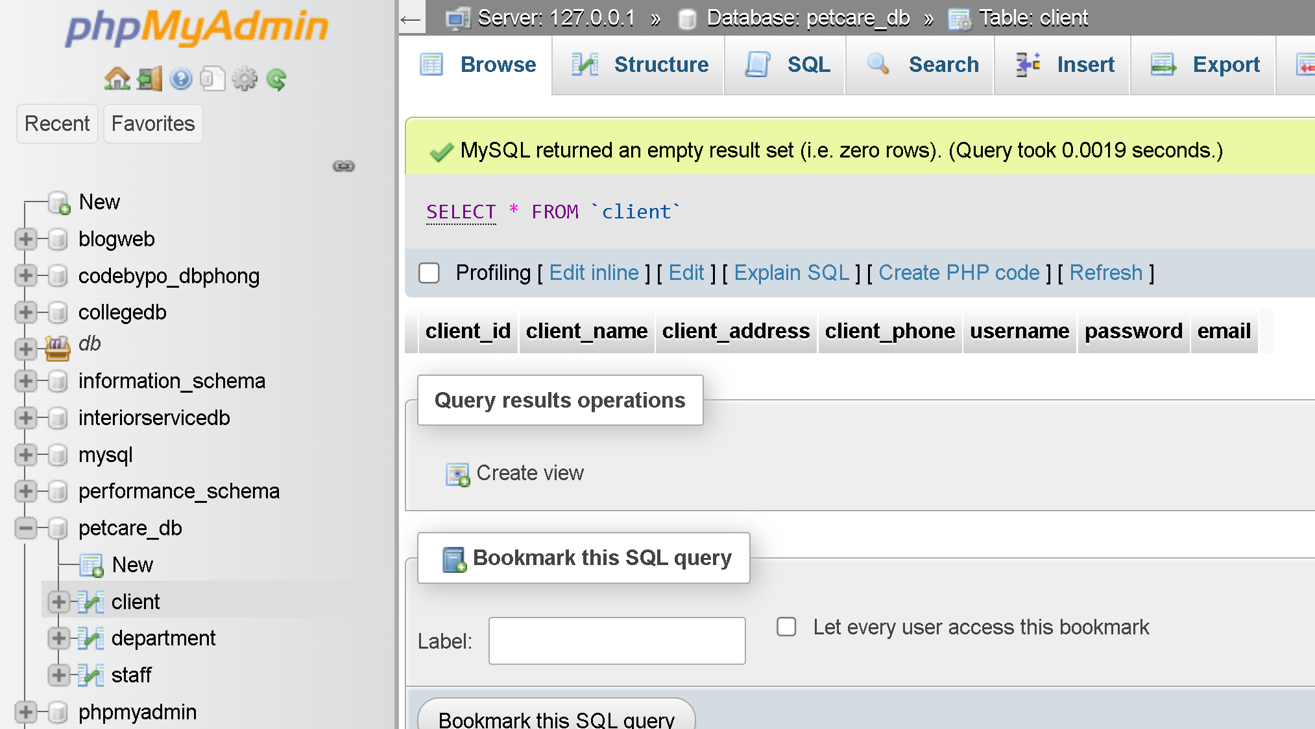

## Create `species` table

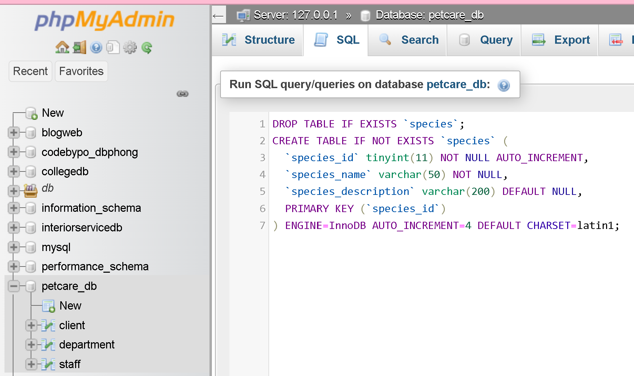

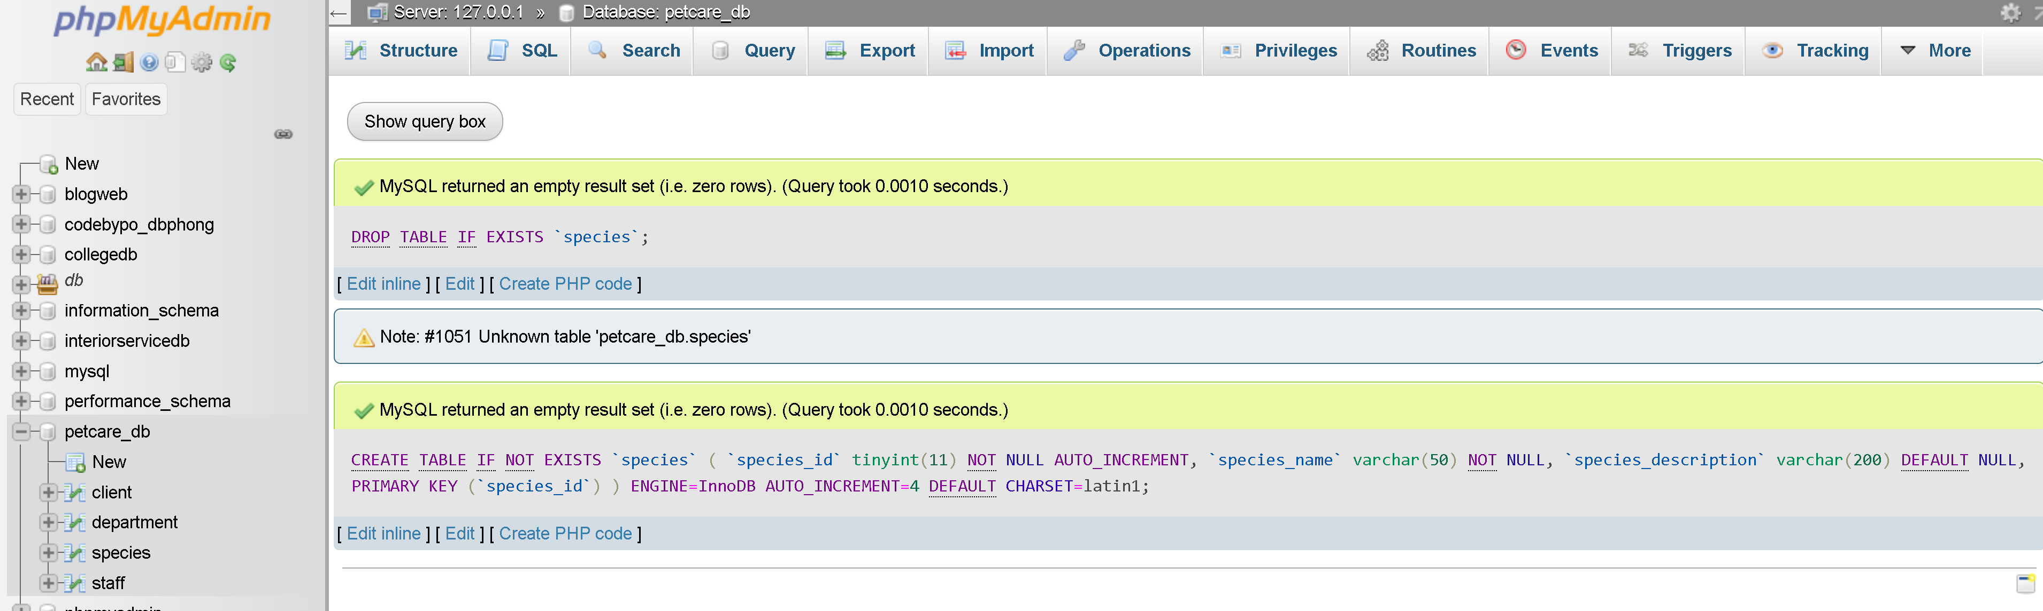

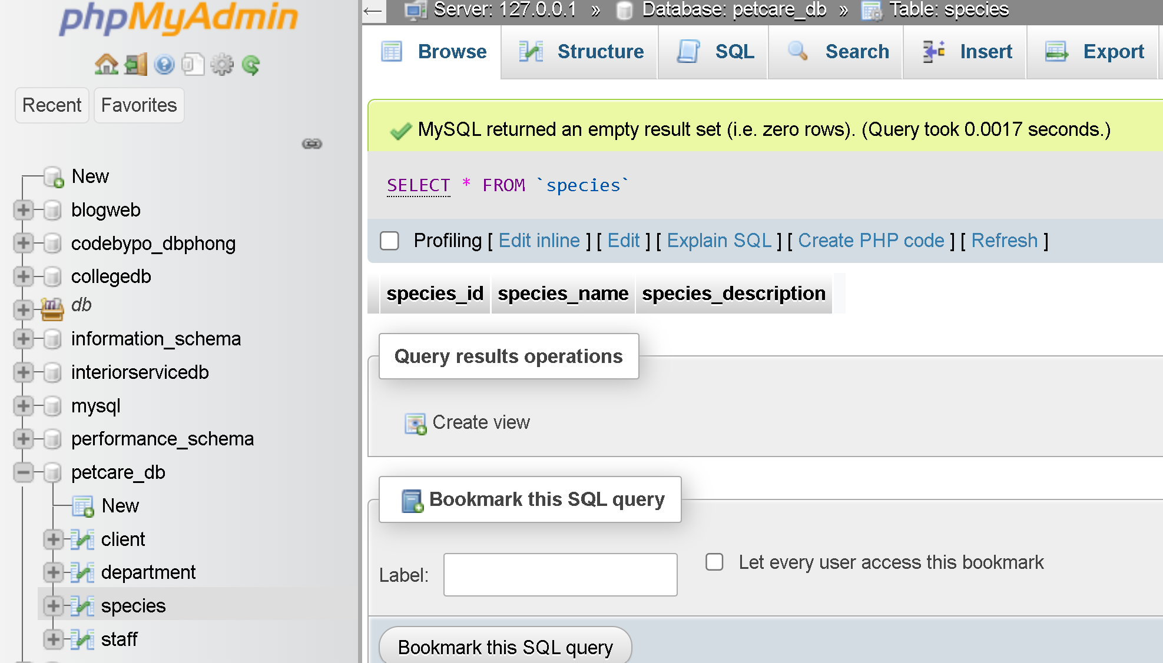

## Create `pet` table

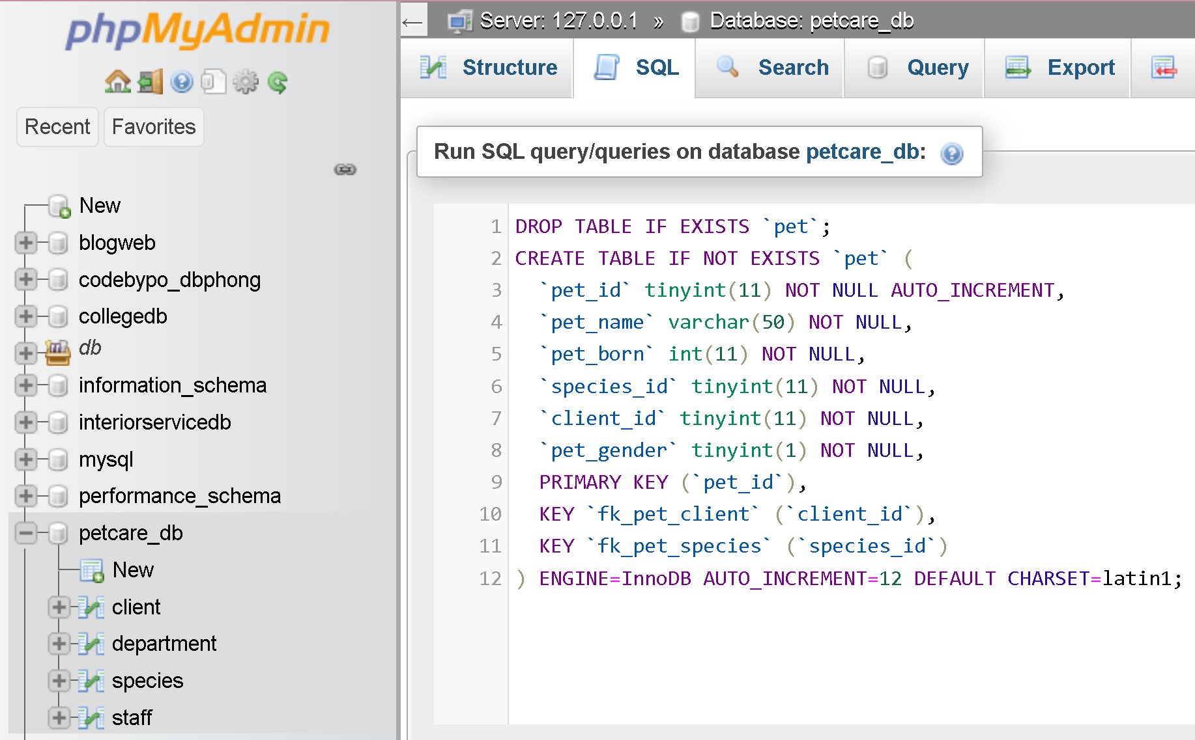

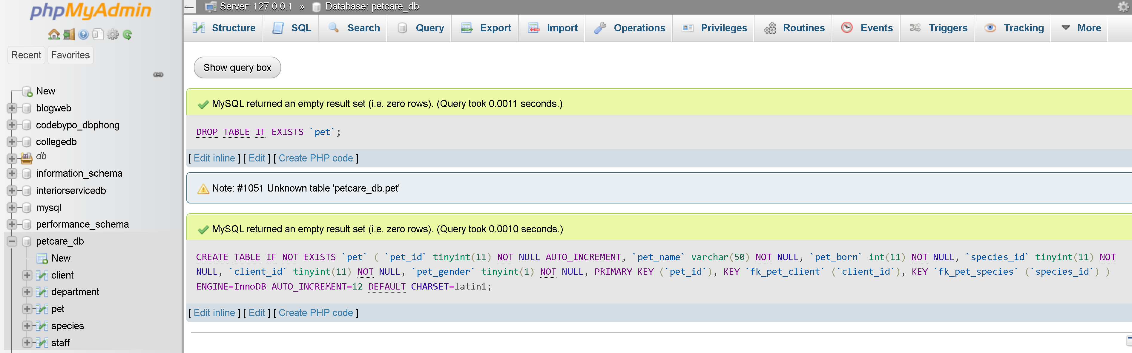

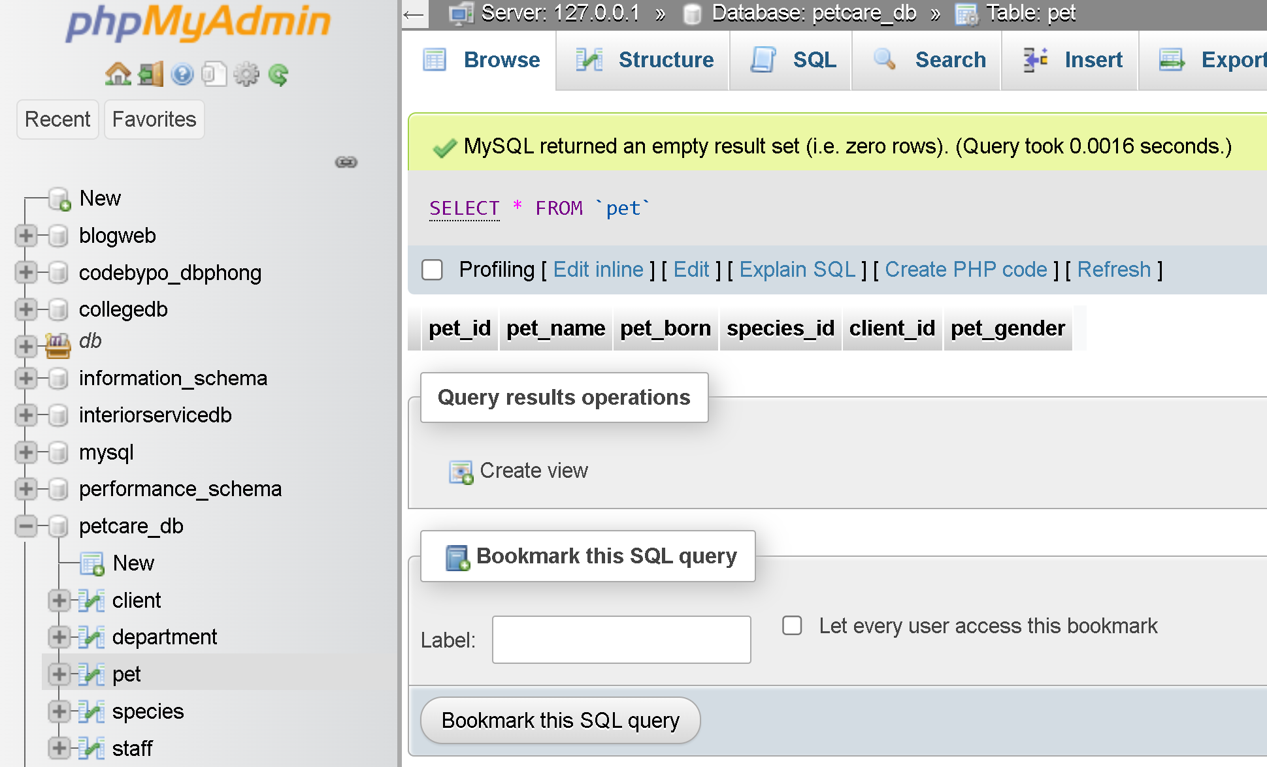

## Create `Booking` table

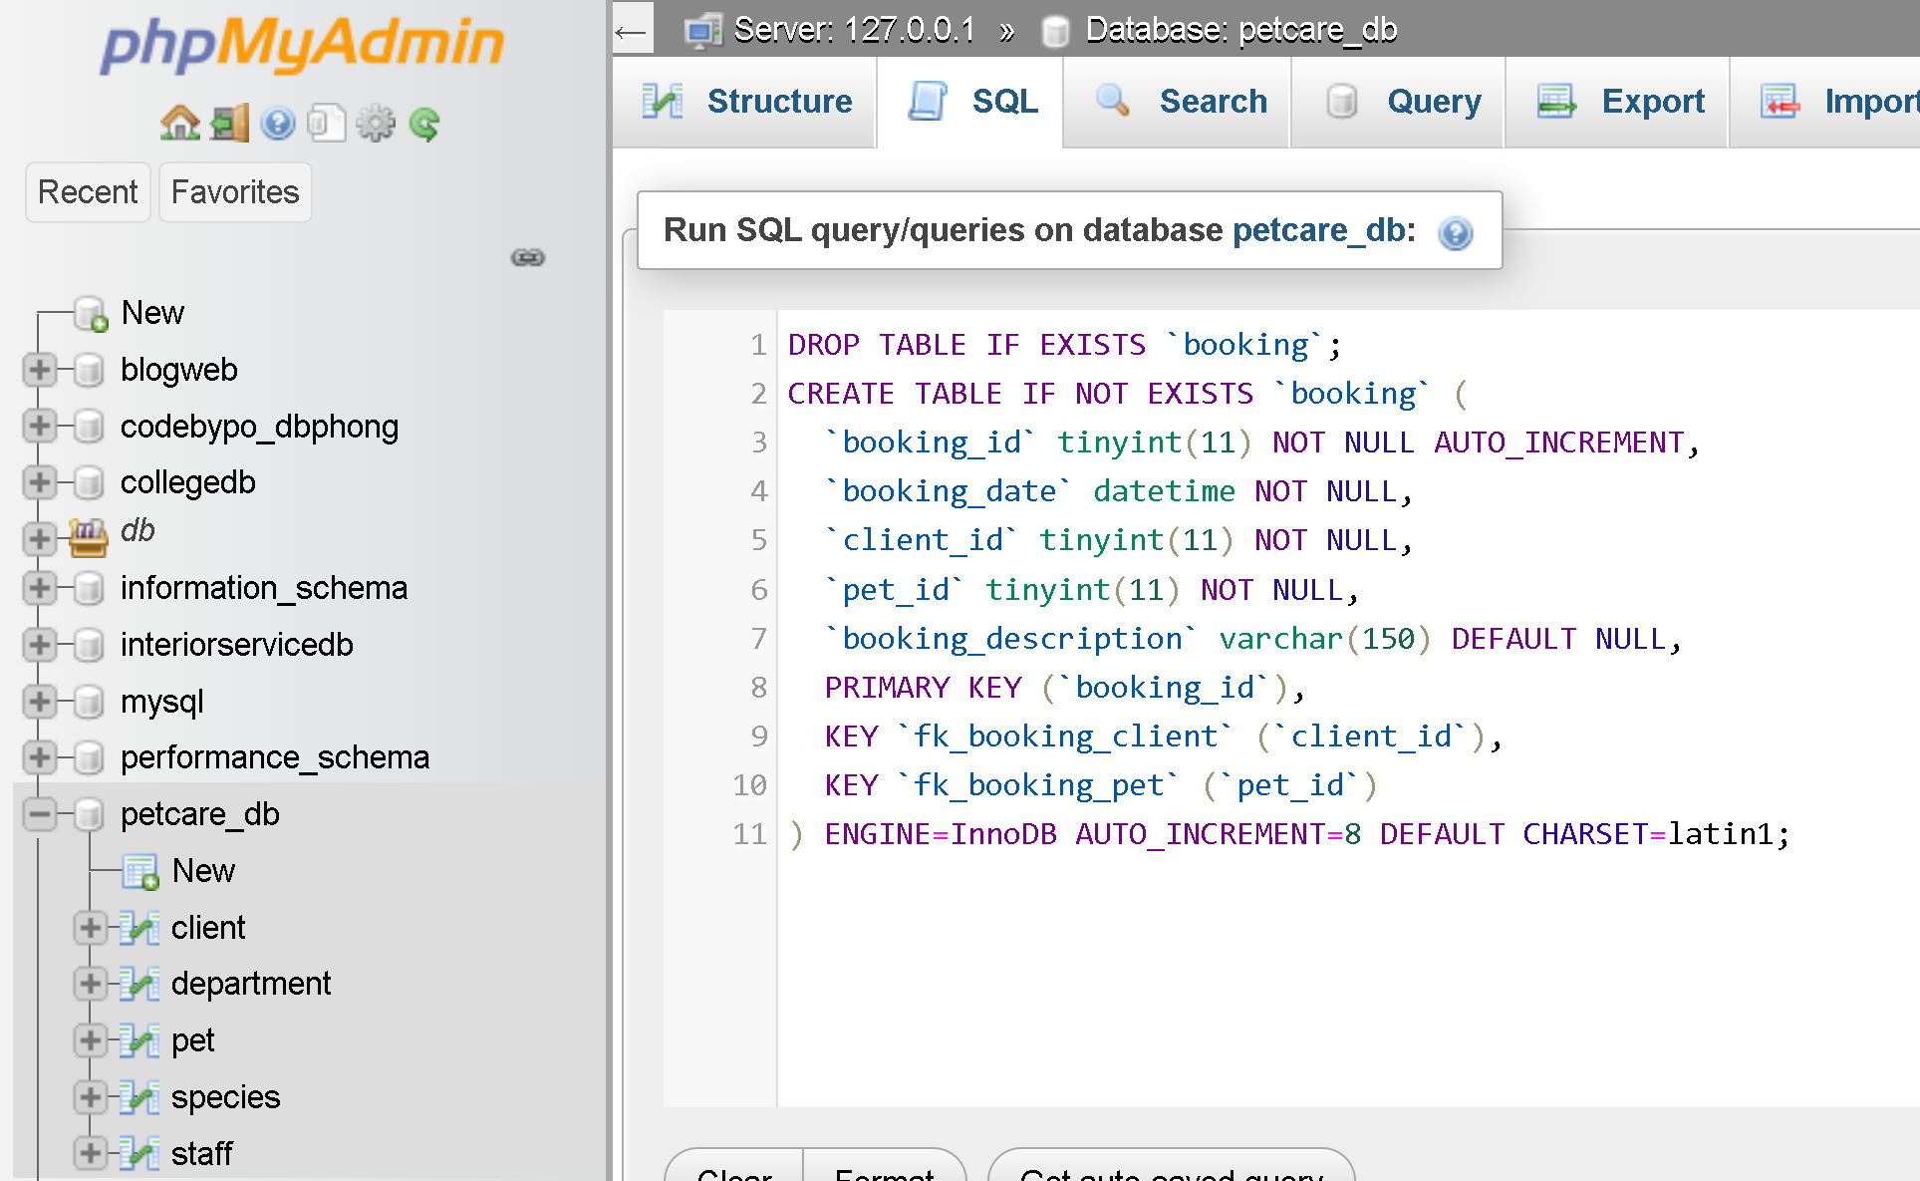

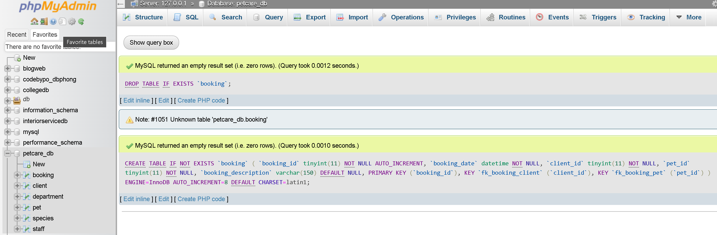

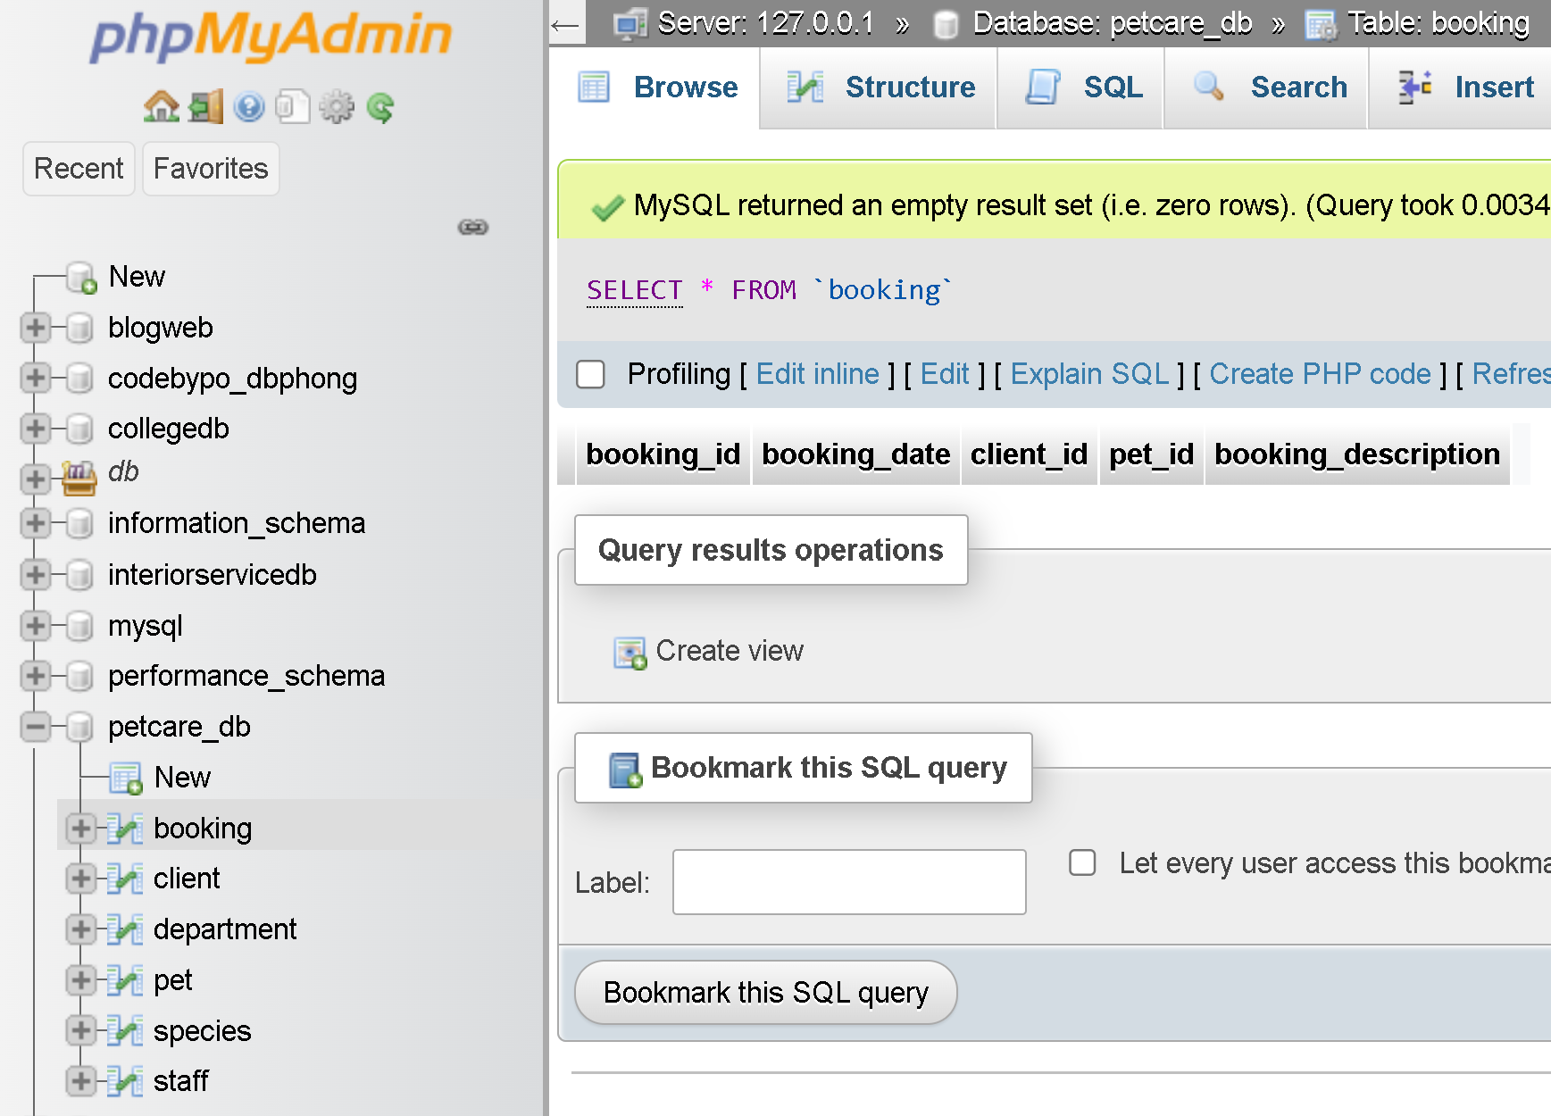

## Create `Service` table

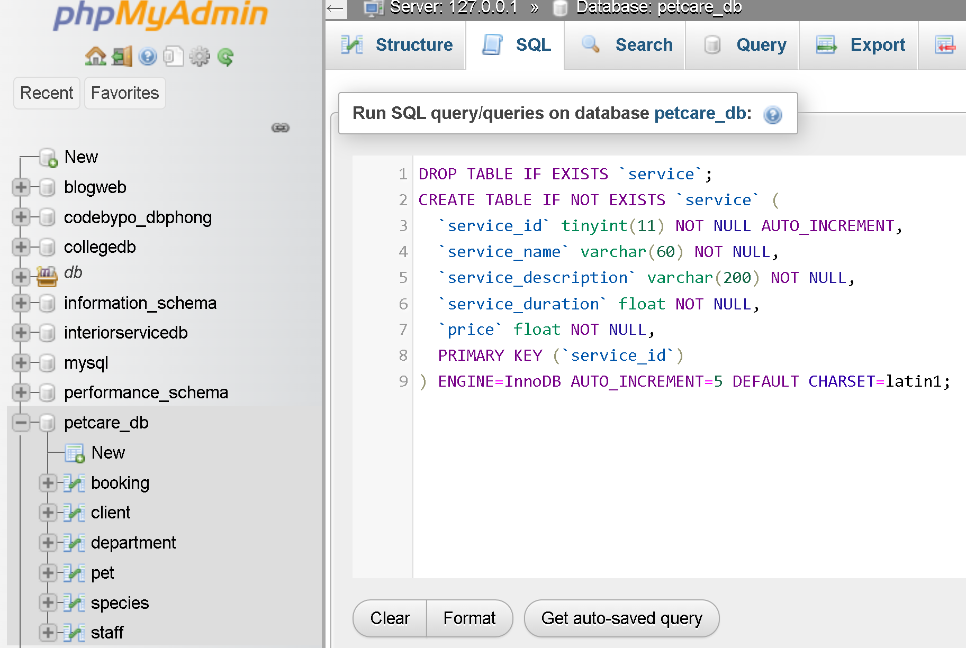

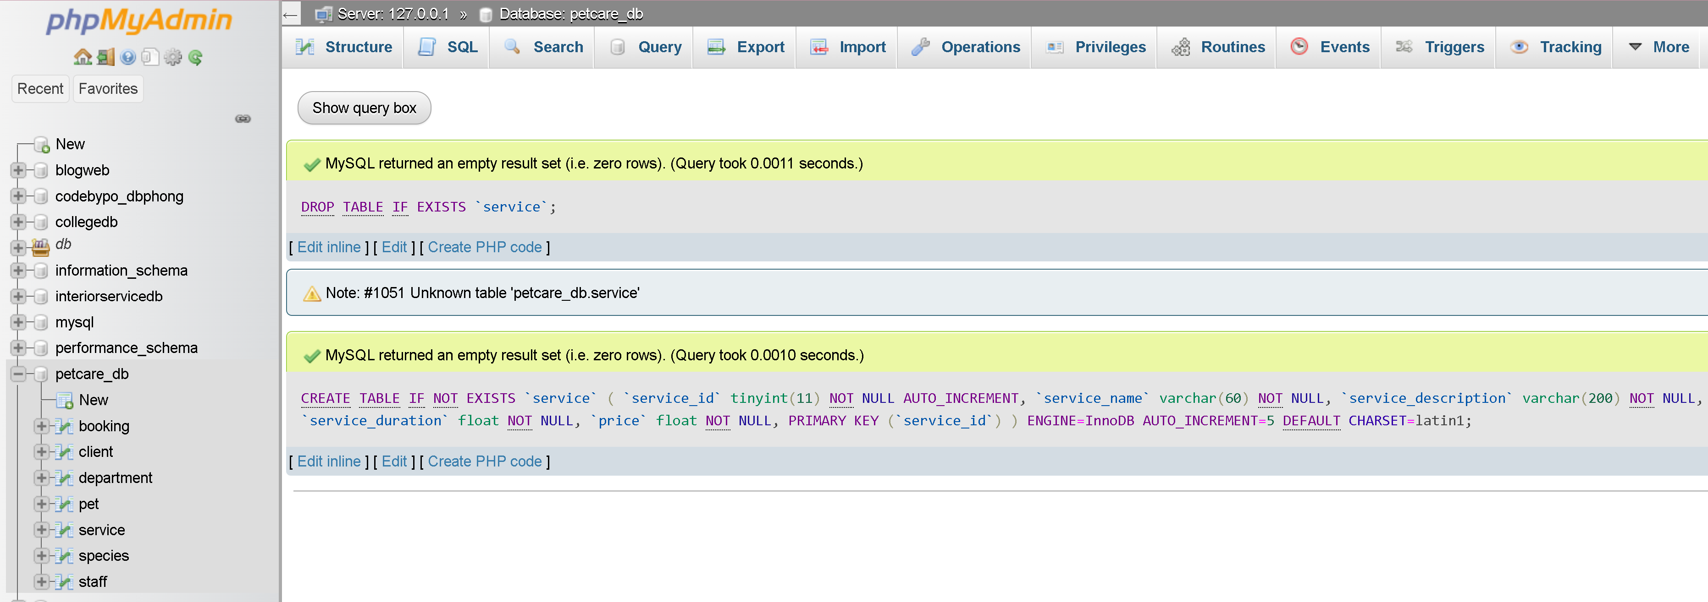

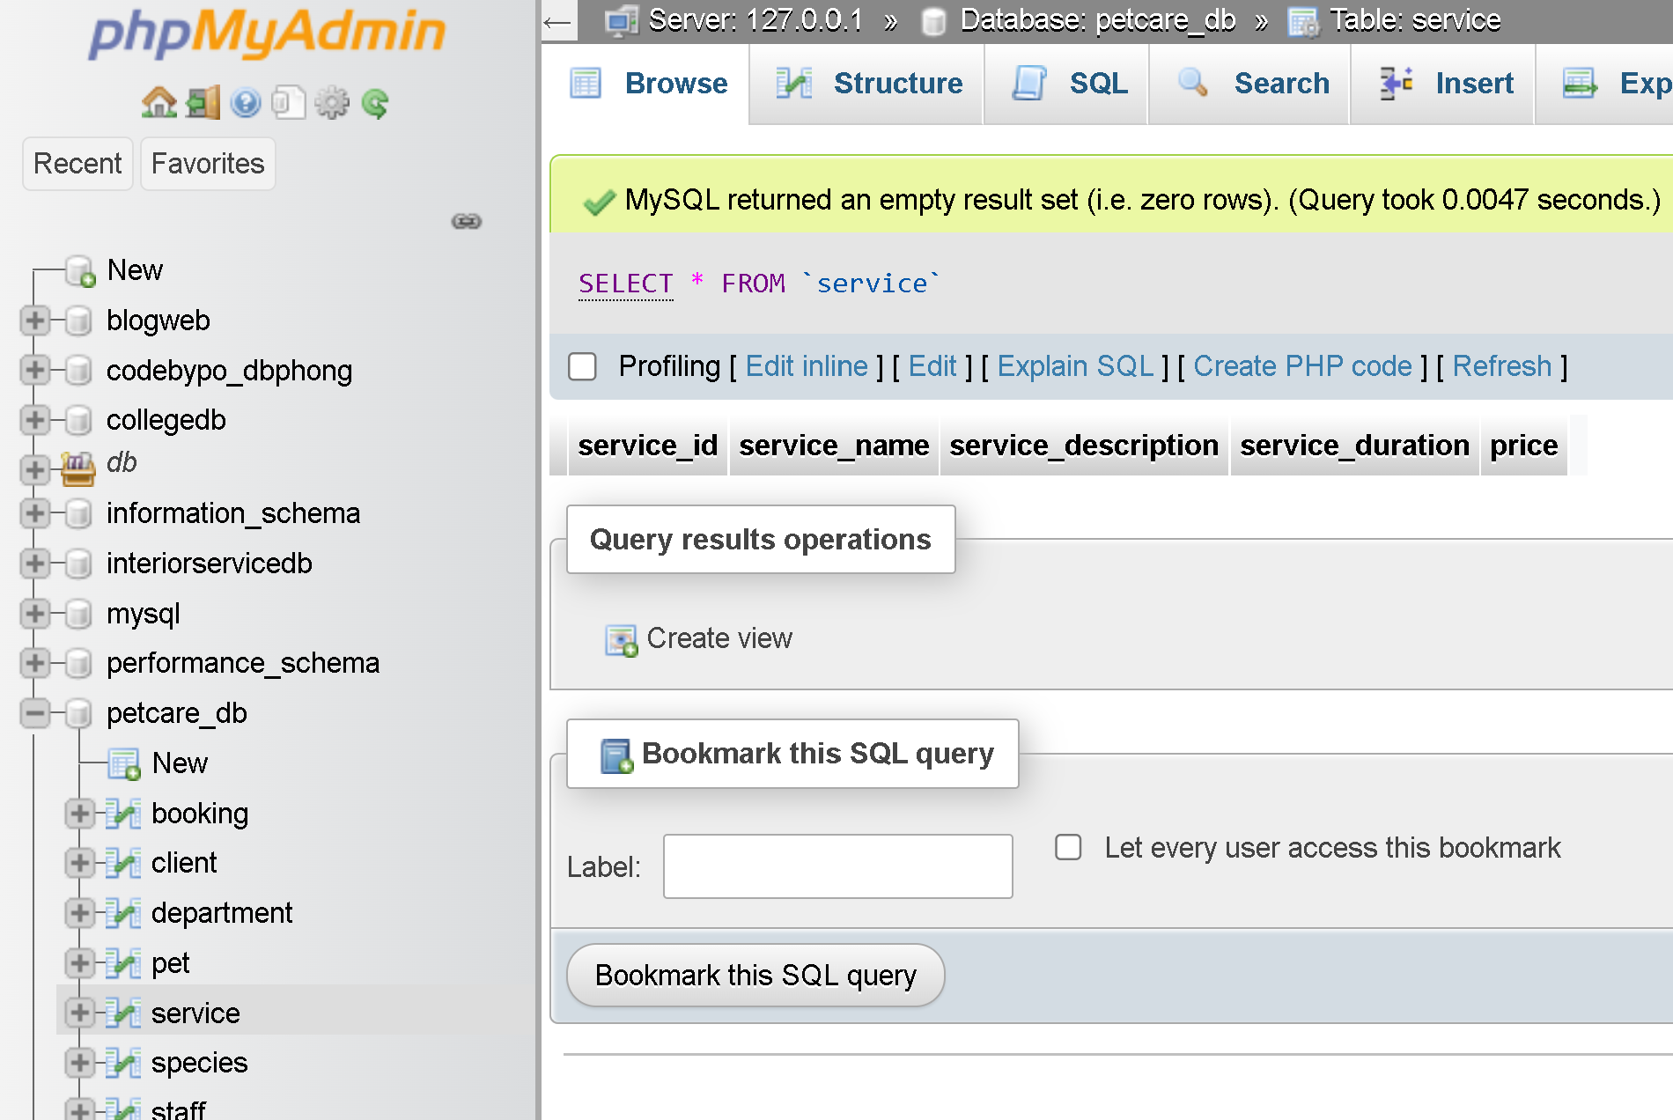

## Create `booking_detail` table

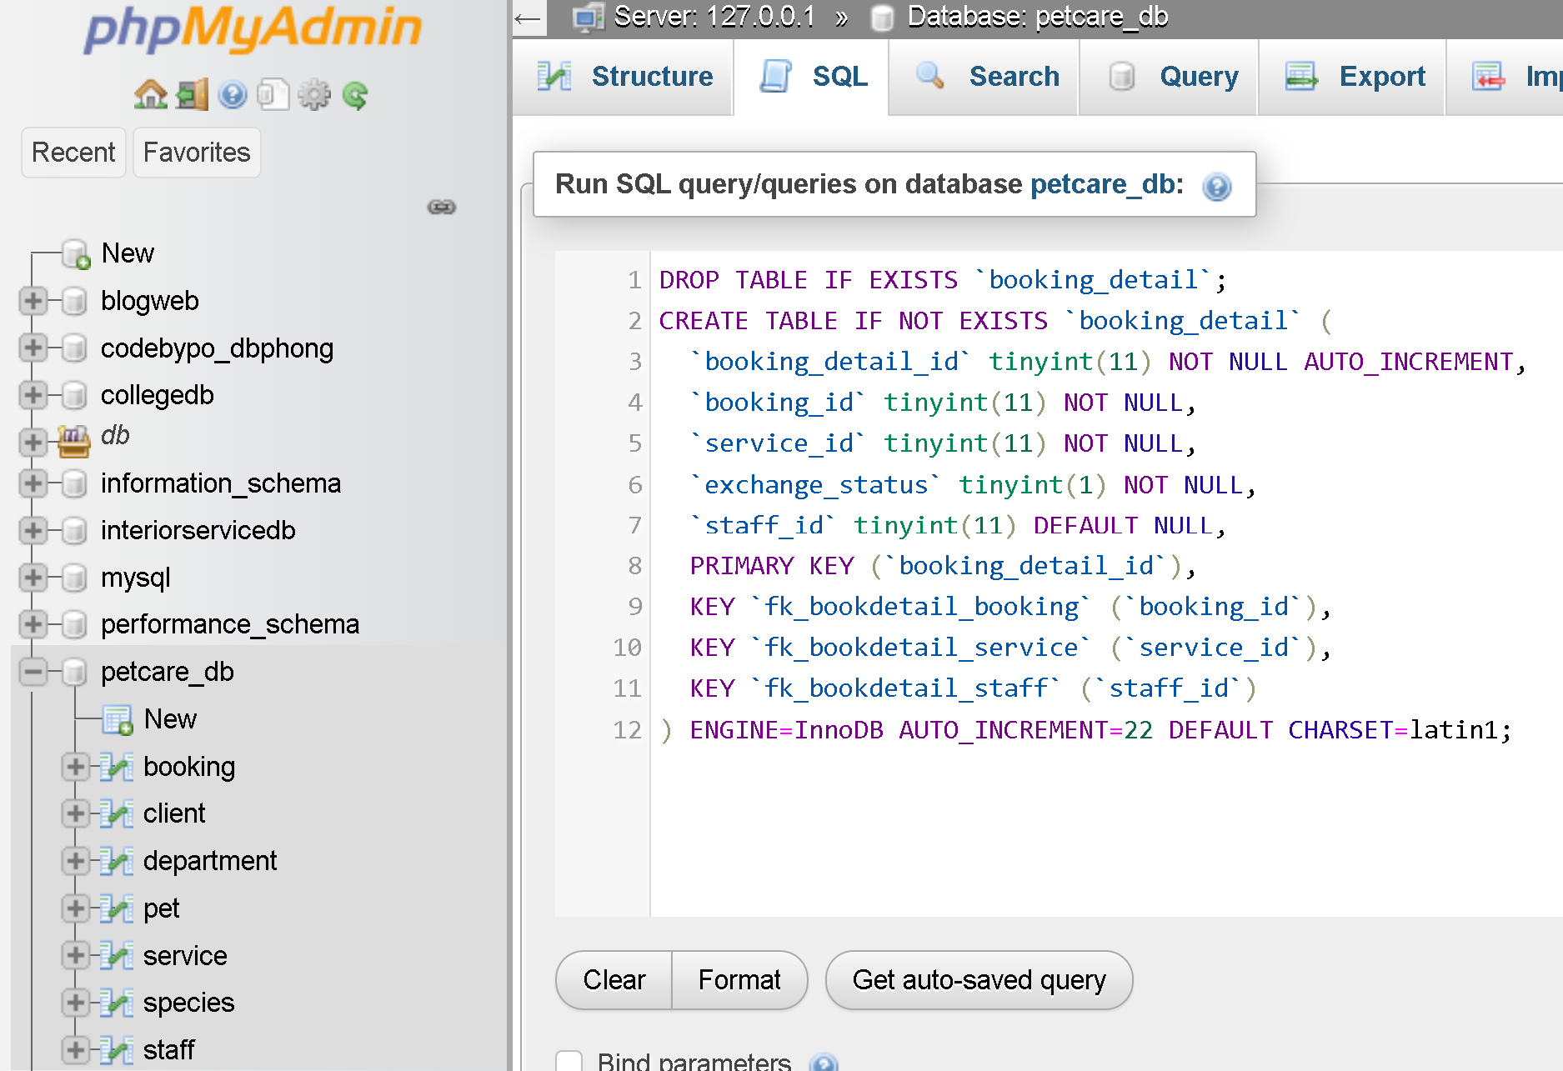

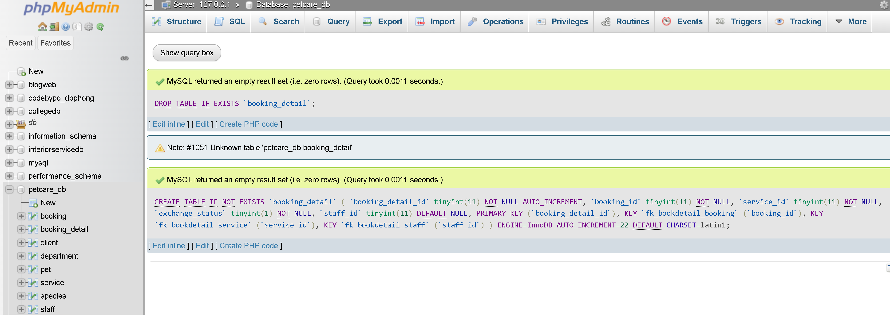

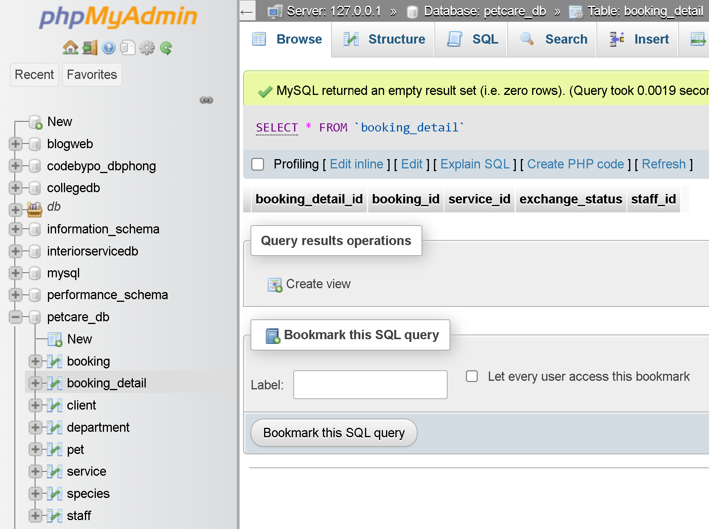

## Create `image` table

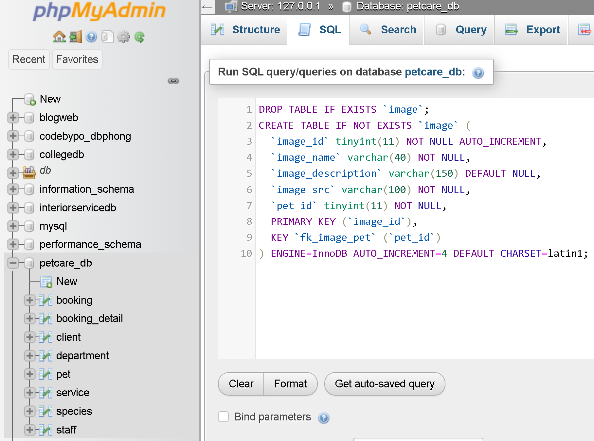

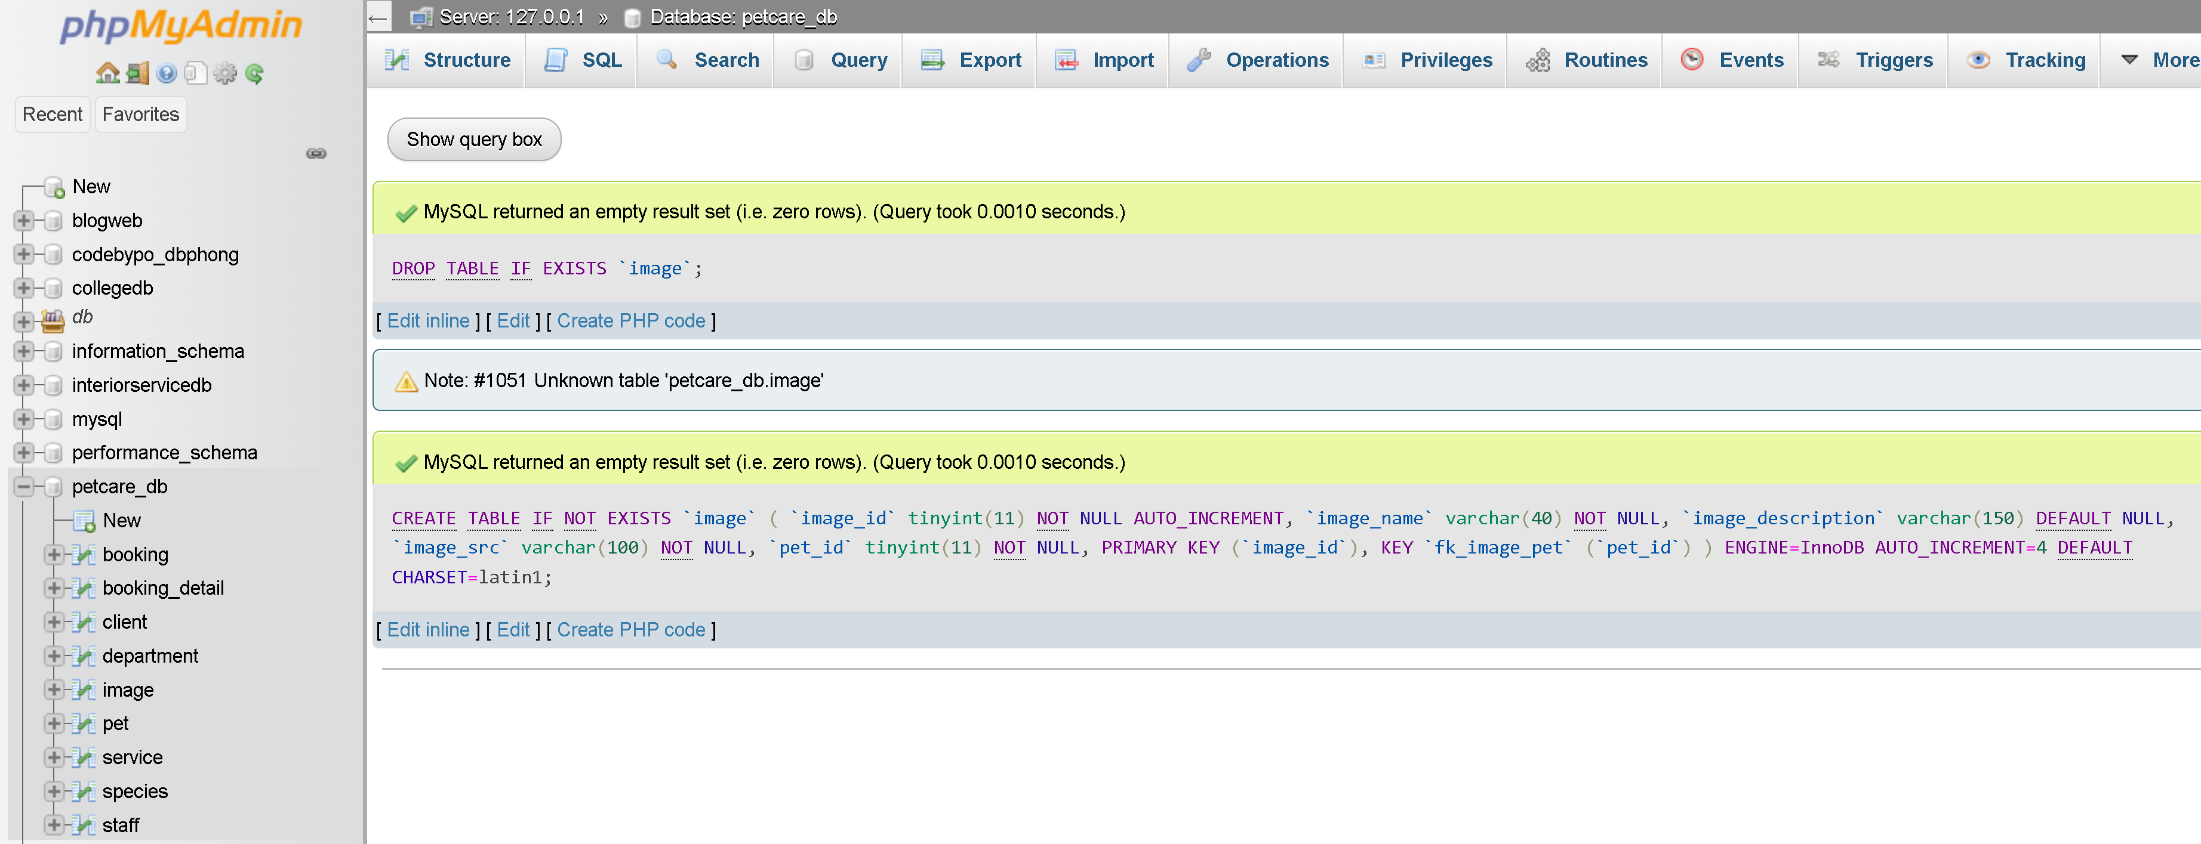

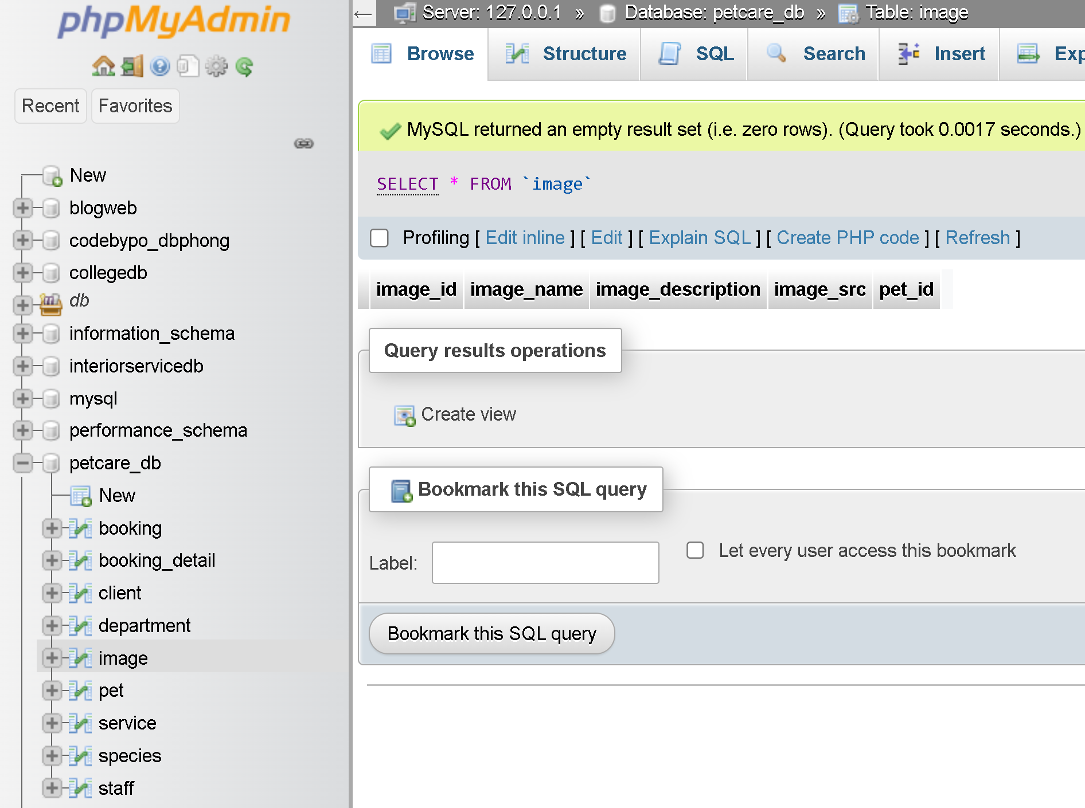

## Create `Progress` table

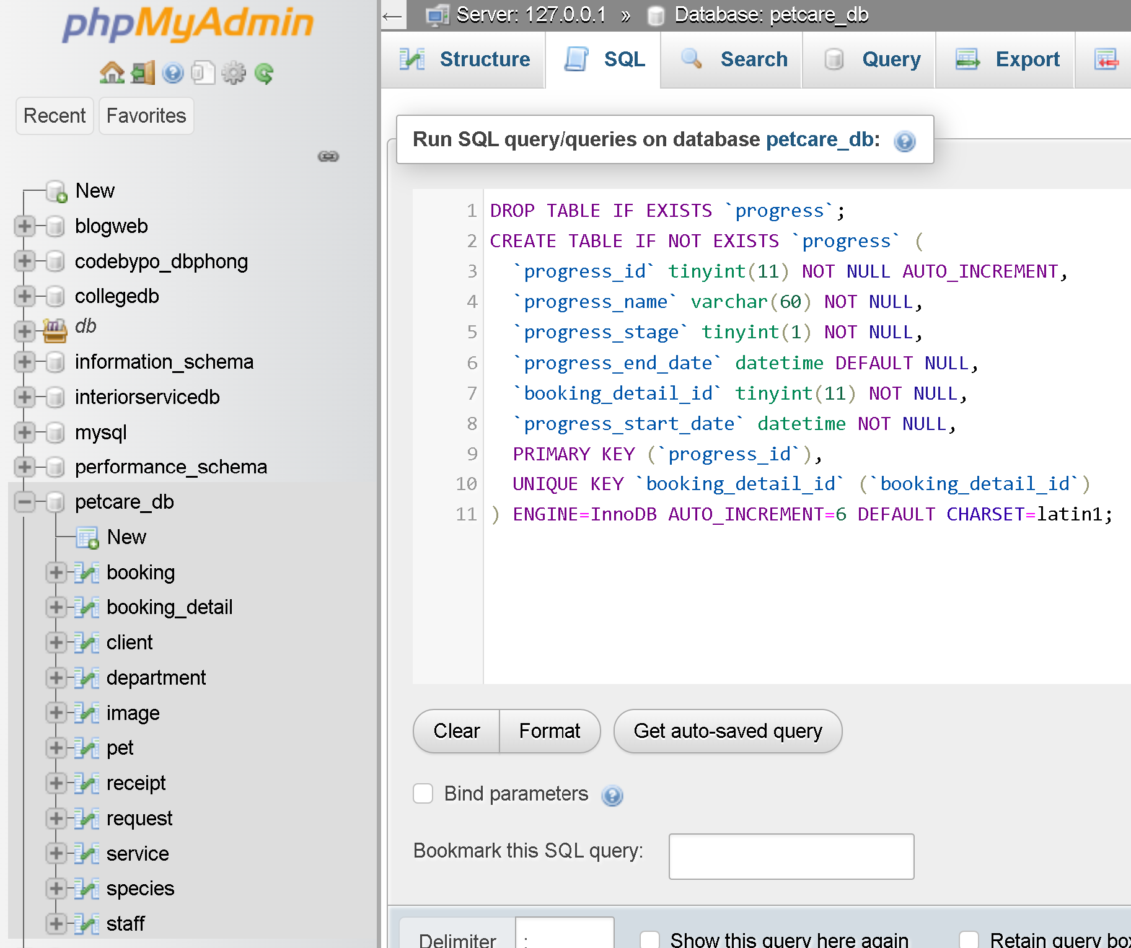

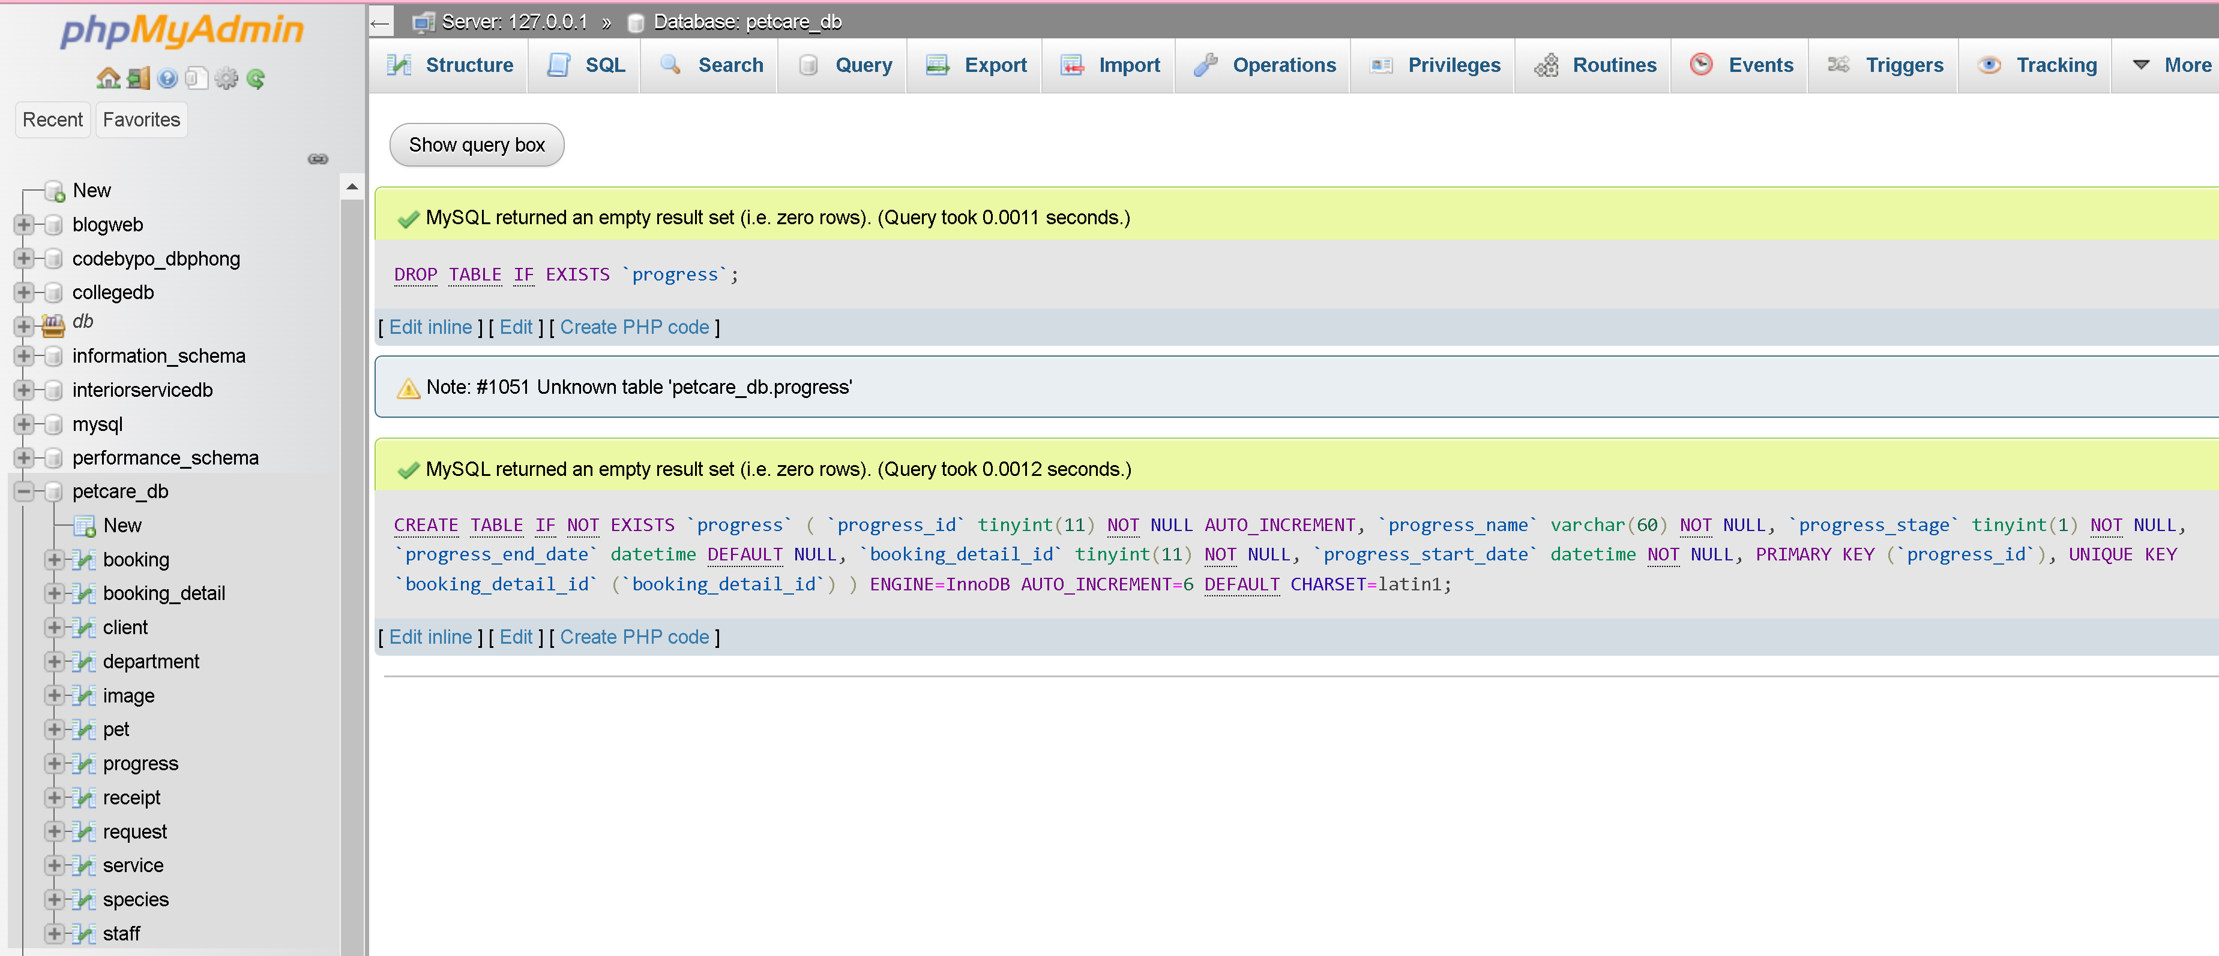

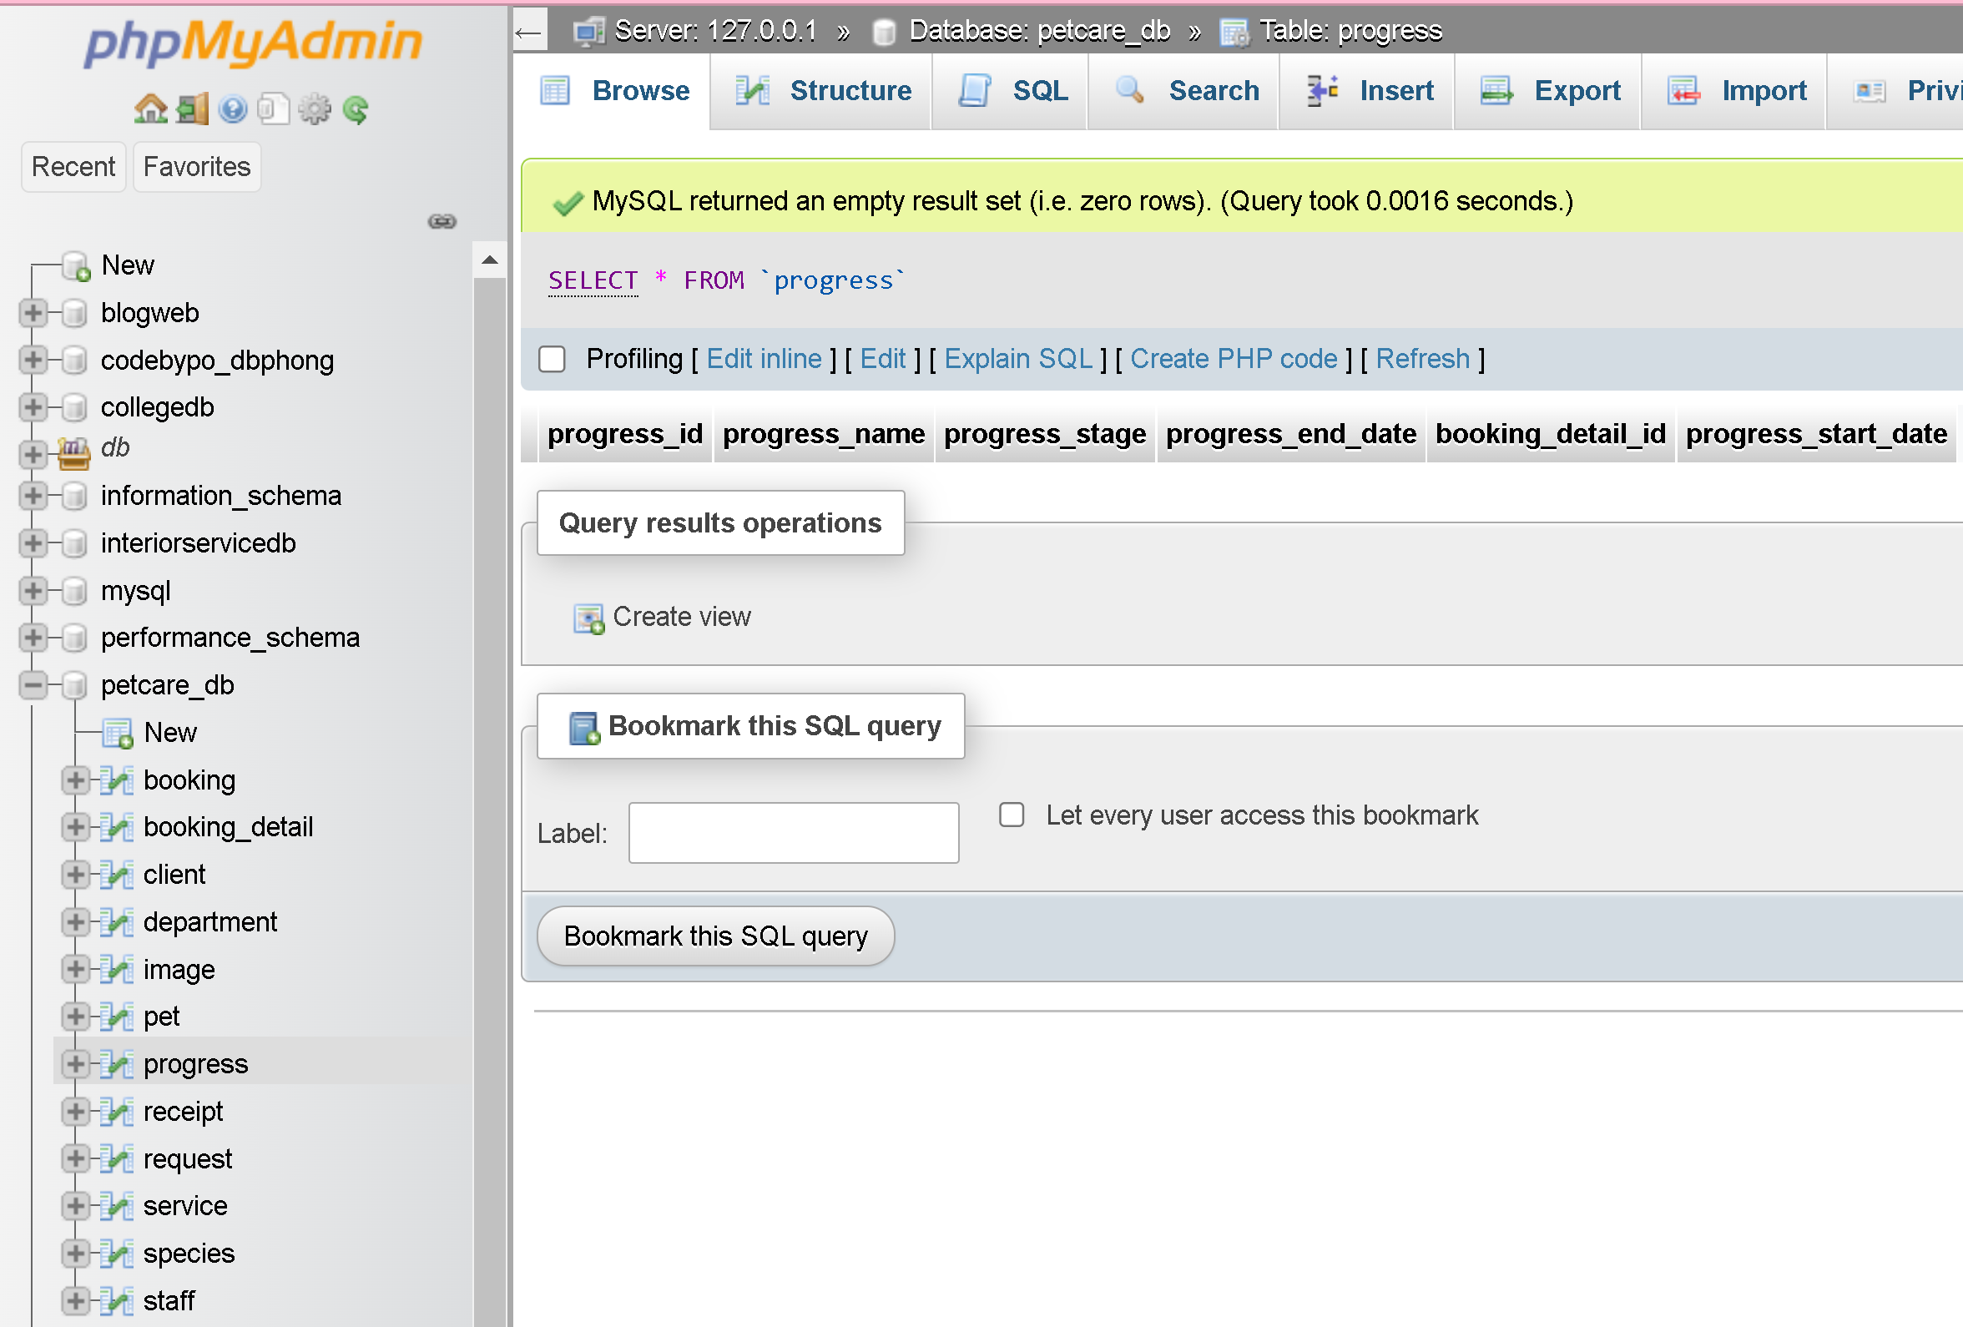

## Create `Receipt` table

**DROP** **TABLE** **IF** **EXISTS** `receipt`**;**

**CREATE** **TABLE** **IF** **NOT** **EXISTS** `receipt` **(**

`receipt_id` tinyint**(**11**)** **NOT** **NULL** AUTO_INCREMENT**,**

`receipt_term` tinyint**(**1**)** **NOT** **NULL,**

`status_payment` tinyint**(**1**)** **NOT** **NULL,**

`client_id` tinyint**(**11**)** **NOT** **NULL,**

`booking_detail_id` tinyint**(**11**)** **NOT** **NULL,**

`receipt_description` varchar**(**200**)** **DEFAULT** **NULL,**

`staff_id` tinyint**(**11**)** **NOT** **NULL,**

`total_costs` bigint**(**20**)** **NOT** **NULL,**

**PRIMARY** **KEY** **(**`receipt_id`**),**

**KEY** `fk_receipt_staff` **(**`staff_id`**),**

**KEY** `fk_receipt_client` **(**`client_id`**),**

**KEY** `fk_receipt_booking_detail` **(**`booking_detail_id`**)**

**)** ENGINE**=**InnoDB AUTO_INCREMENT**=**2 **DEFAULT** CHARSET**=**latin1**;**

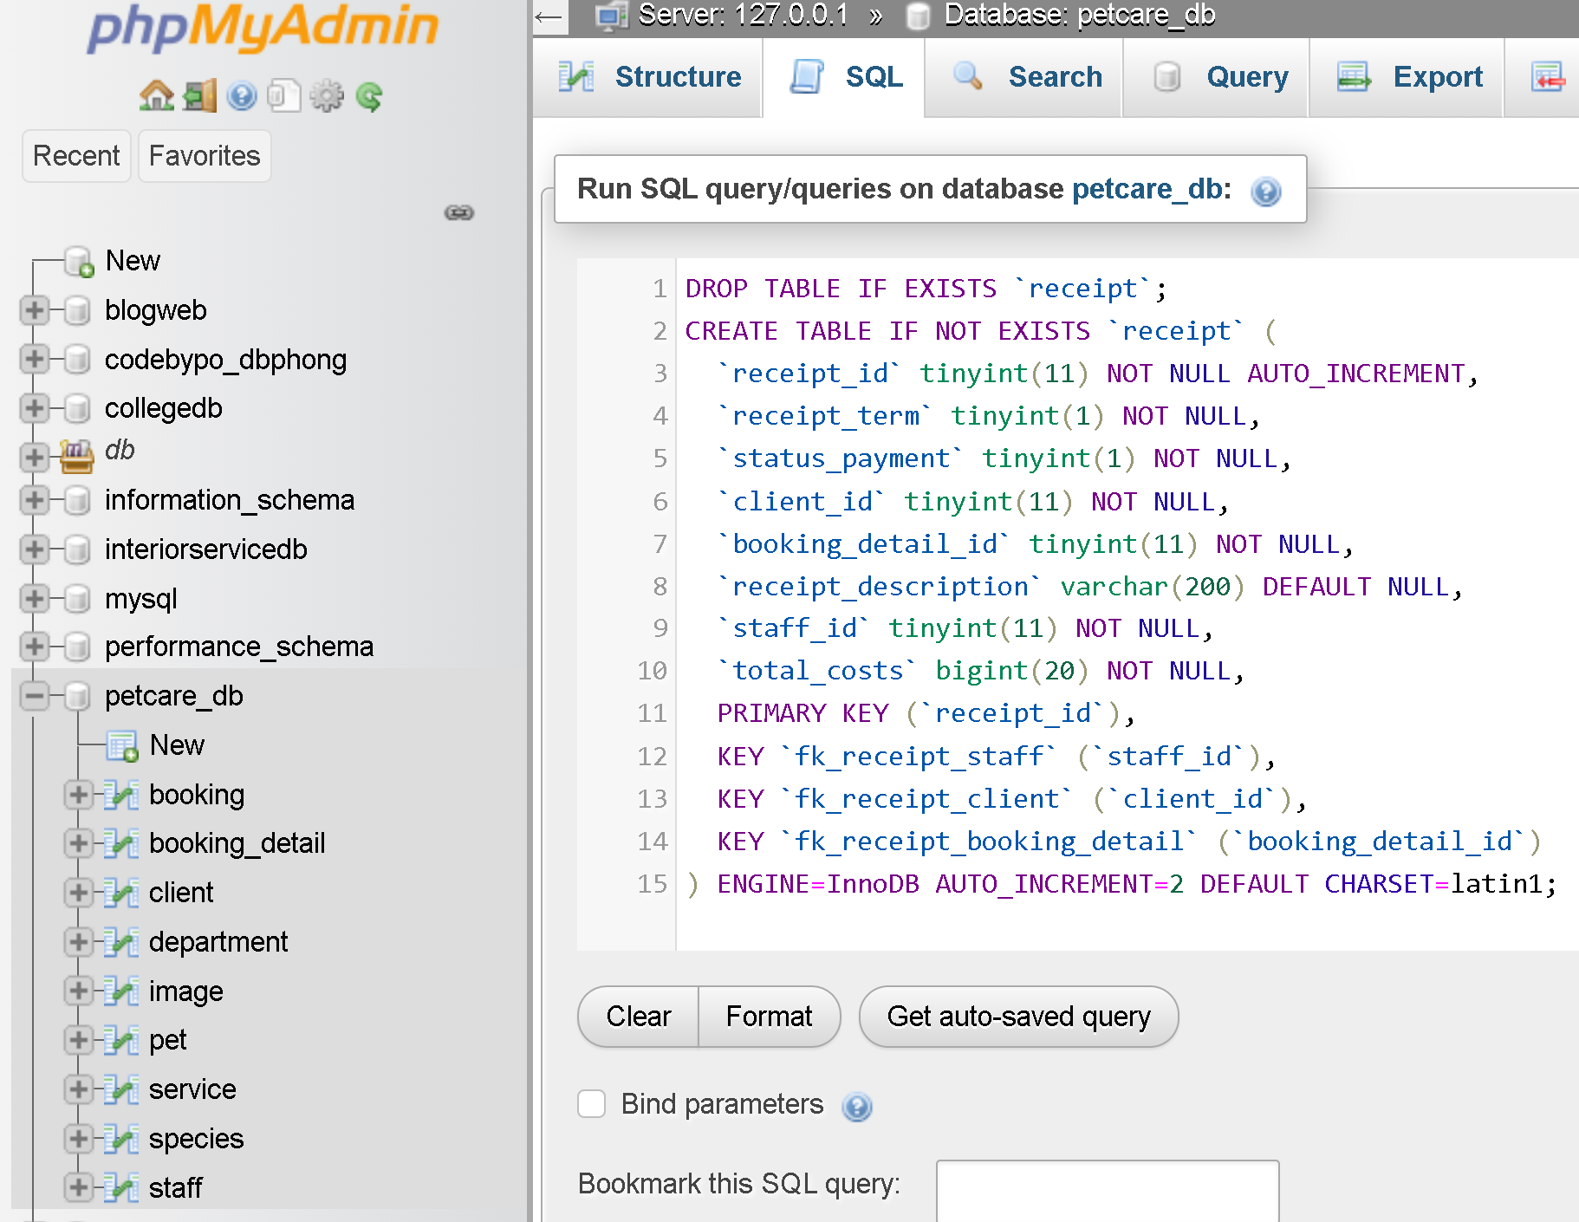

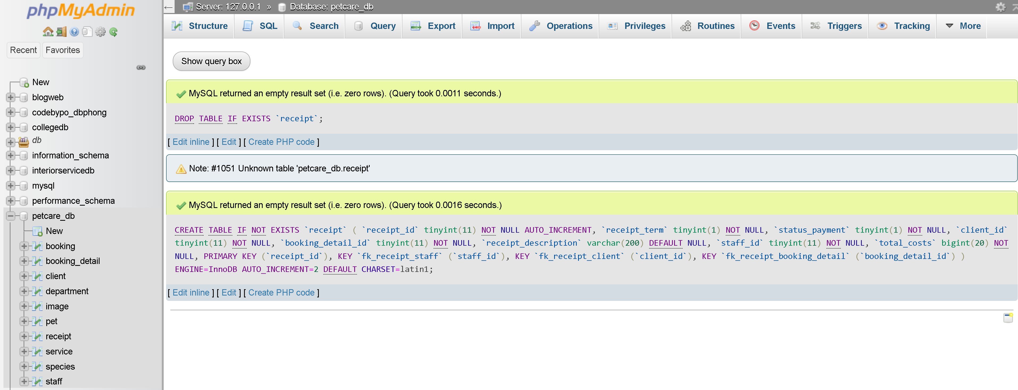

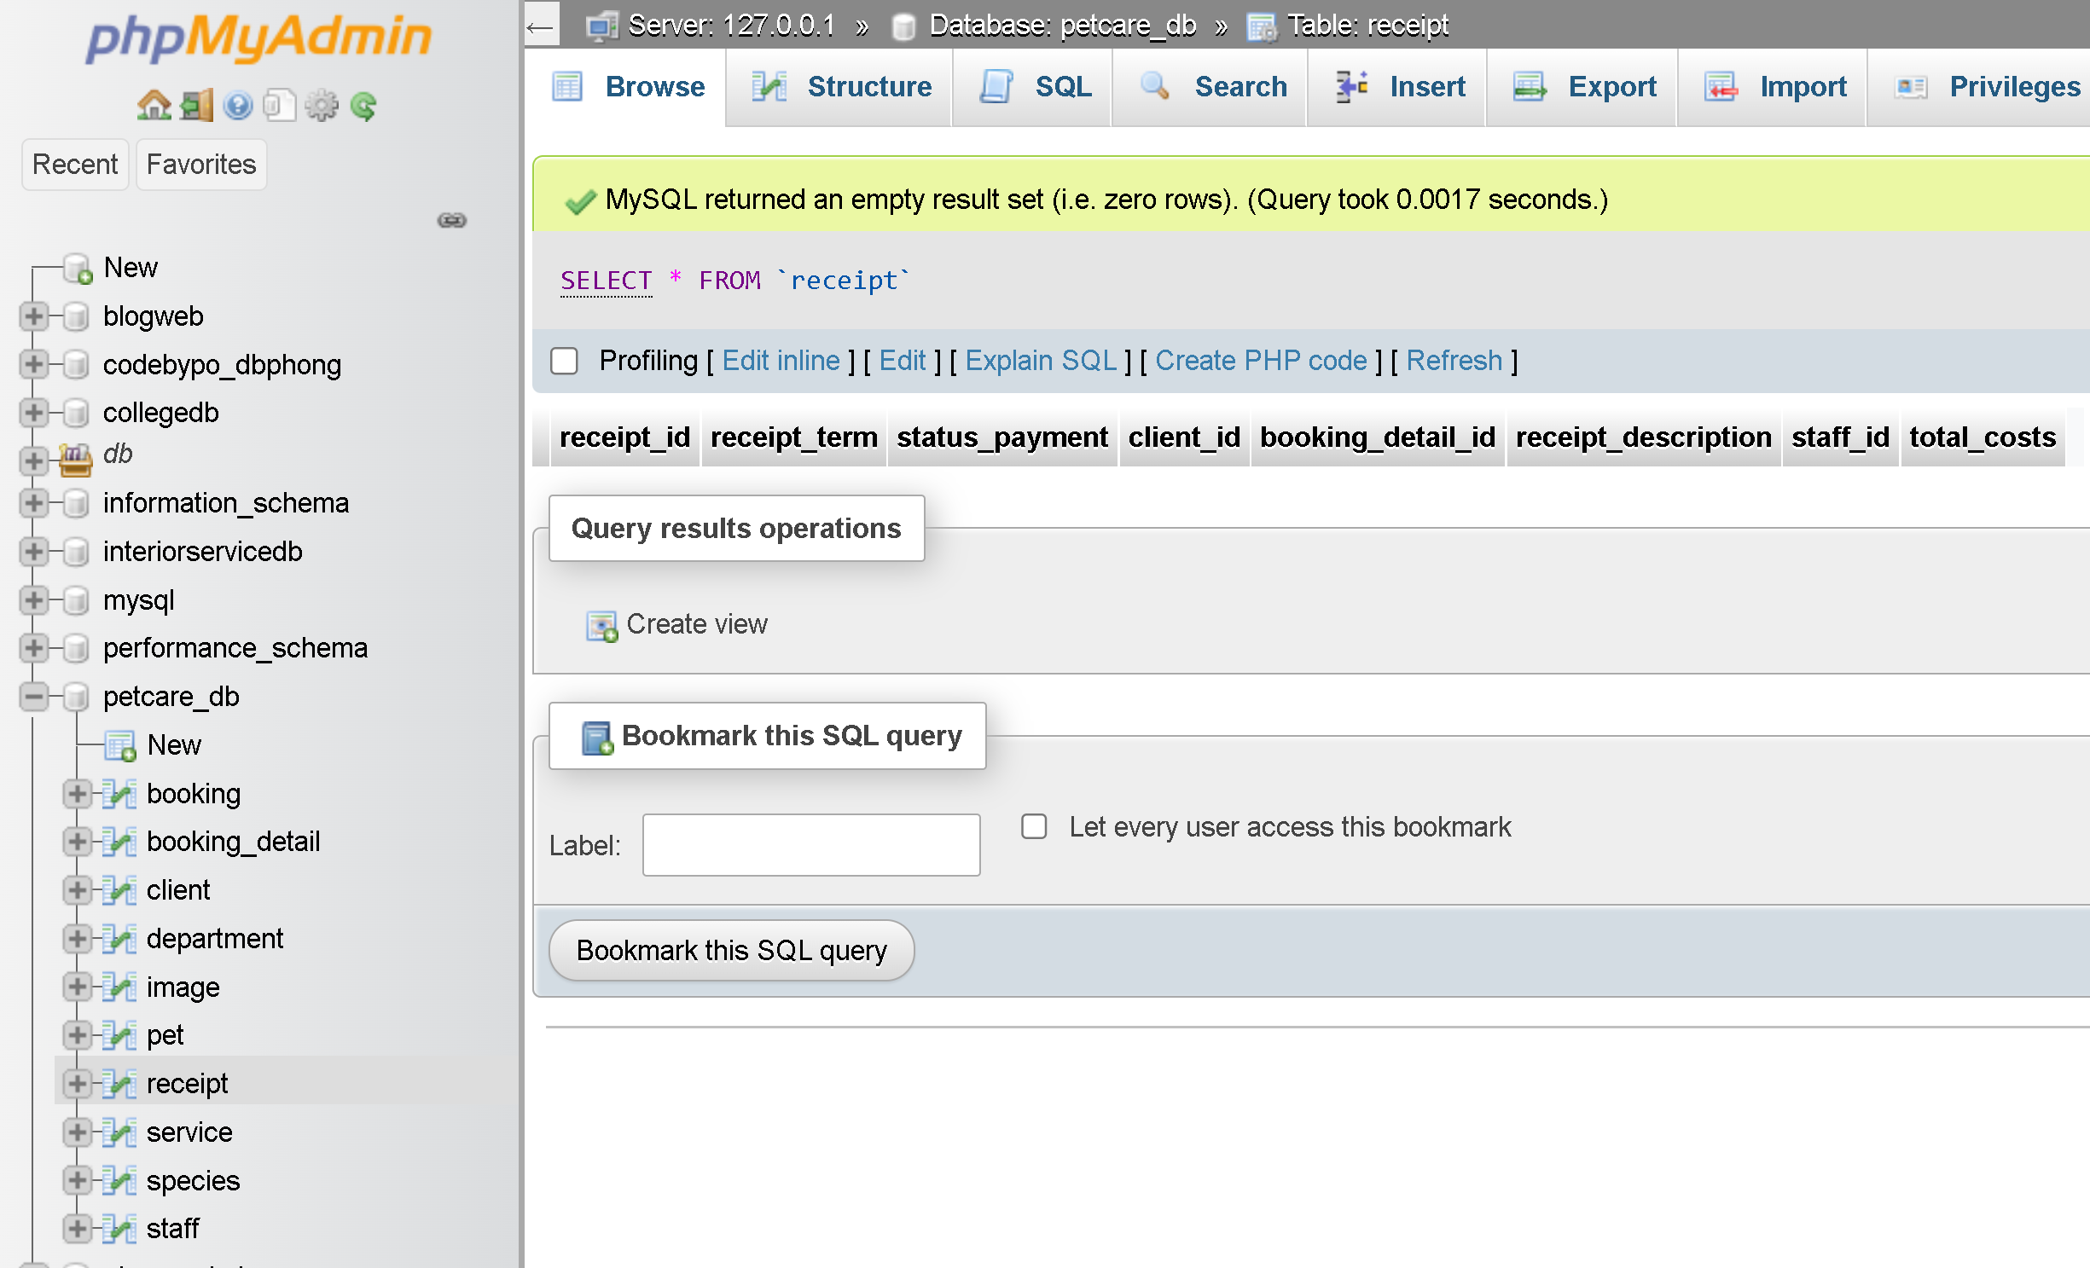

## Create `request` table

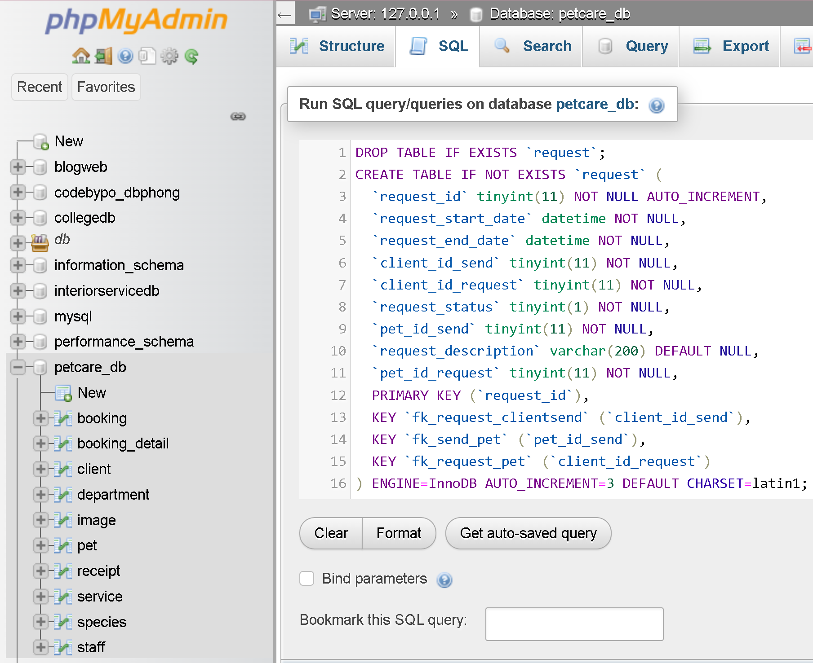

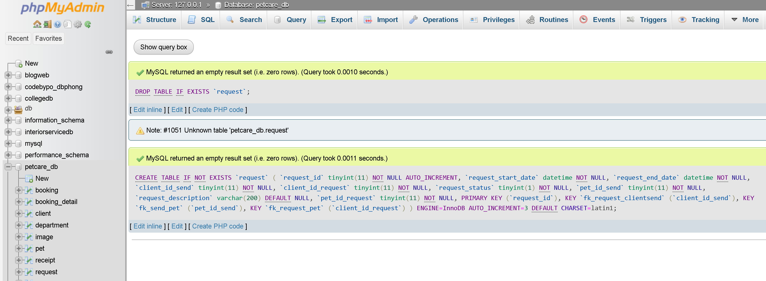

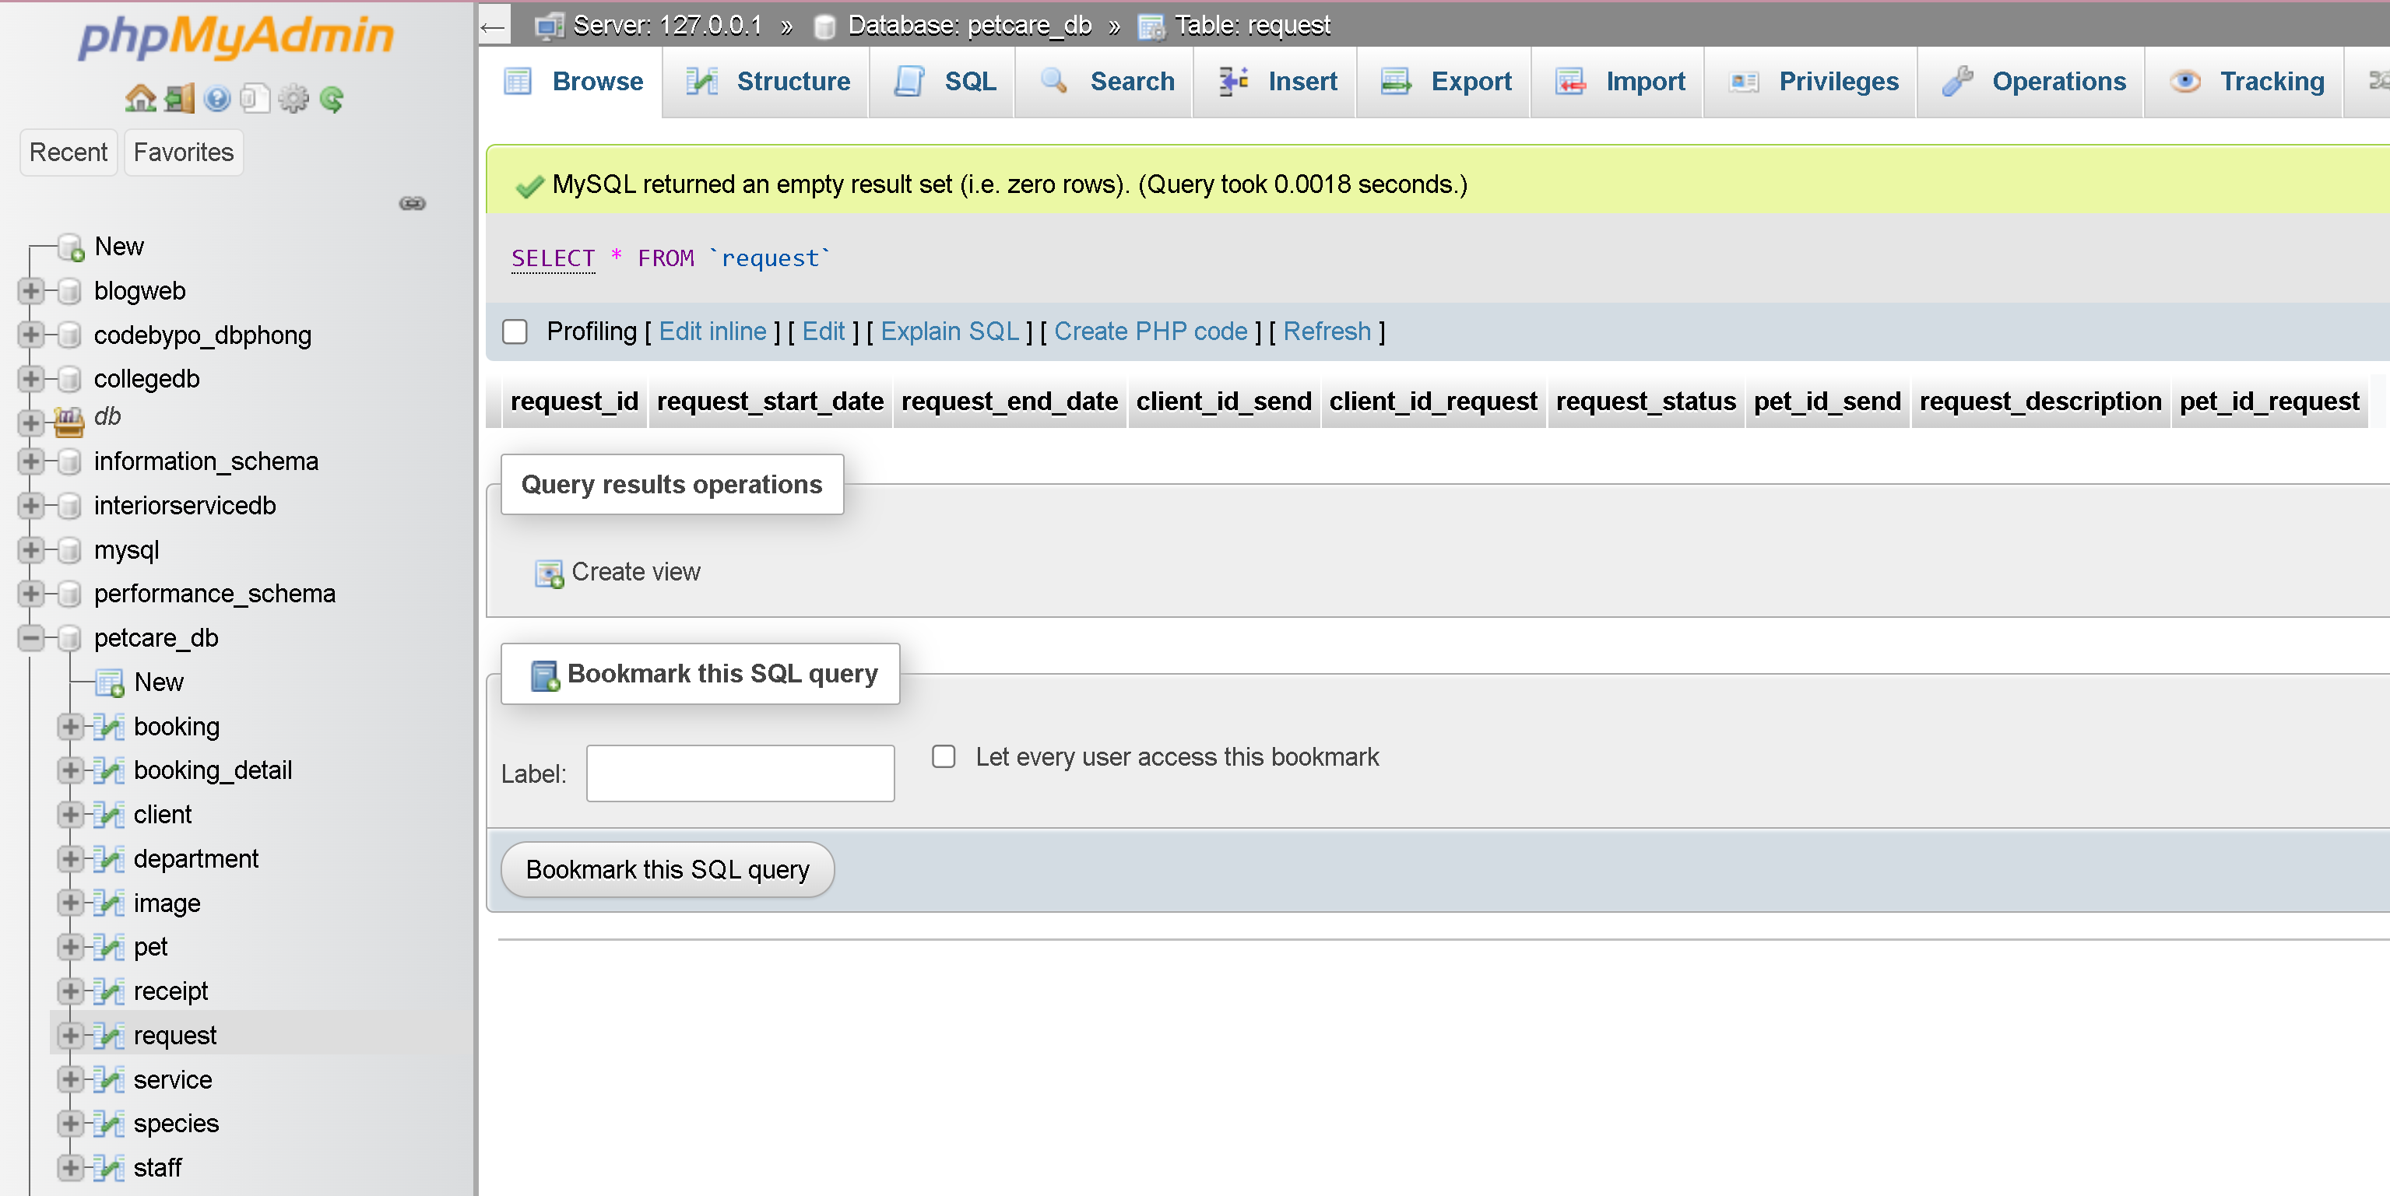

## Constraints for table `booking`

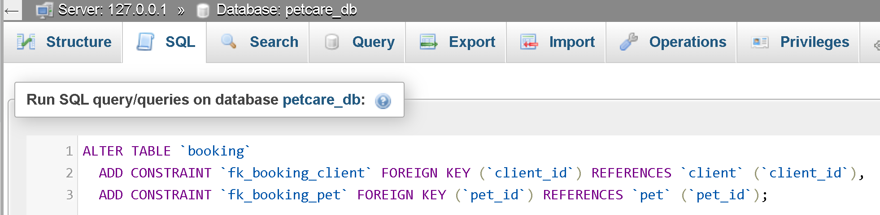

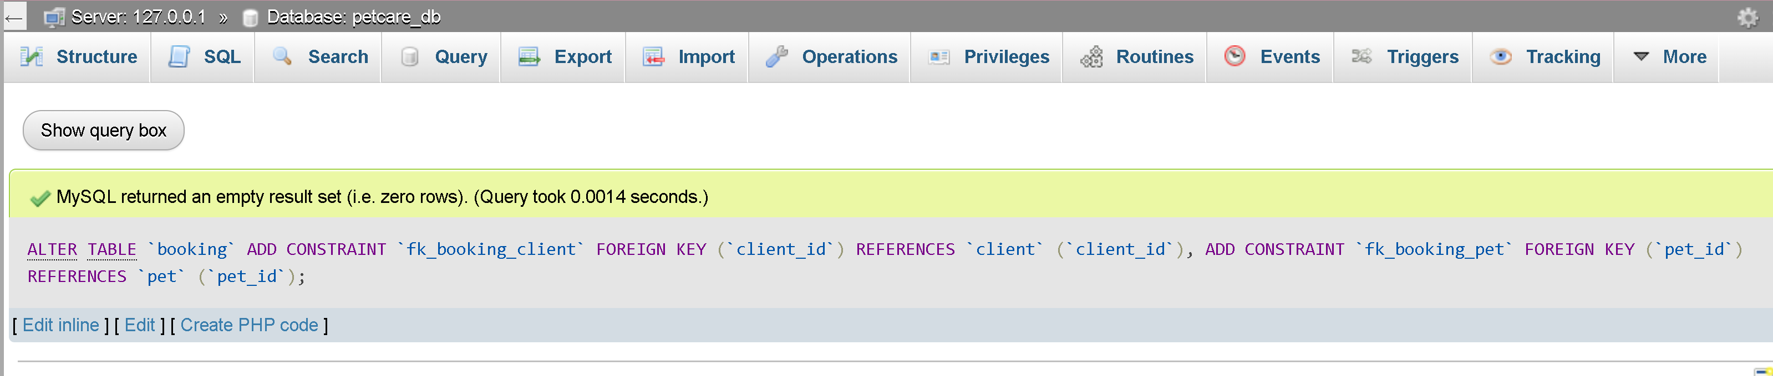

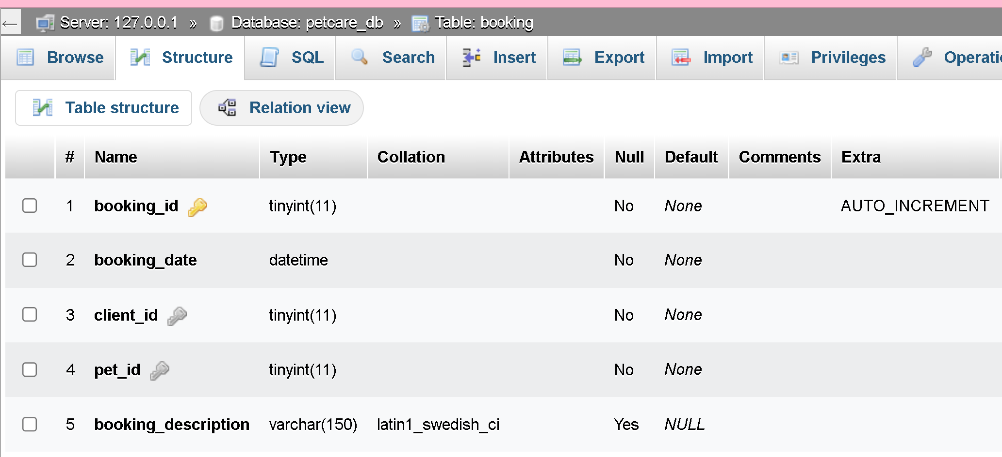

## Constraints for table `booking_detail`

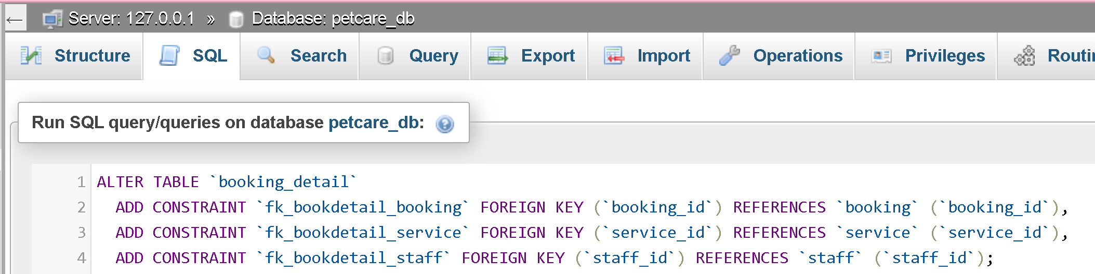

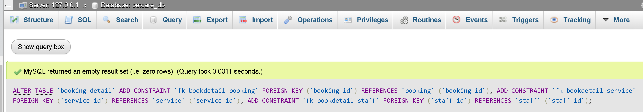

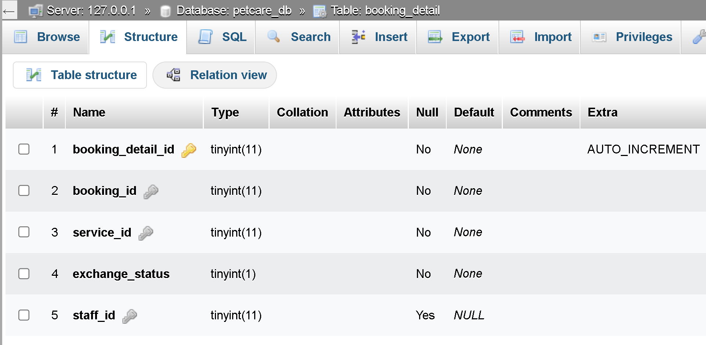

## Constraints for table `image`

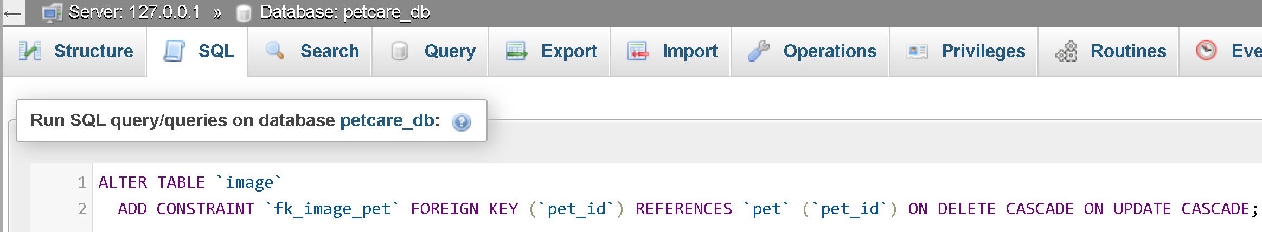

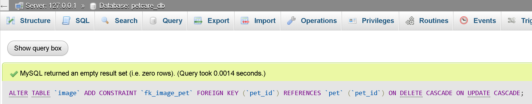

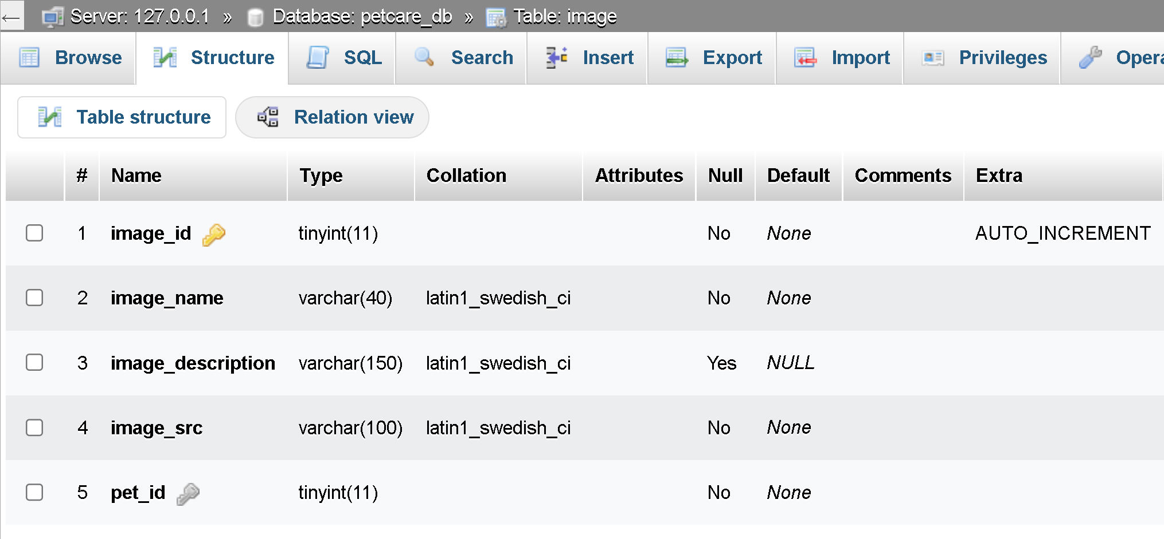

## Constraints for table `pet`

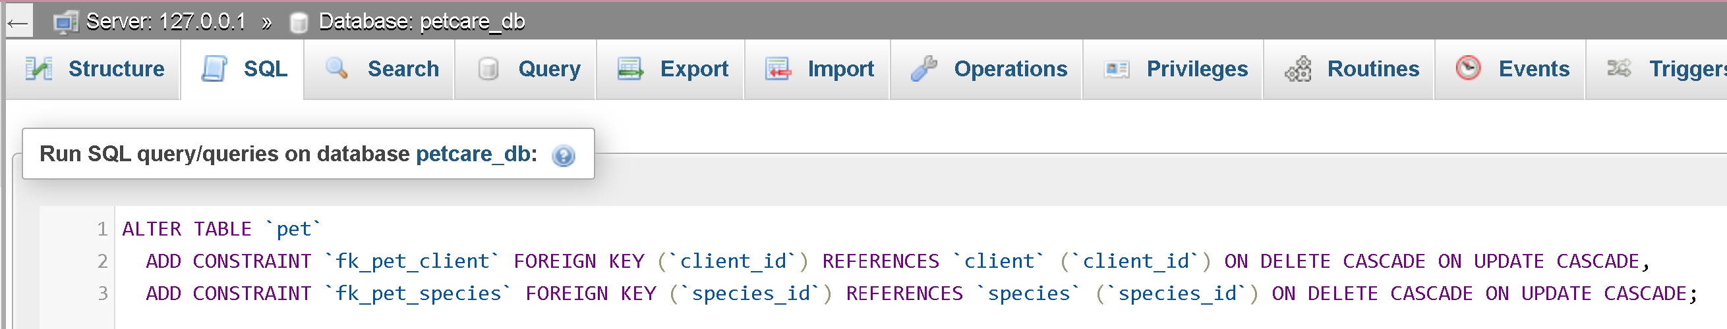

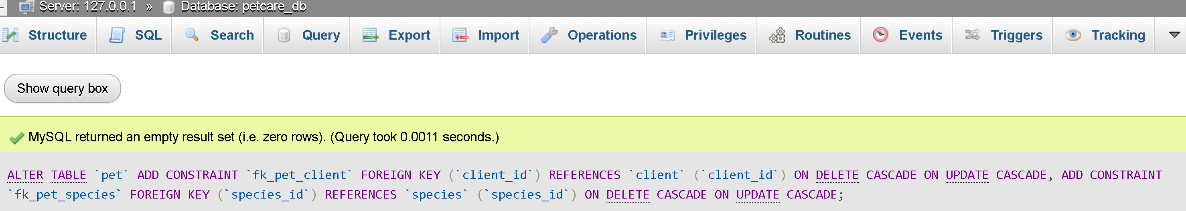

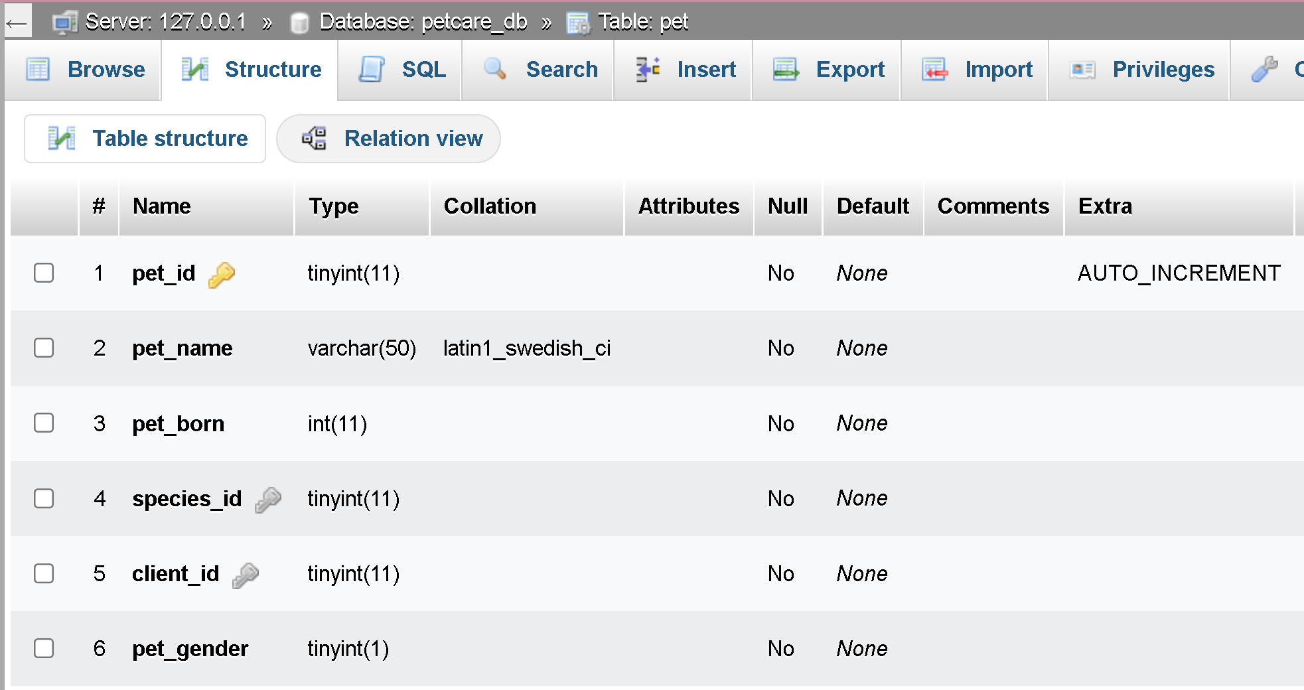

## Constraints for table `progress`

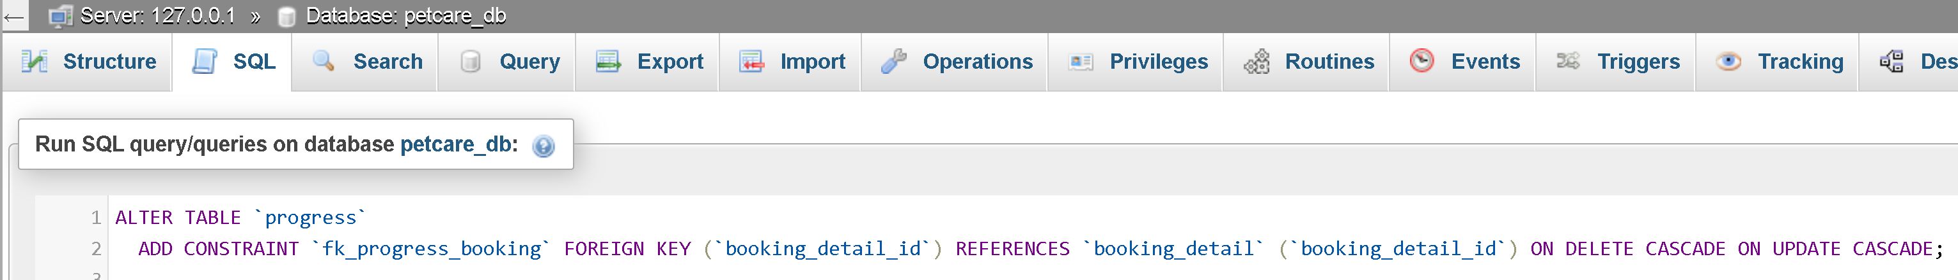

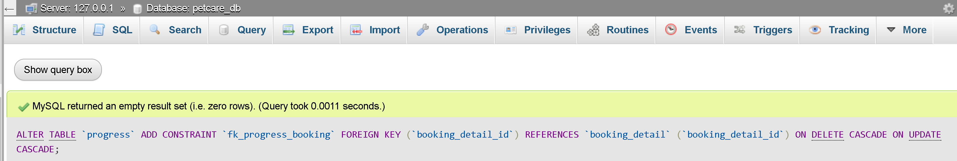

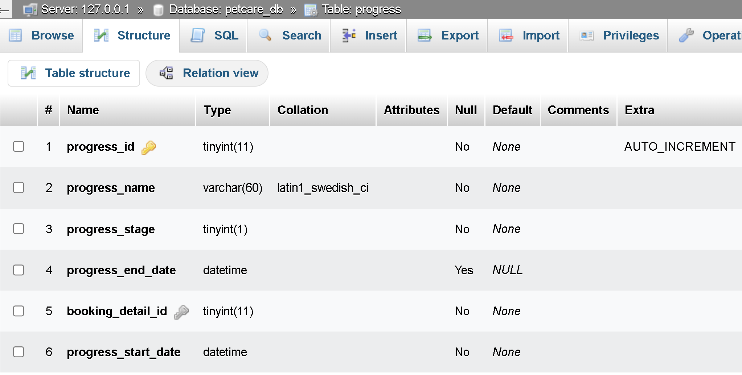

## Constraints for table `receipt`

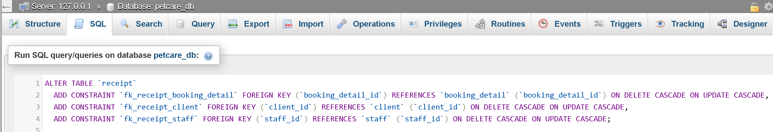

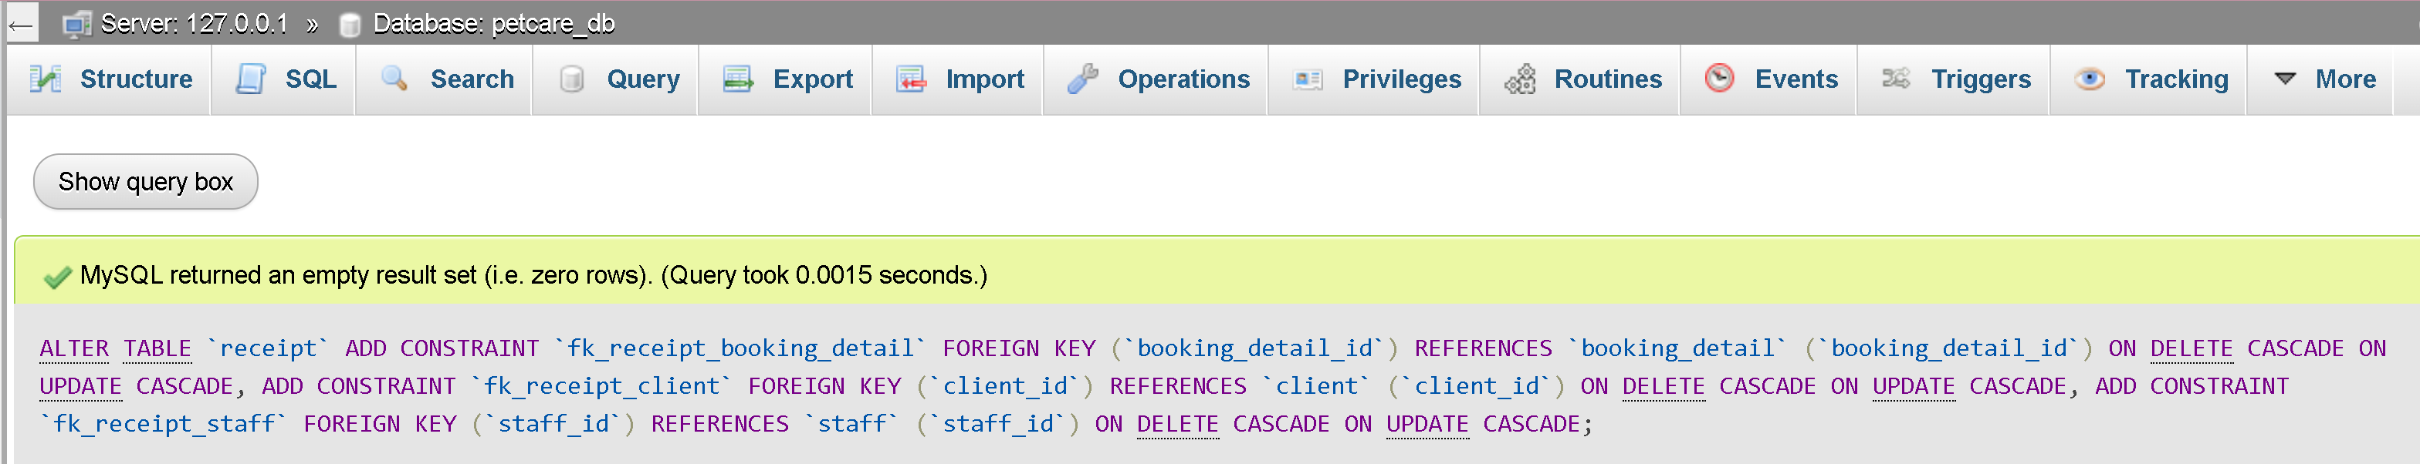

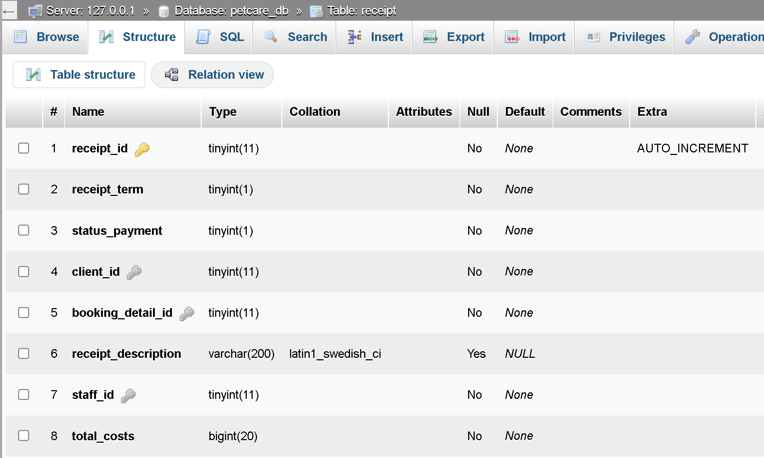

## Constraints for table `request

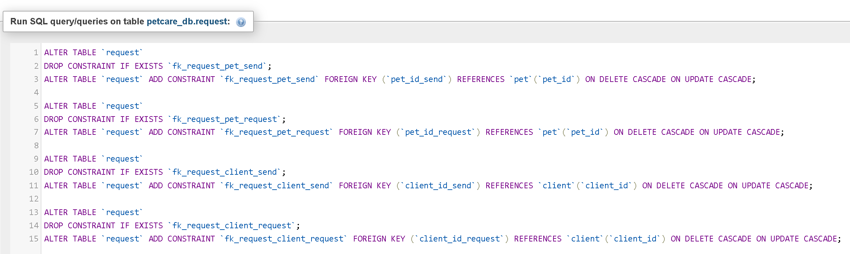

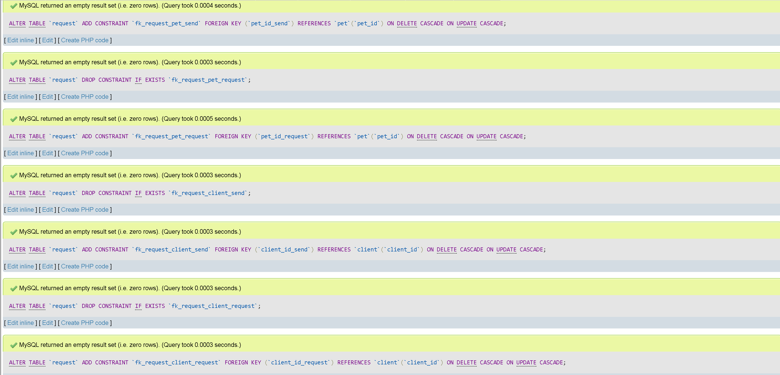

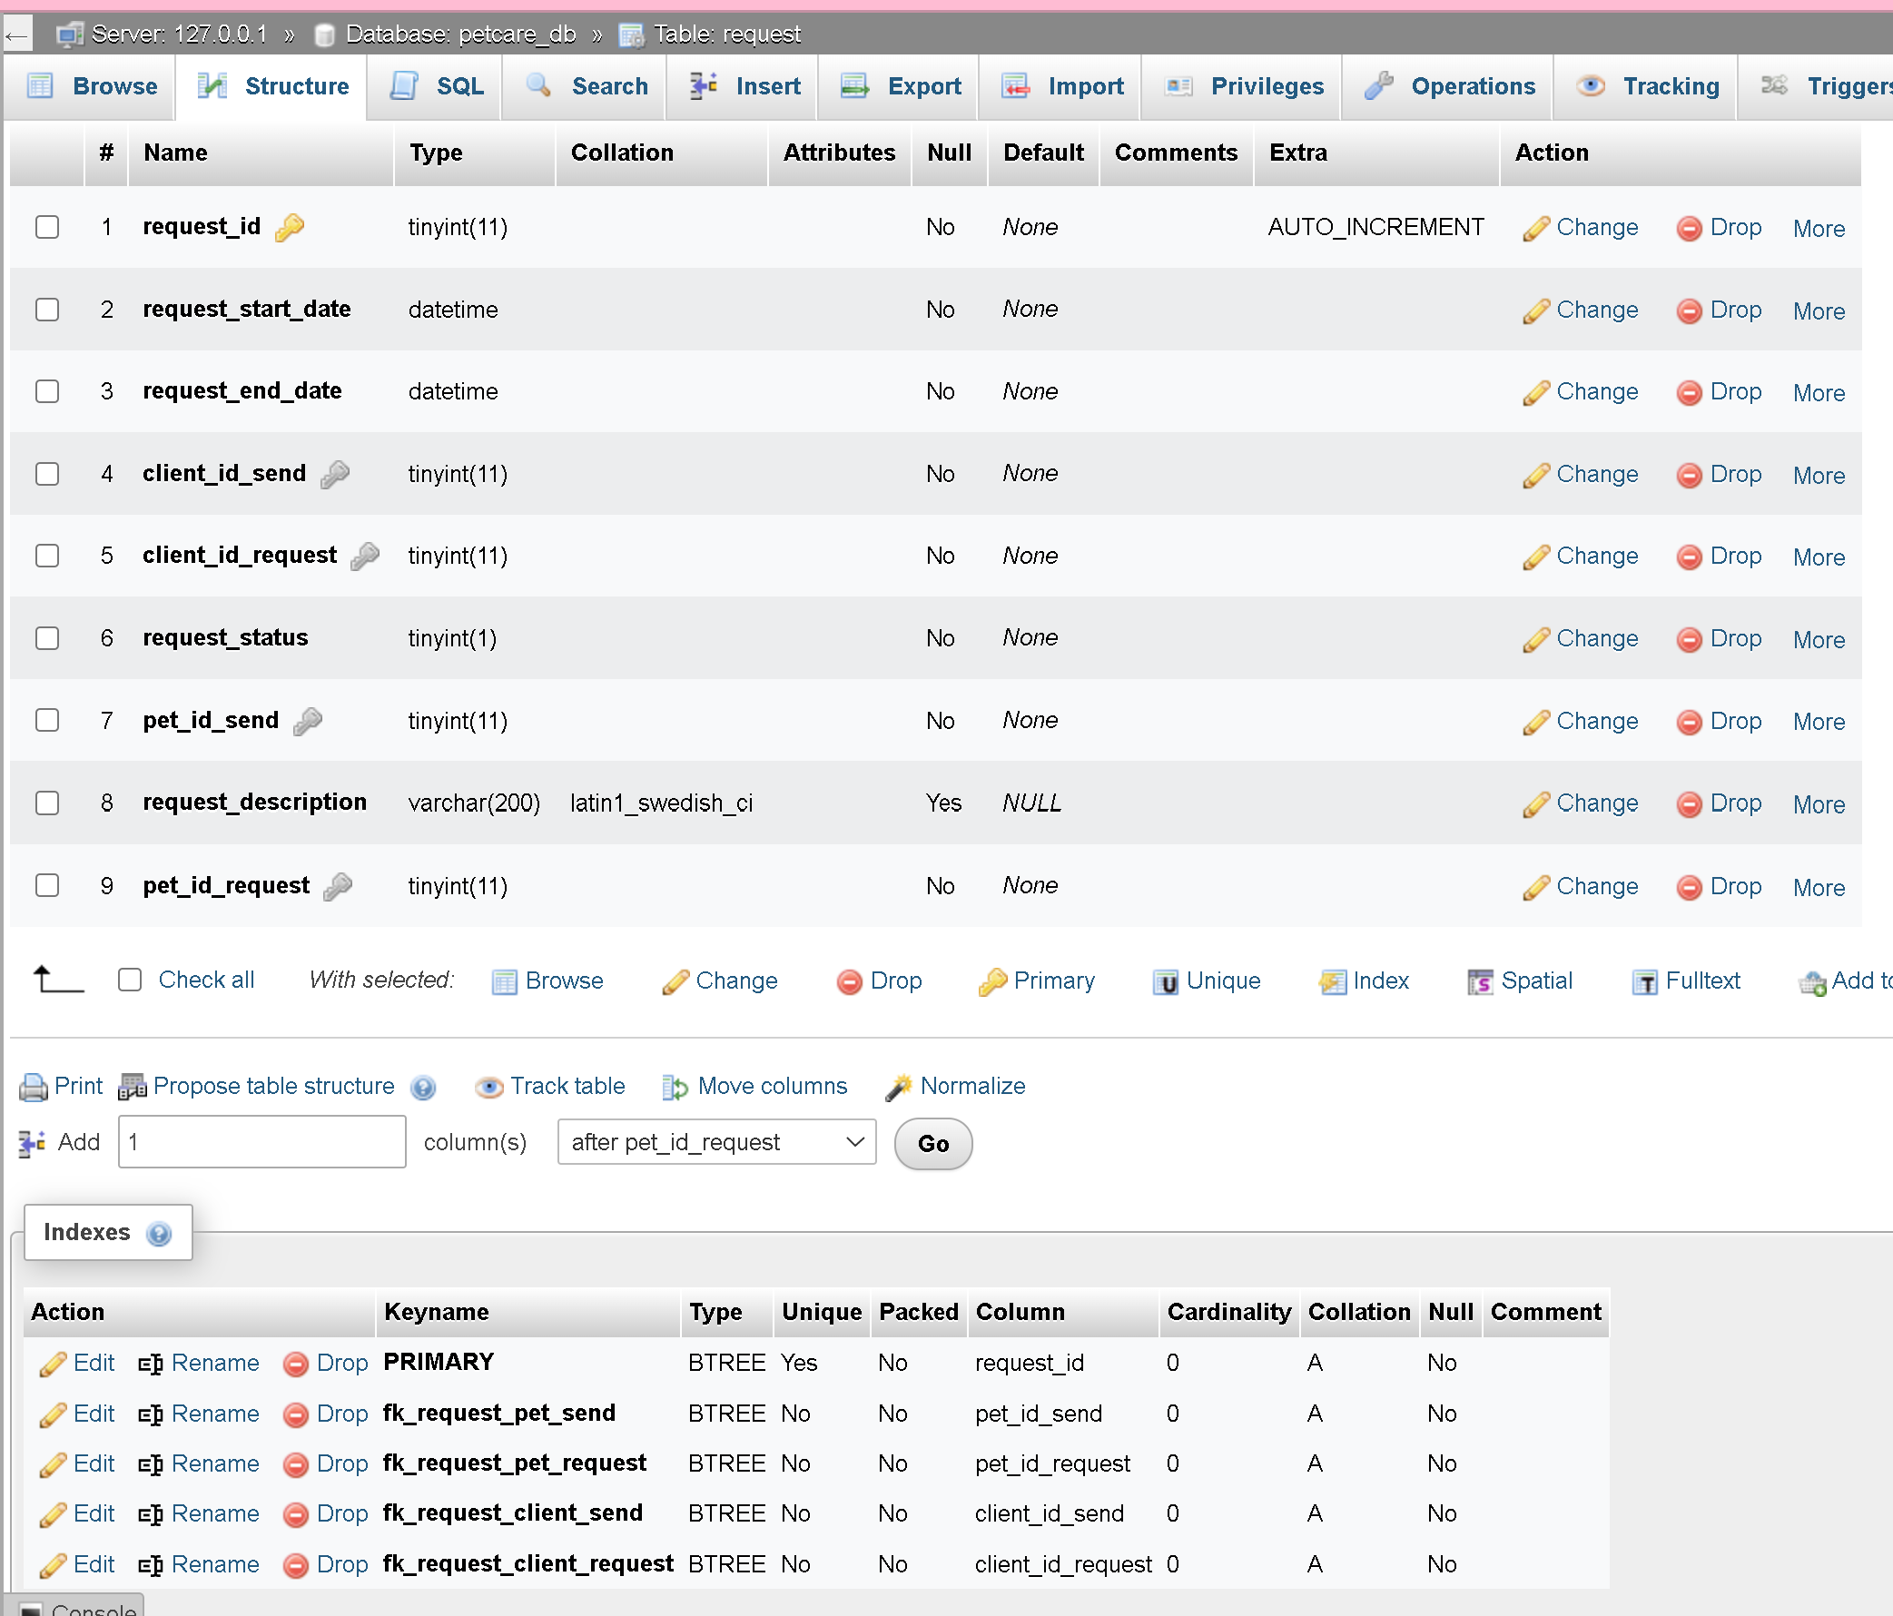

## Constraints for table `staff`



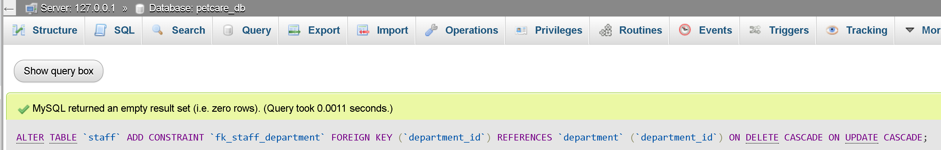

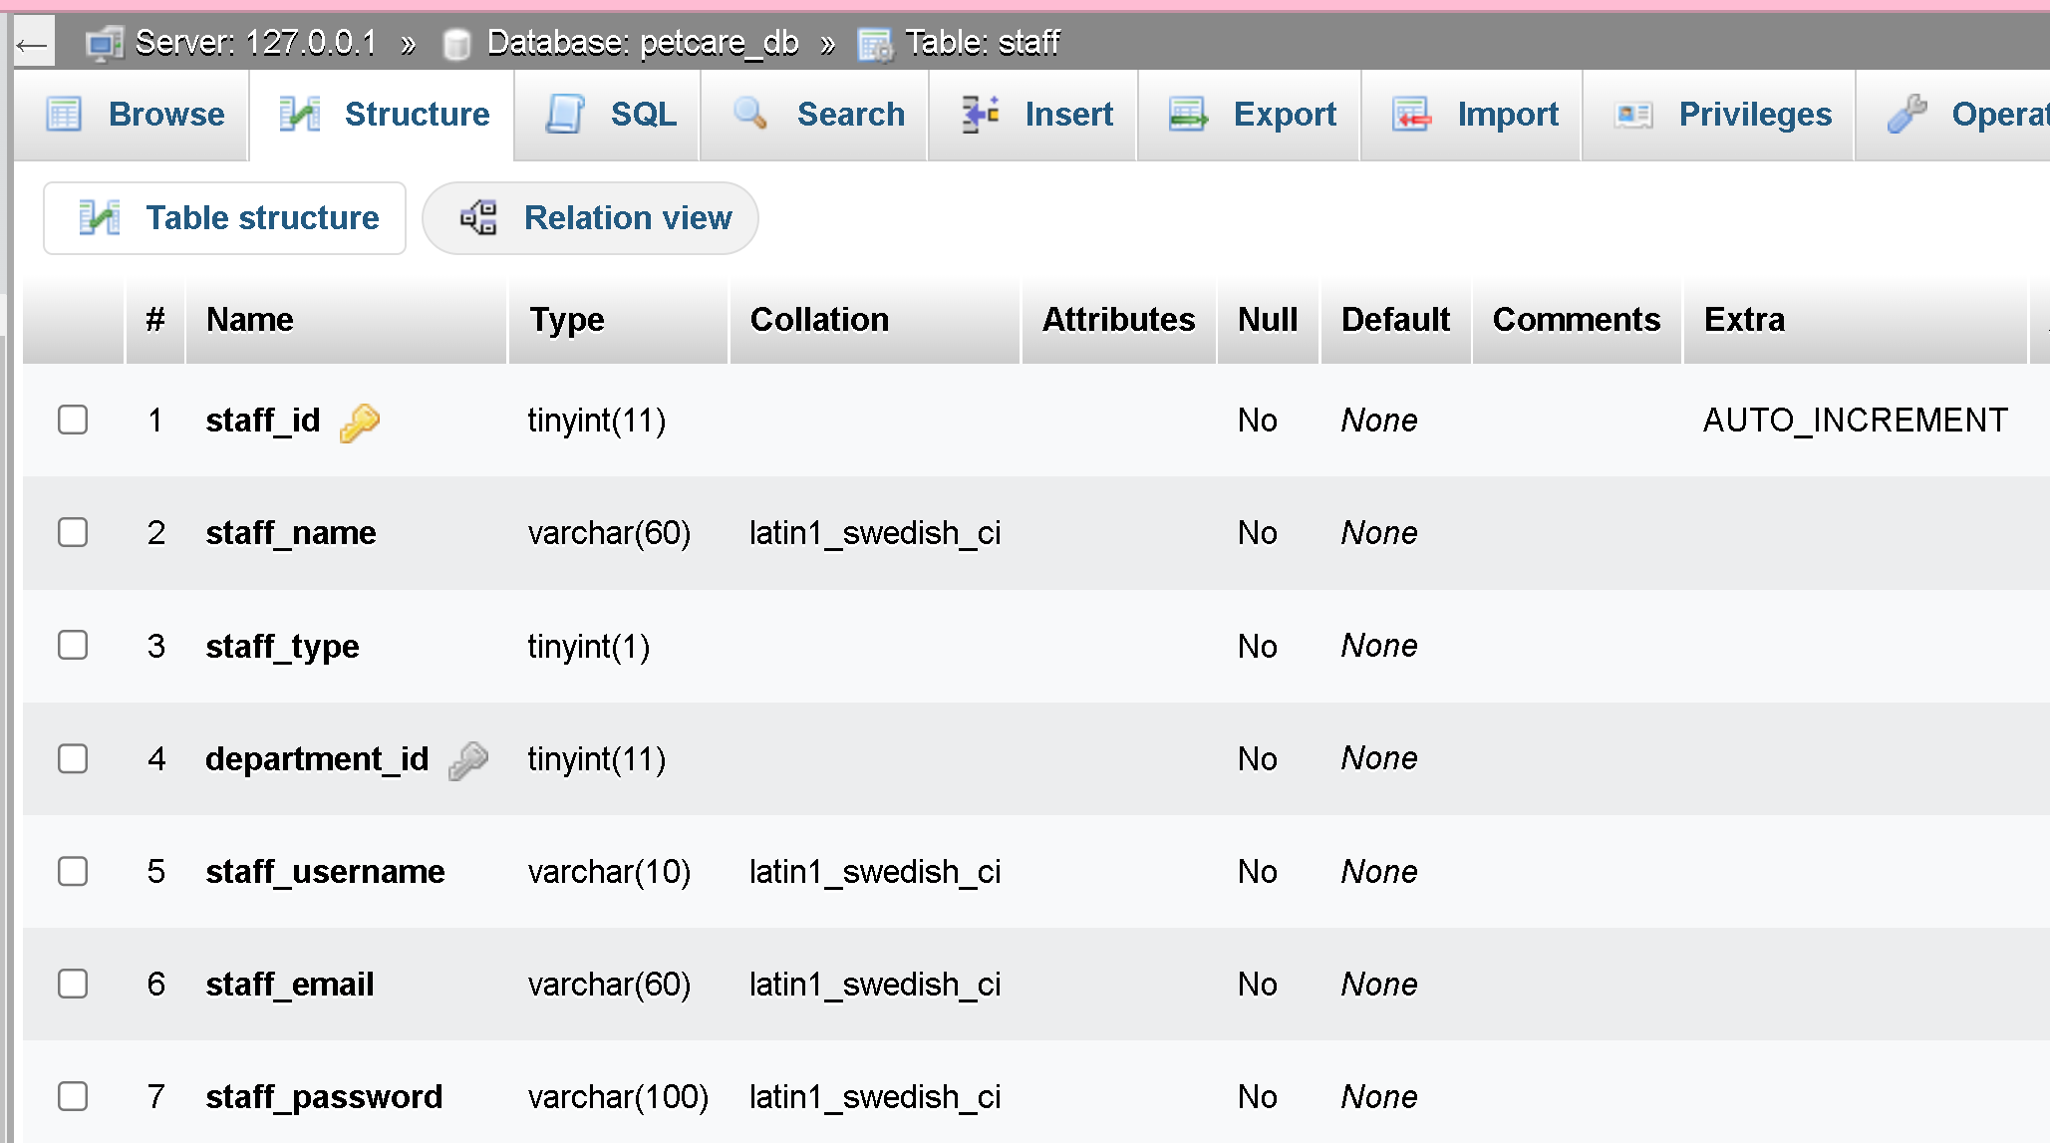

## Because MySQL – Phpmyadmin doesn’t support check, I will use trigger to check the data

### Triggers `pet`

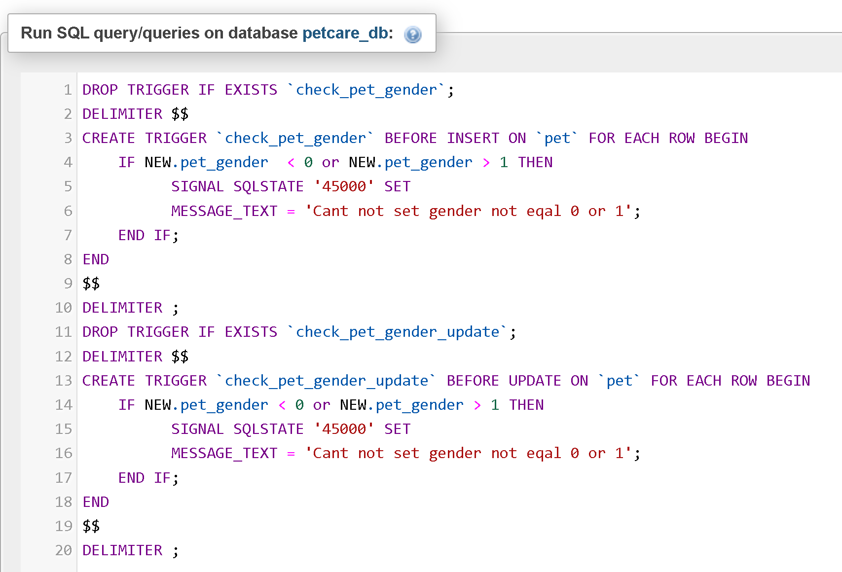

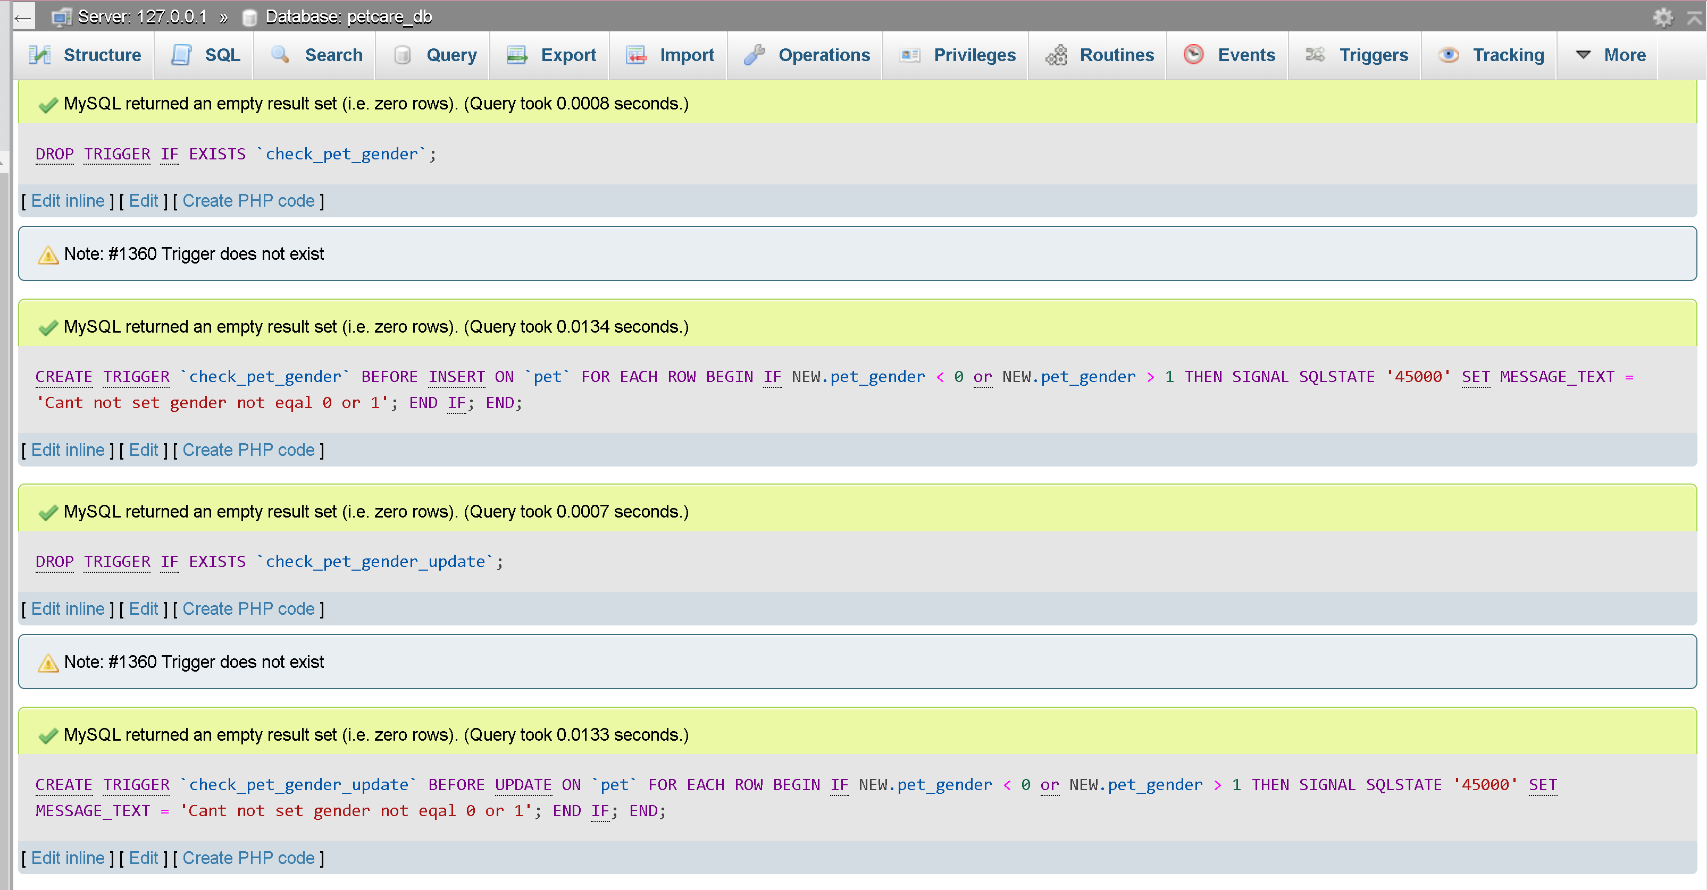

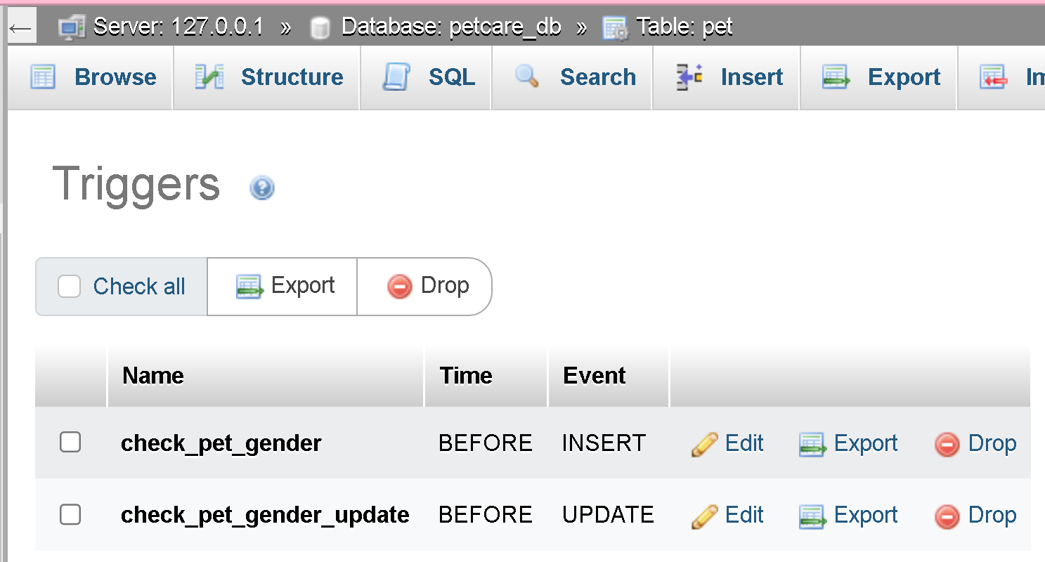

### Triggers `progress`

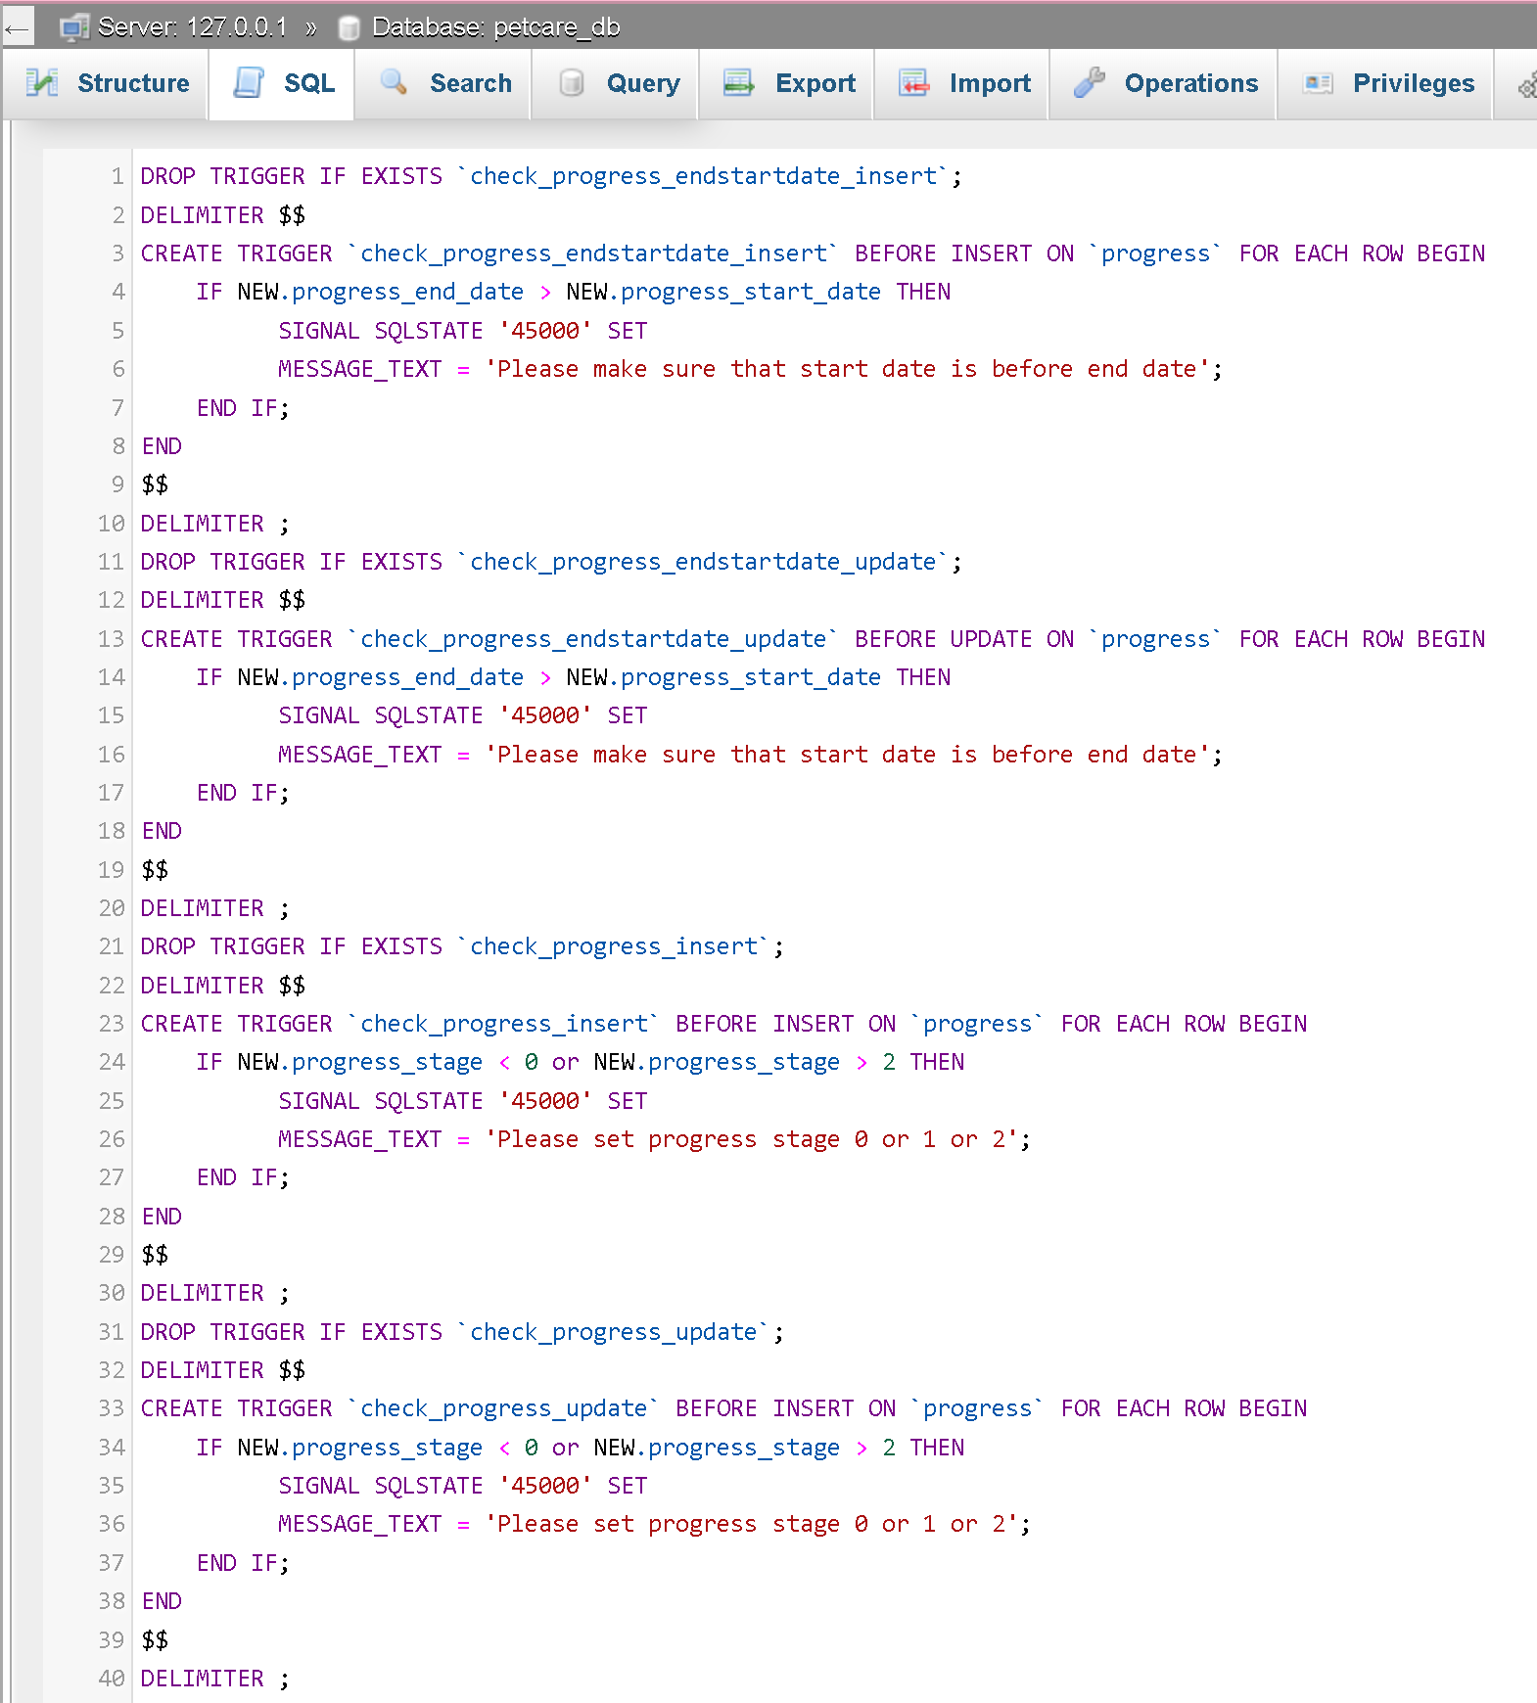

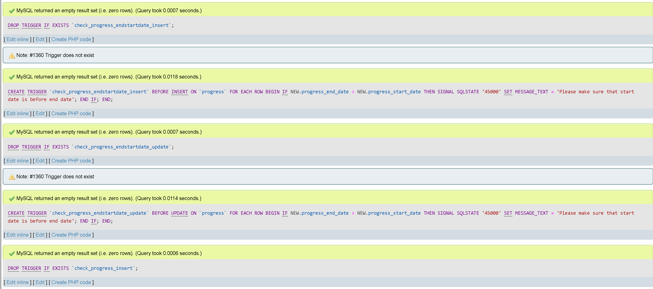

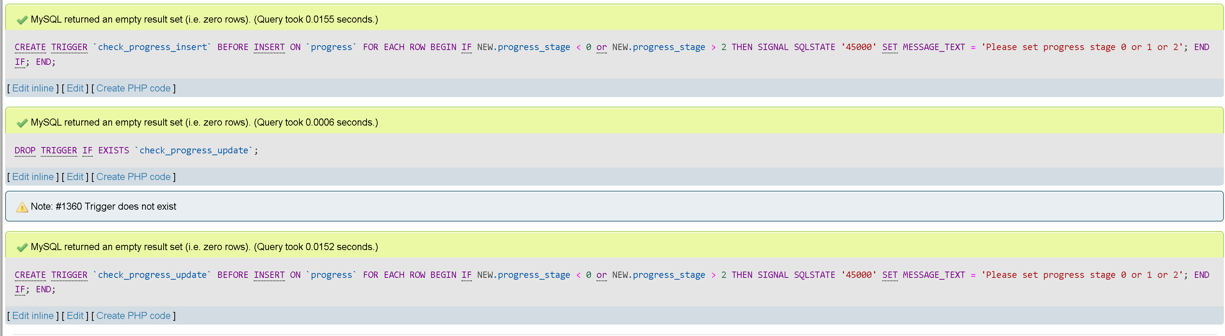

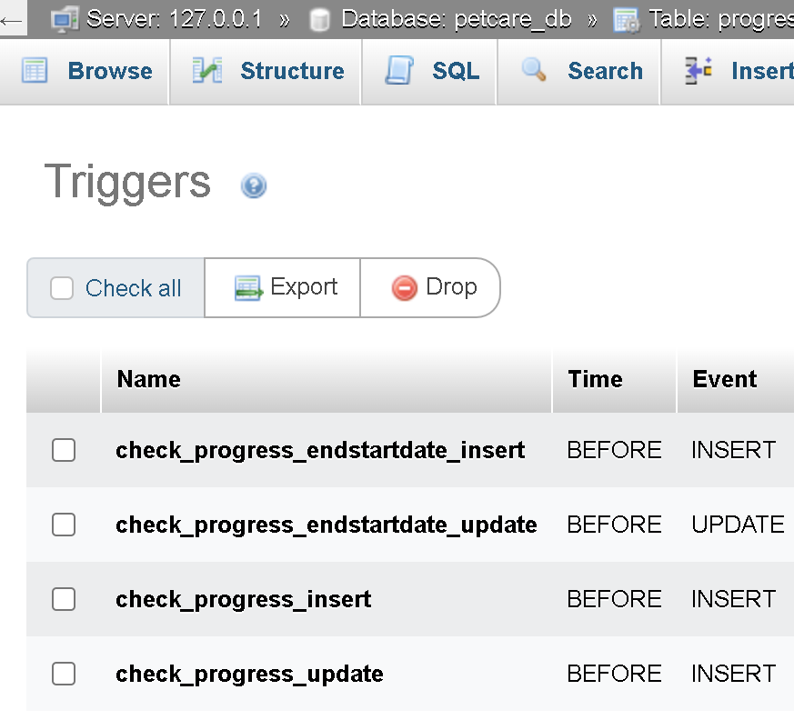

### Triggers `request`

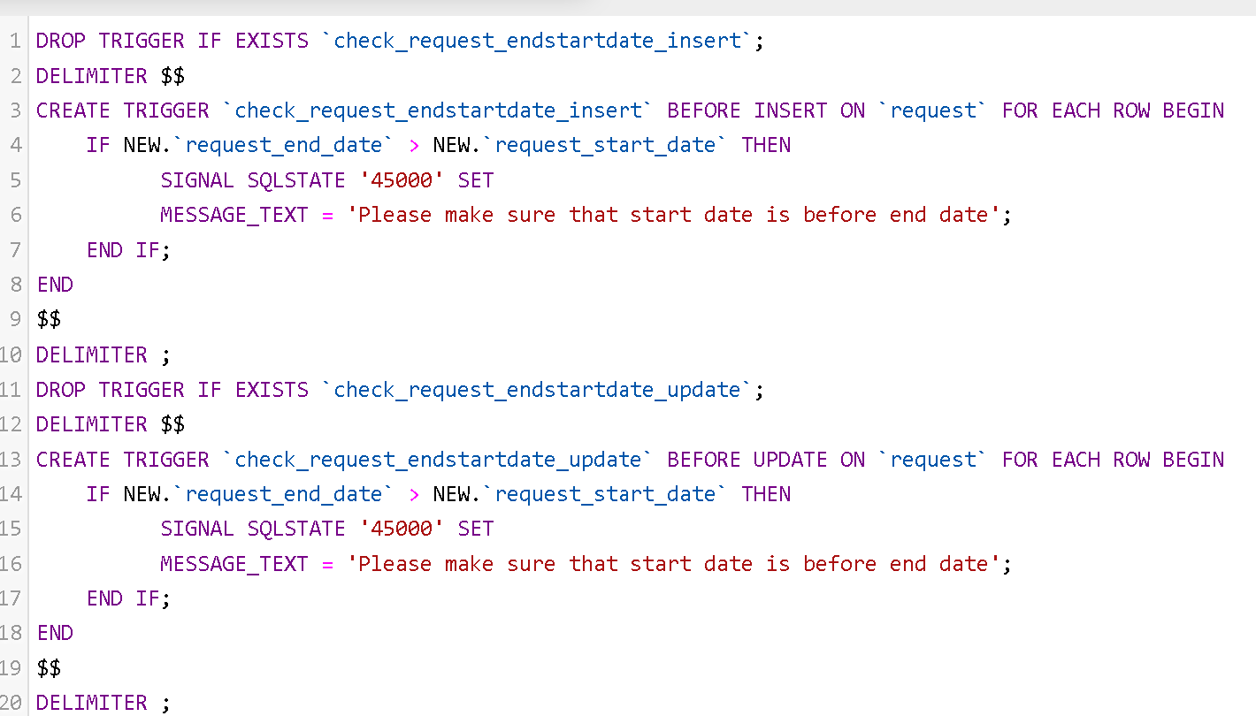

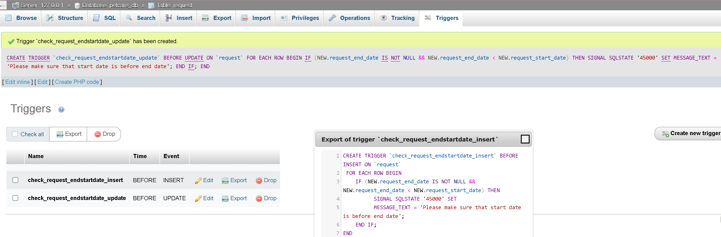

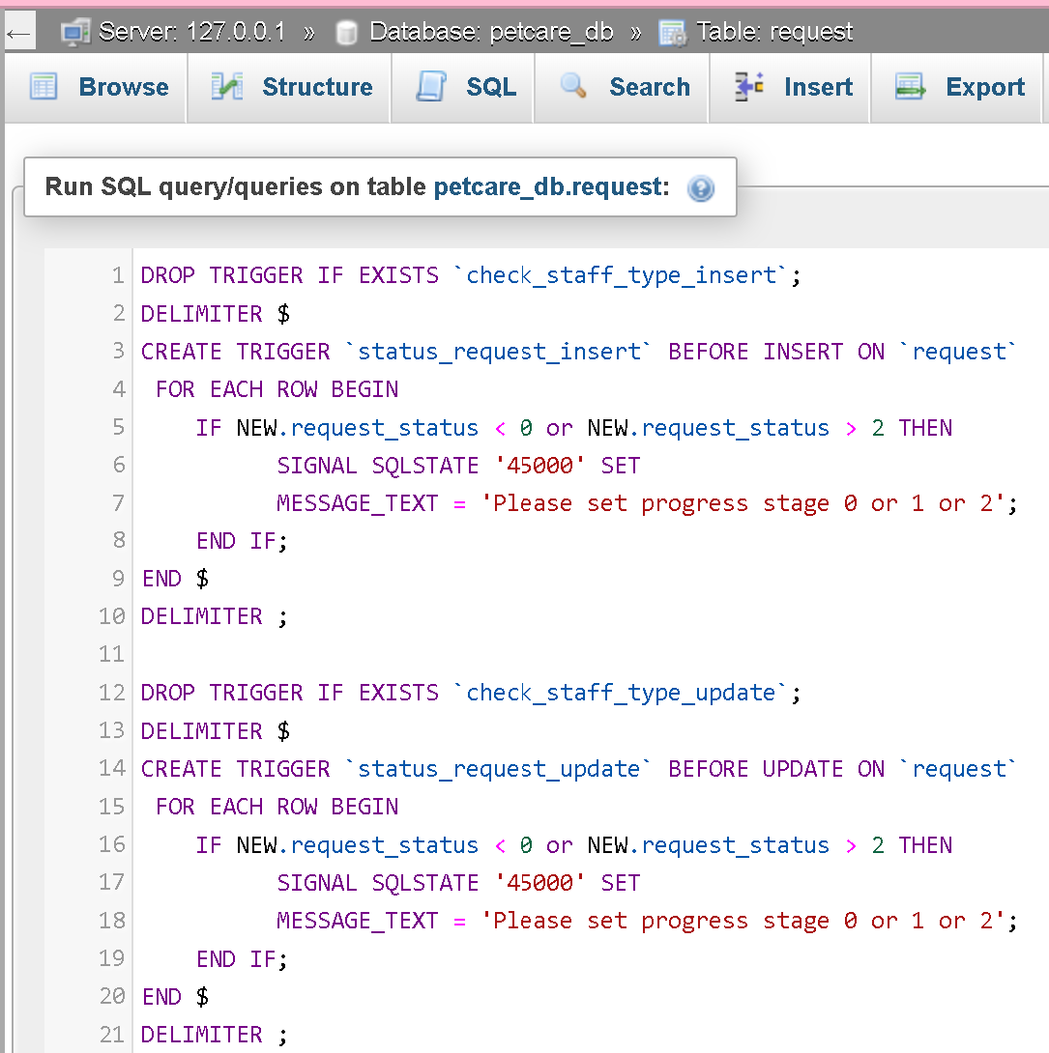

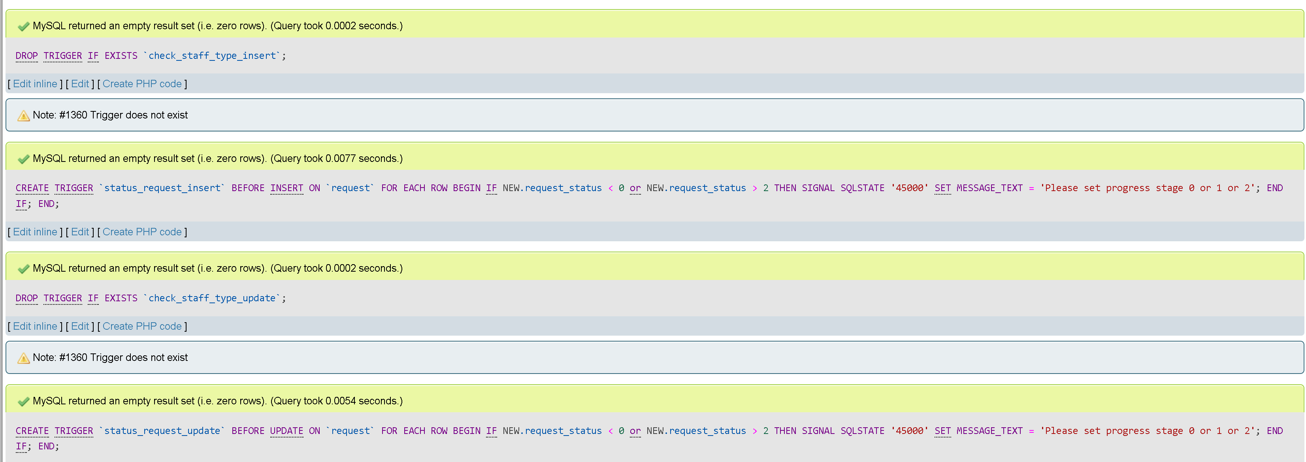

### Triggers `staff`

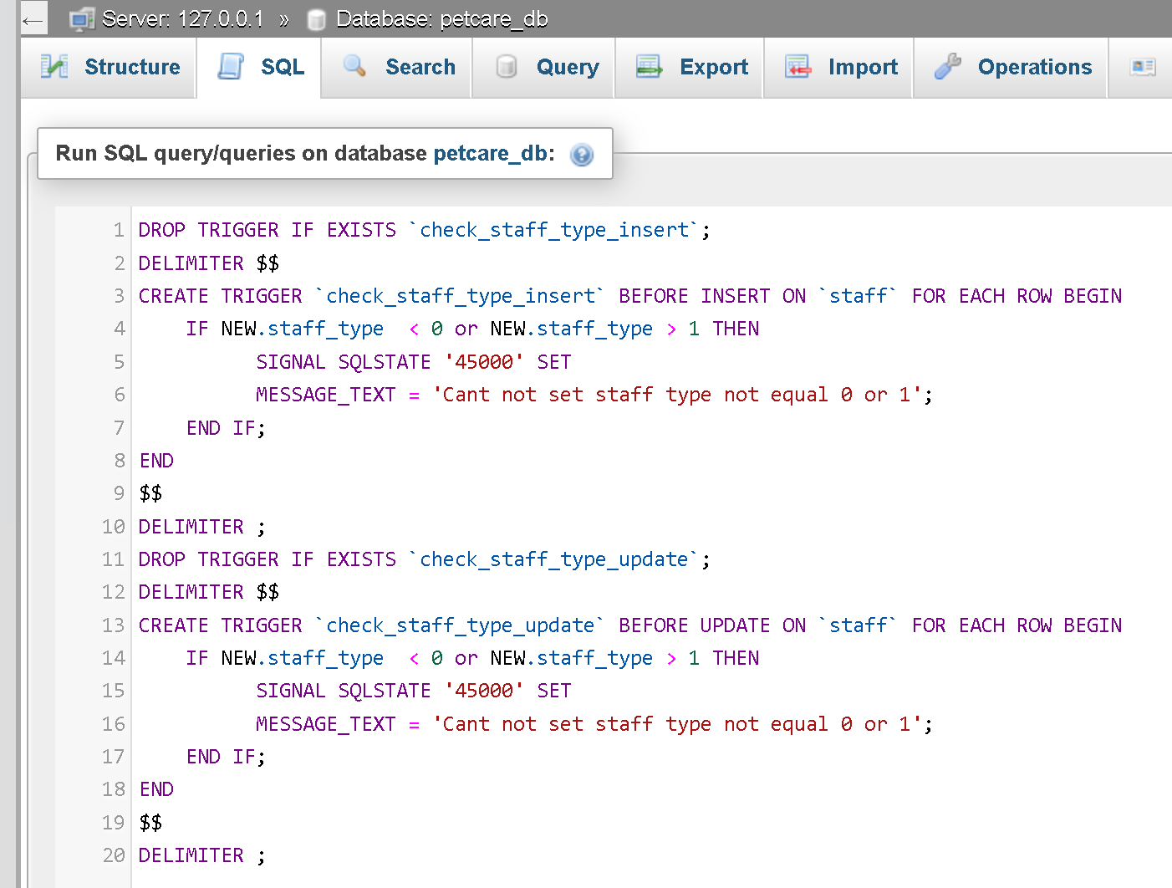

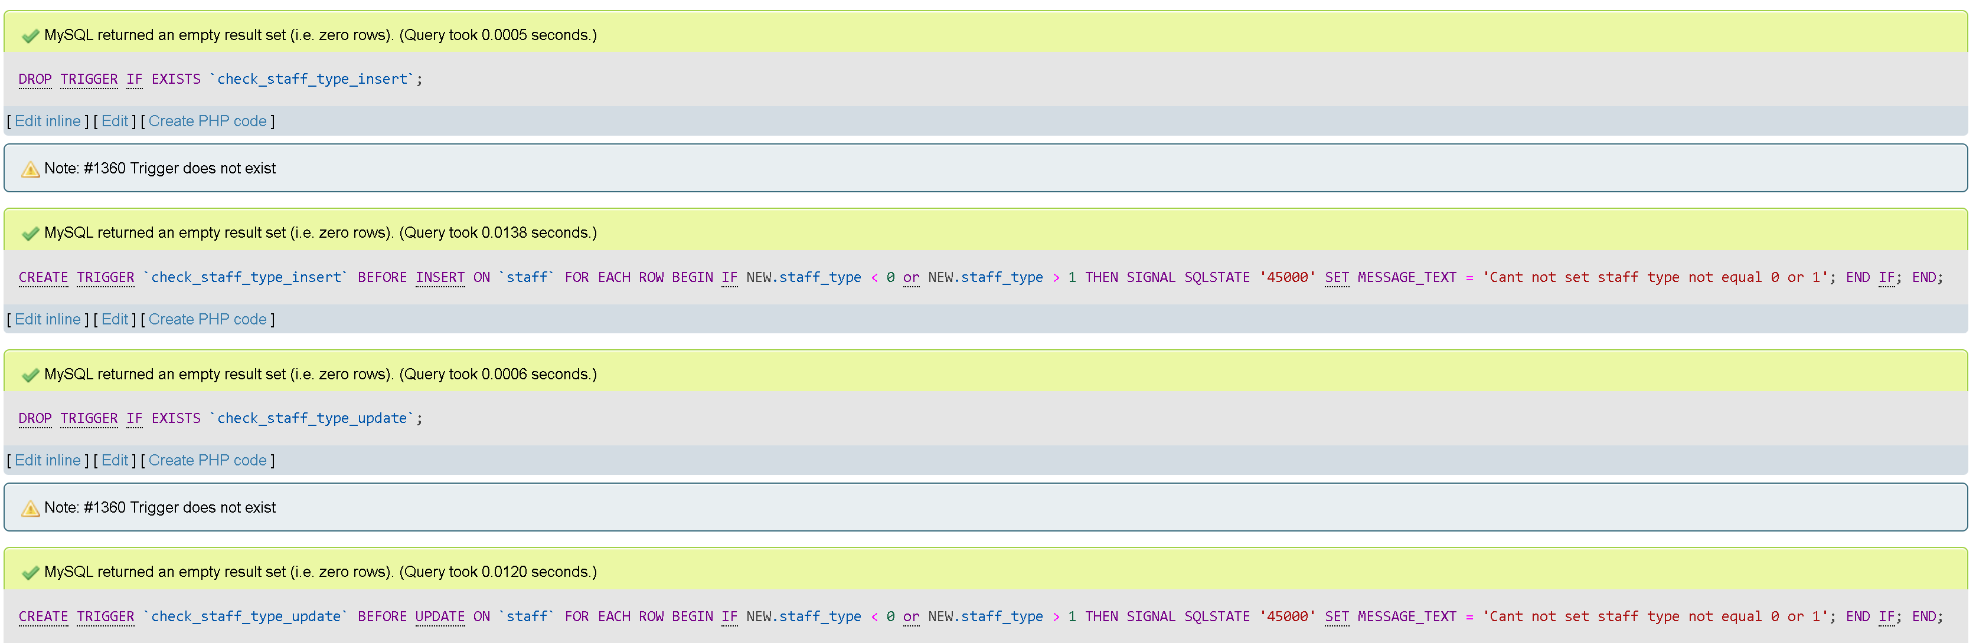

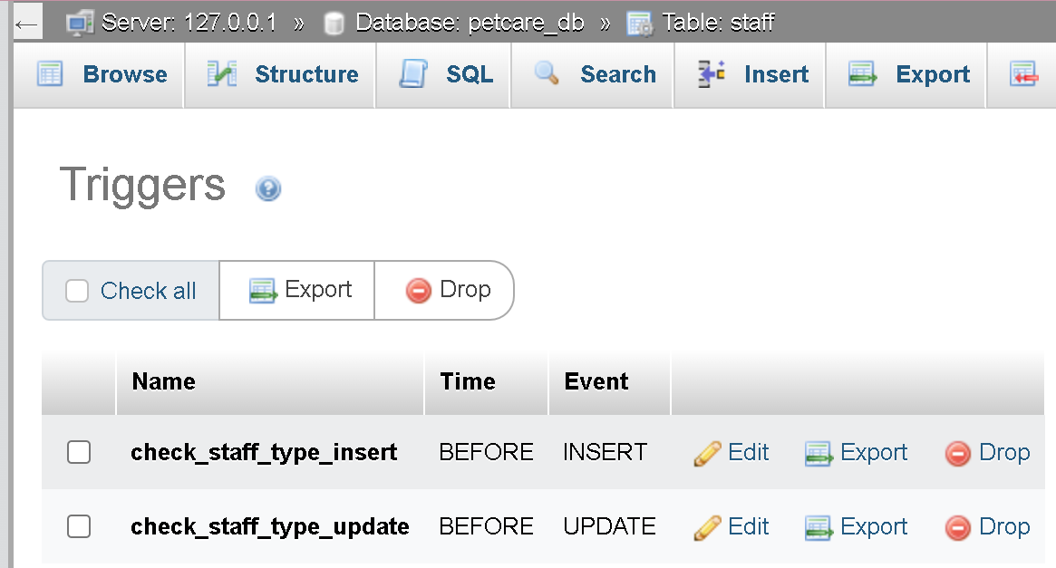

# Task 4 – Data Population (10 points)

## Dumping data for table `department`

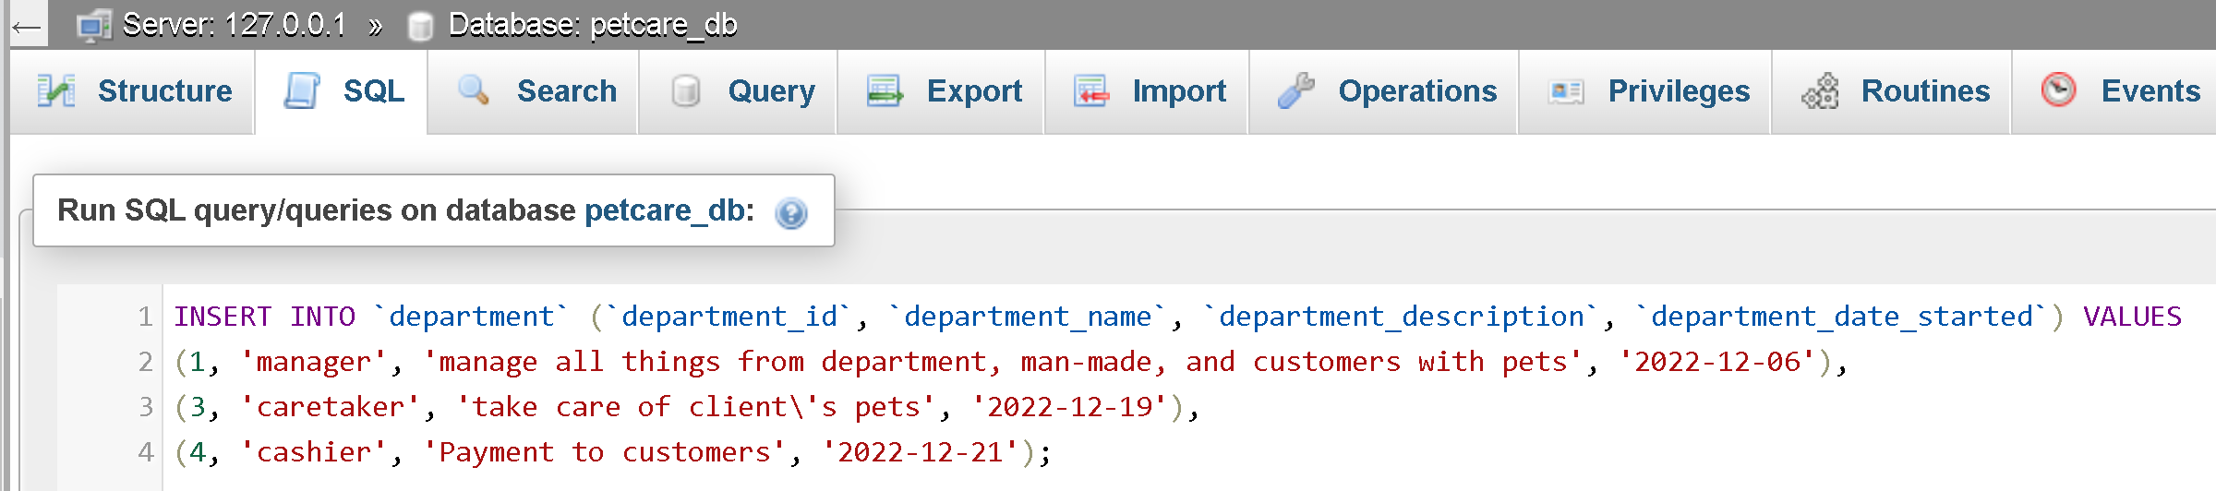

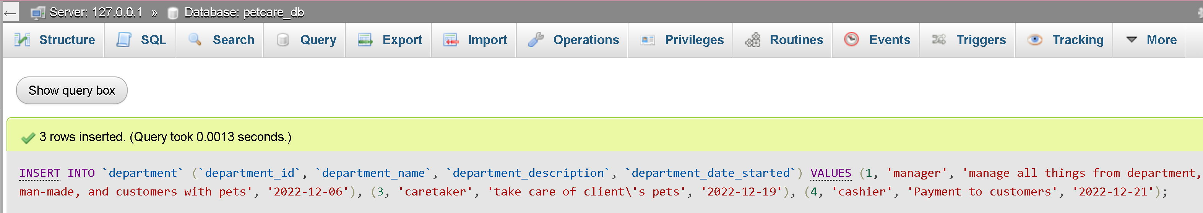

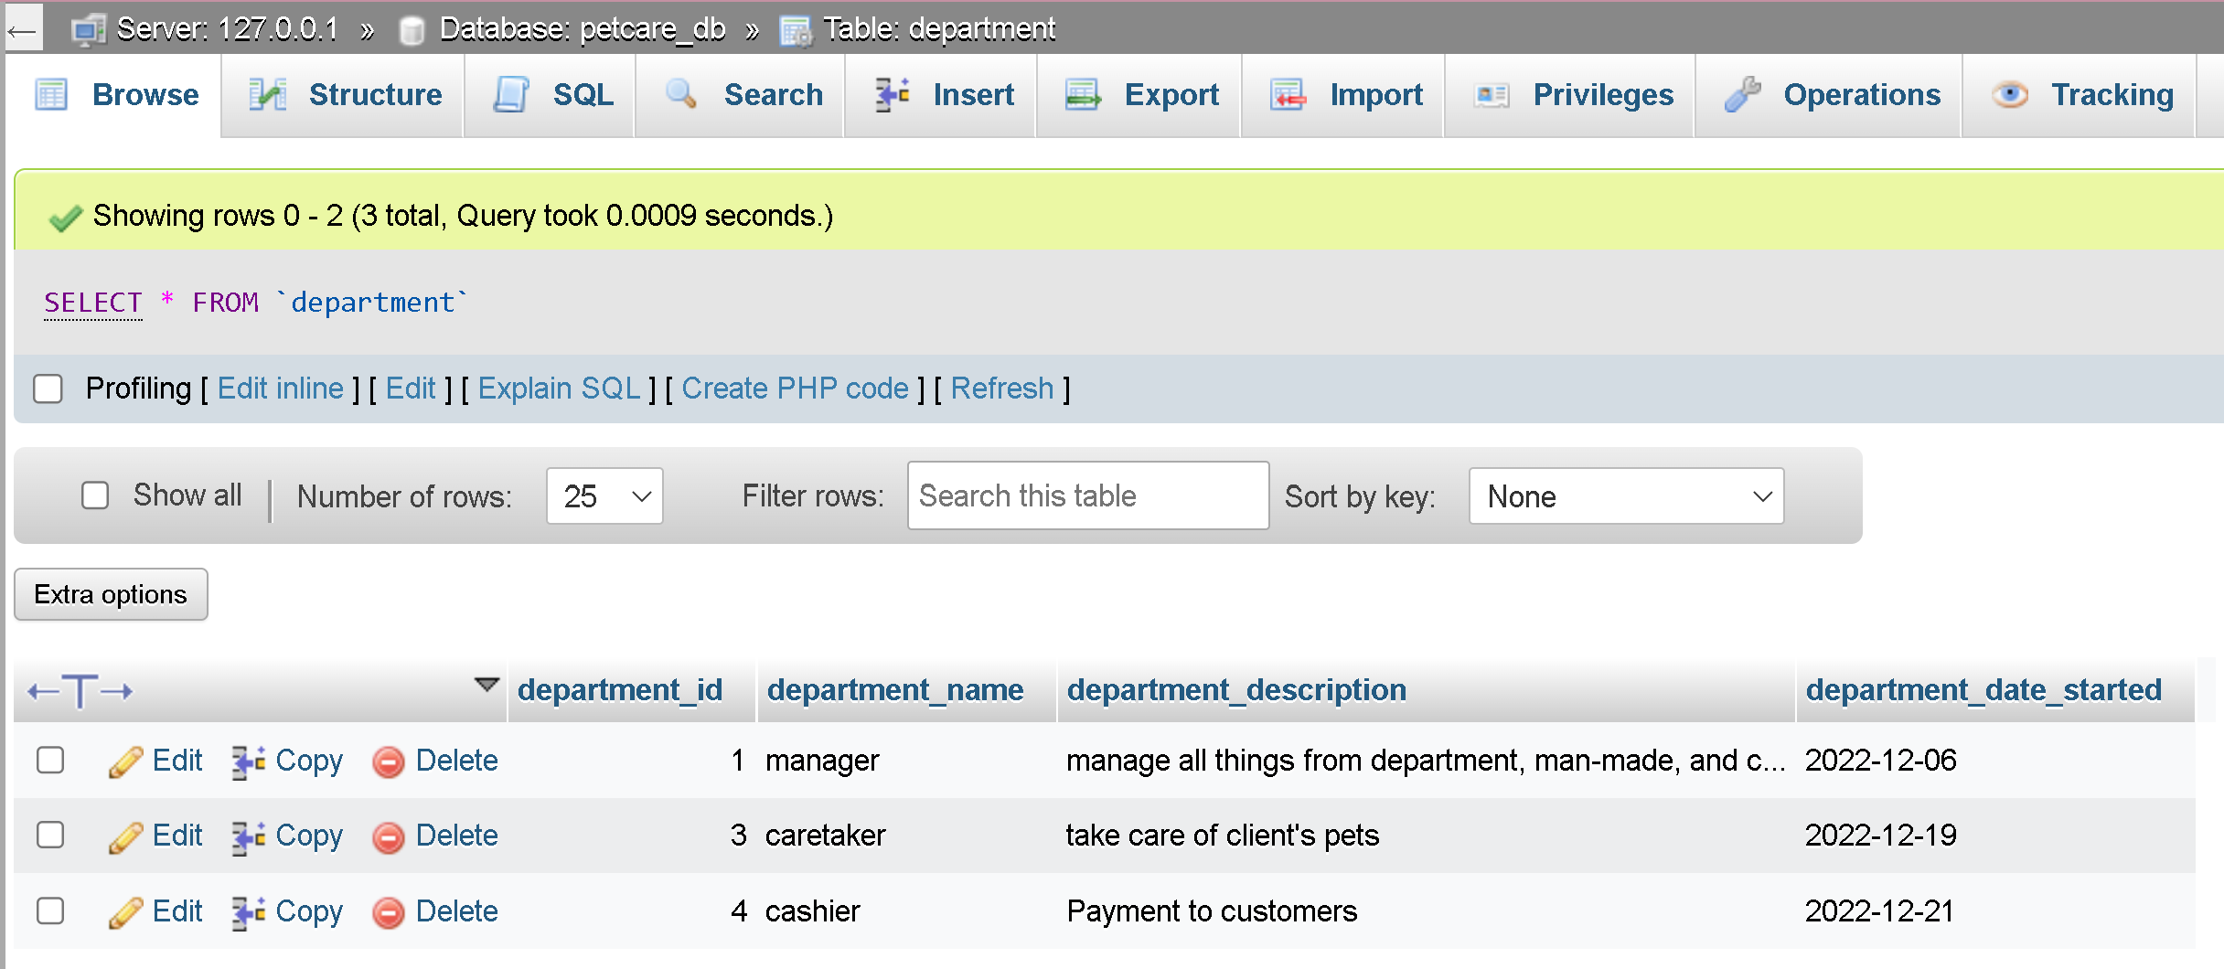

## Dumping data for table `staff`

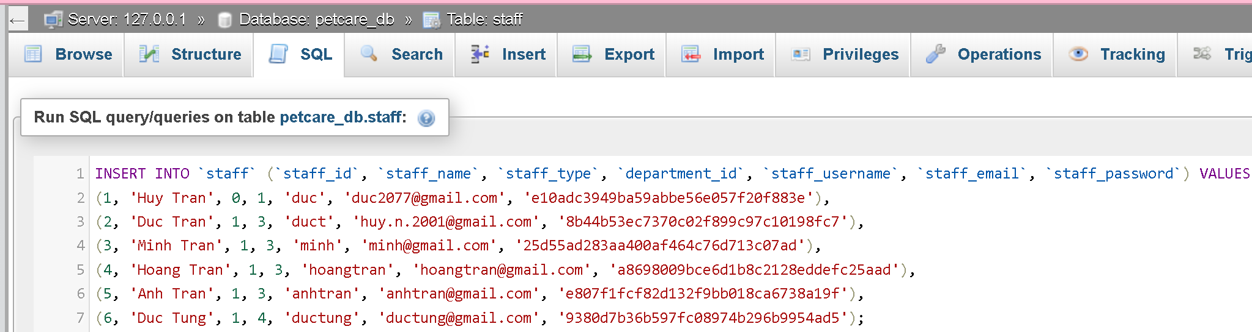

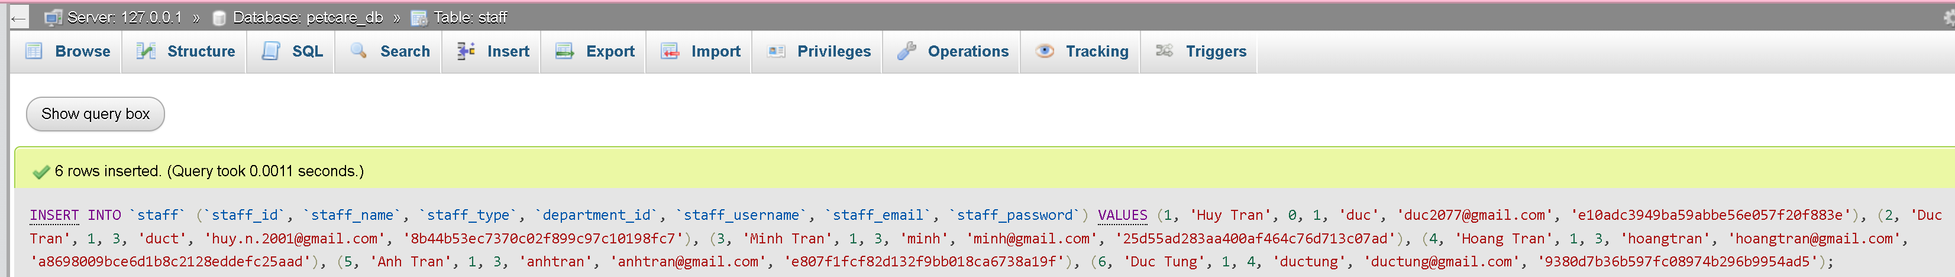

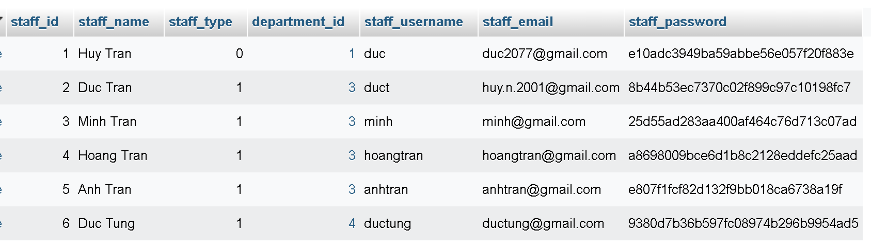

## Dumping data for table `client`

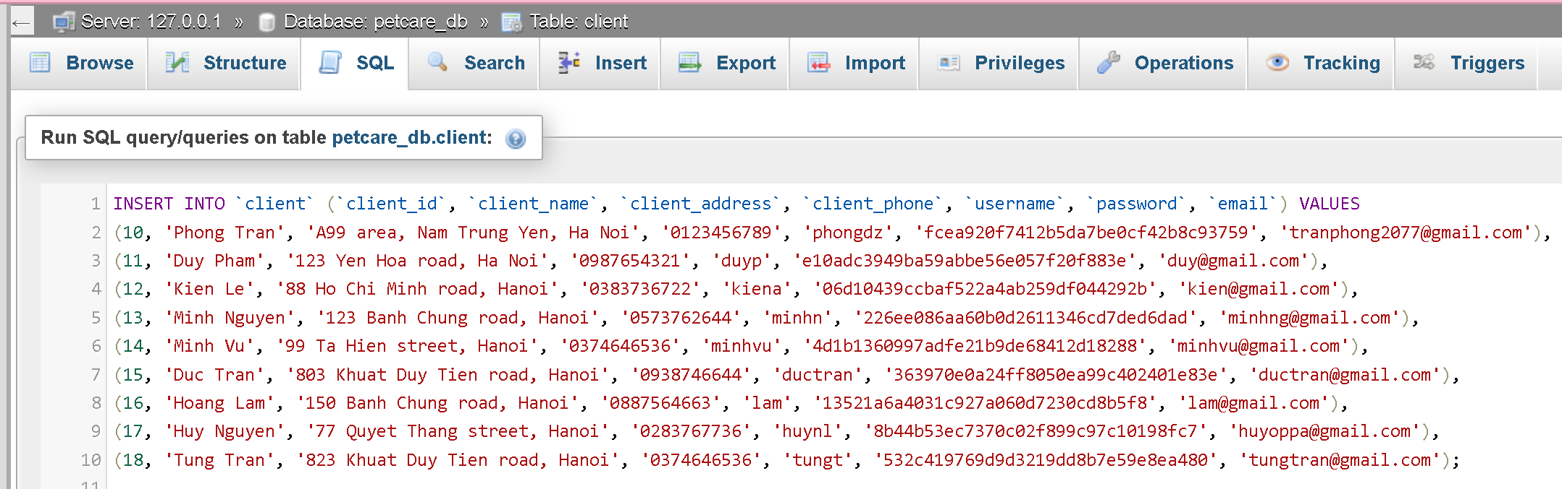

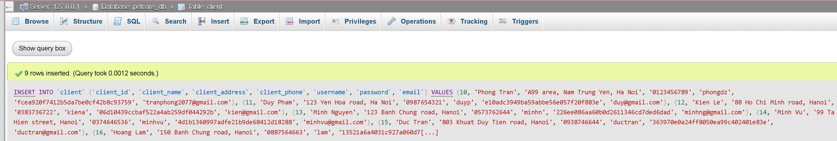

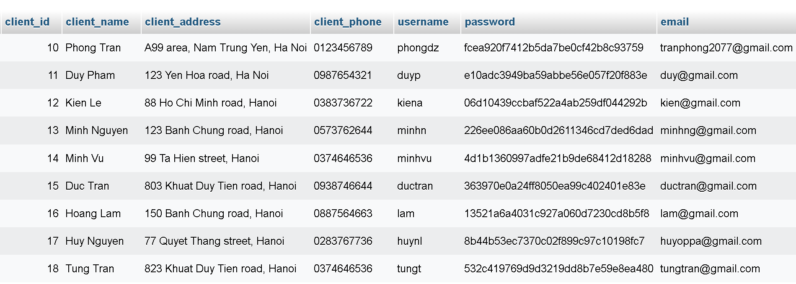

## Dumping data for table `species`

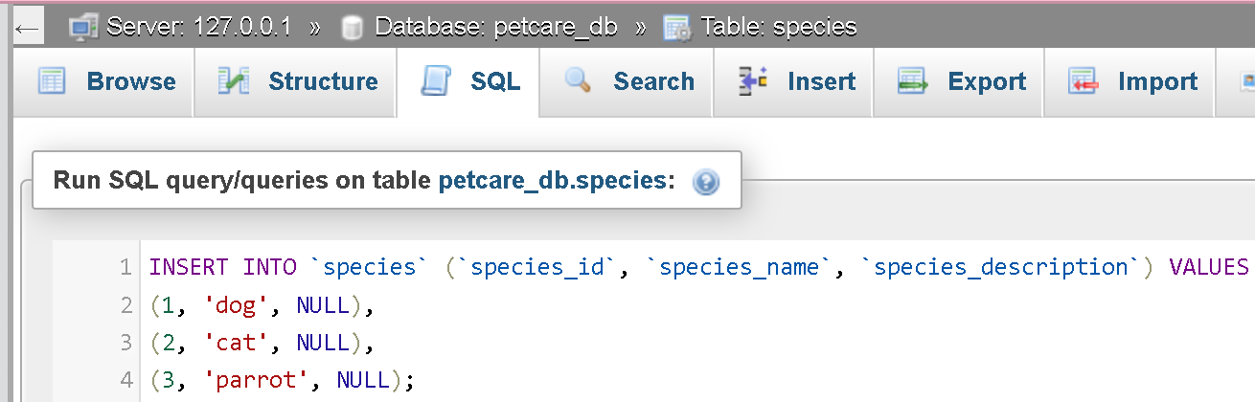

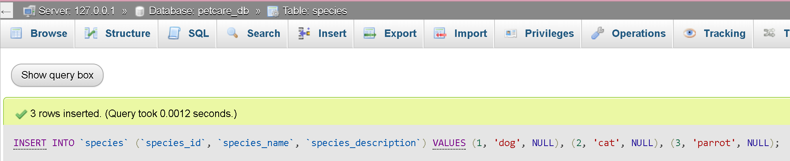

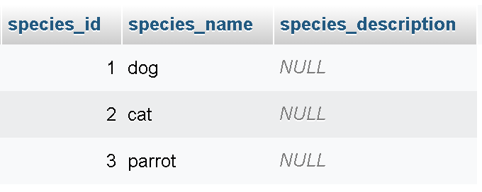

## Dumping data for table `pet`

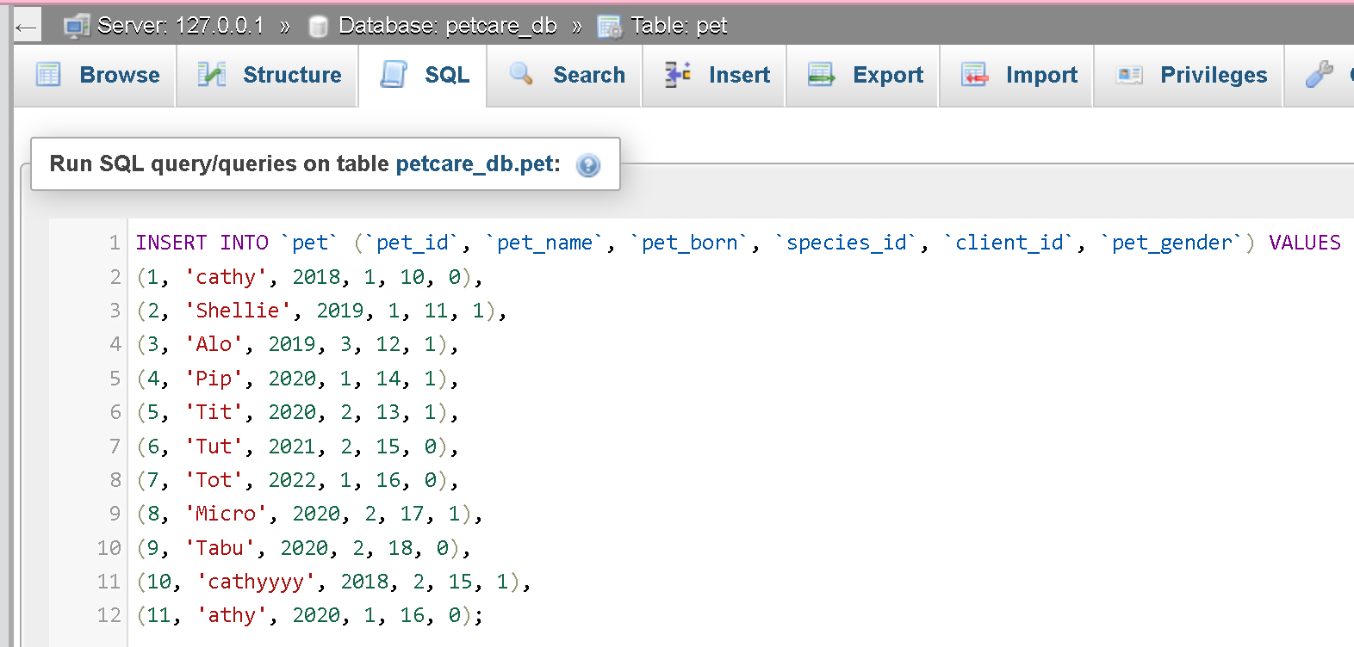



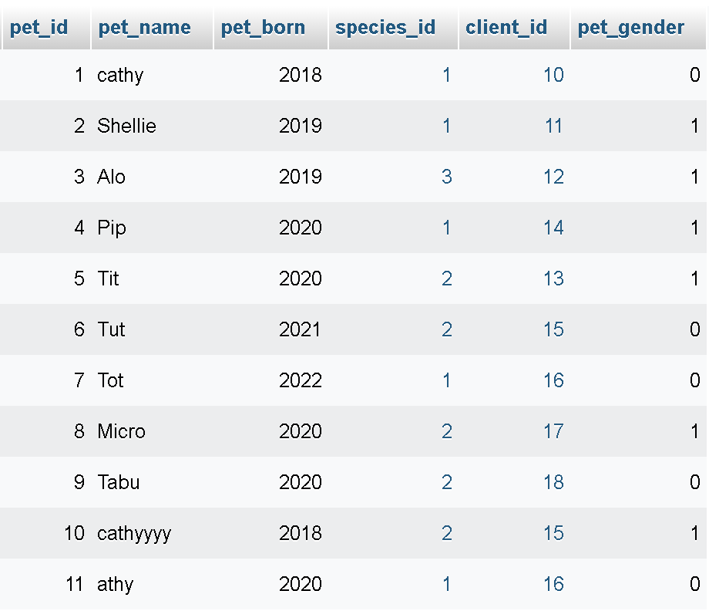

## Dumping data for table `booking`

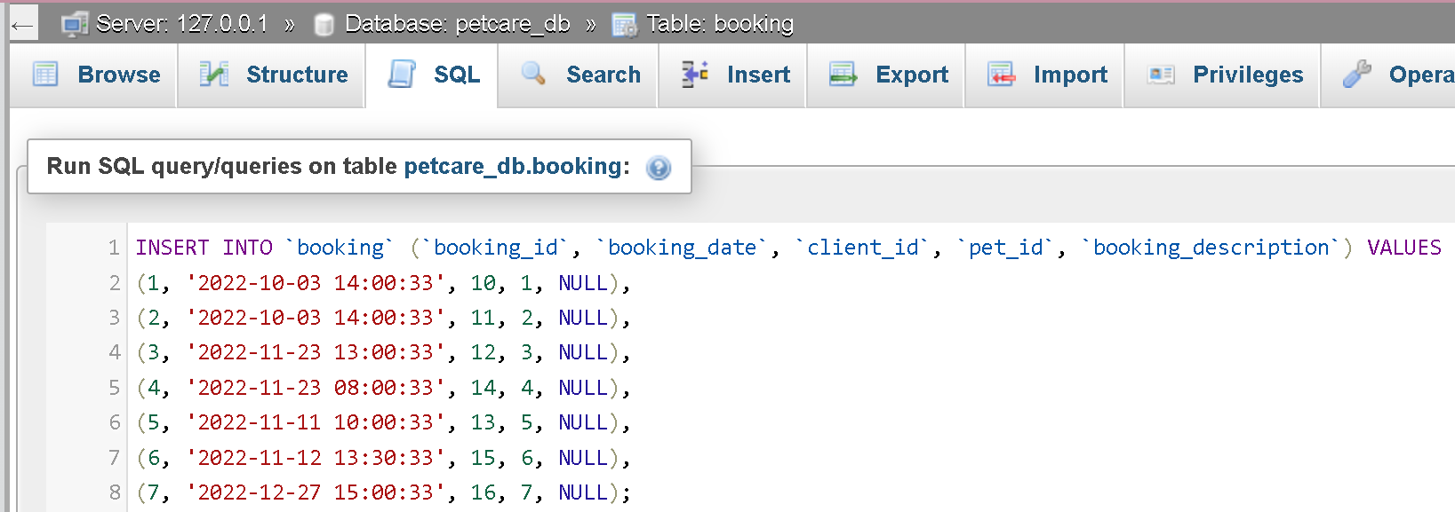



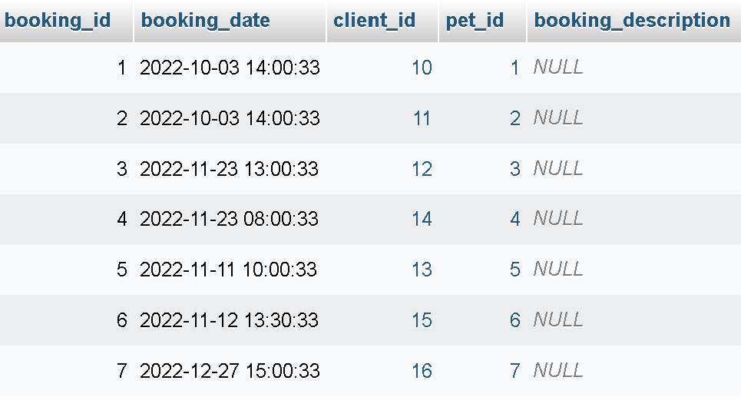

## Dumping data for table `service`

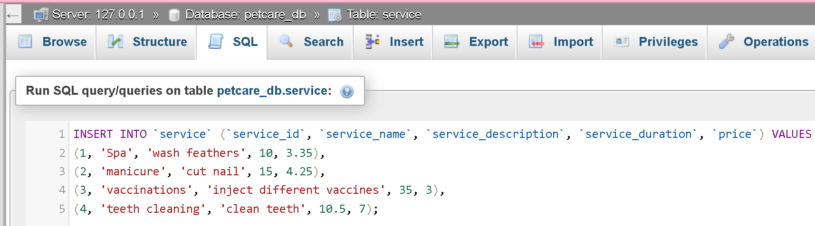



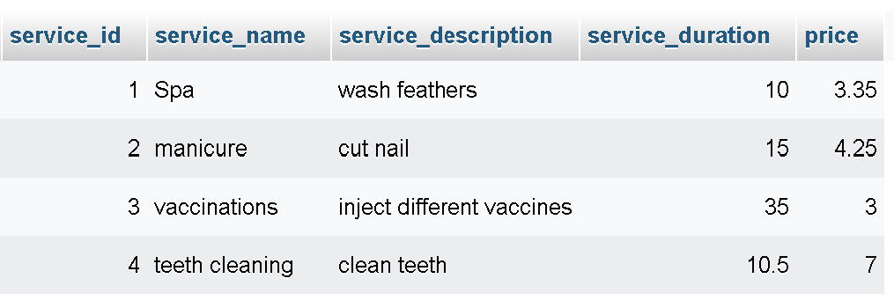

## Dumping data for table `booking_detail`

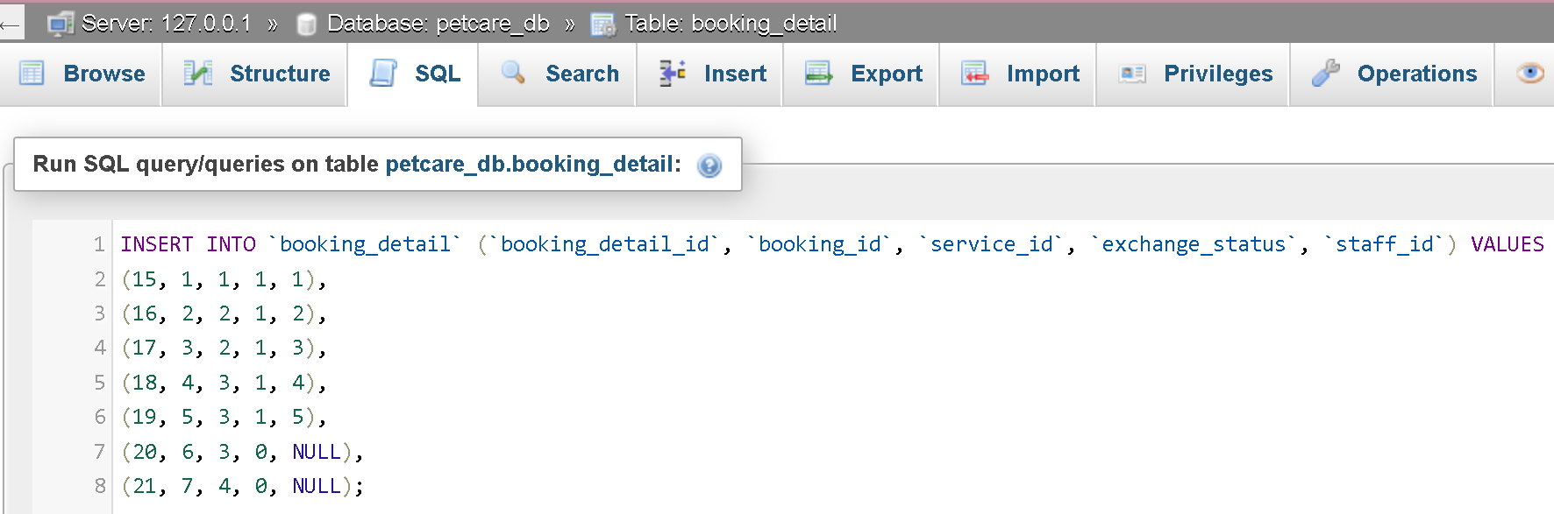



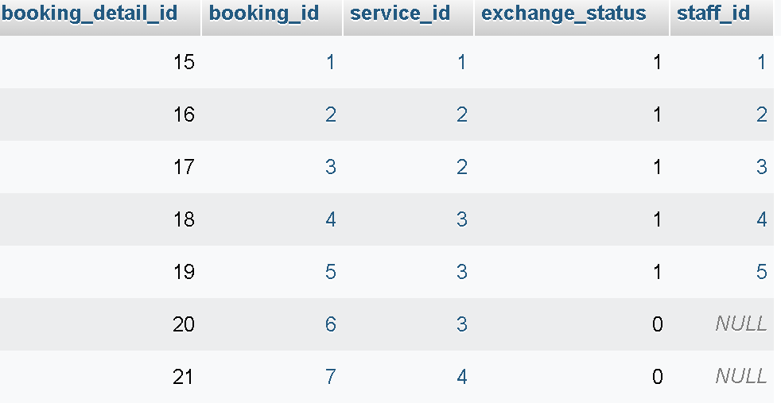

## Dumping data for table `image`

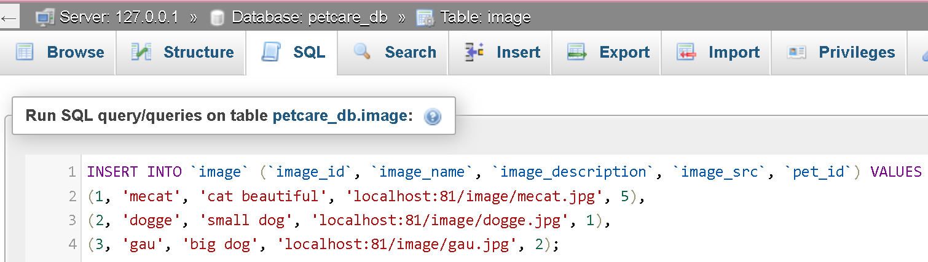



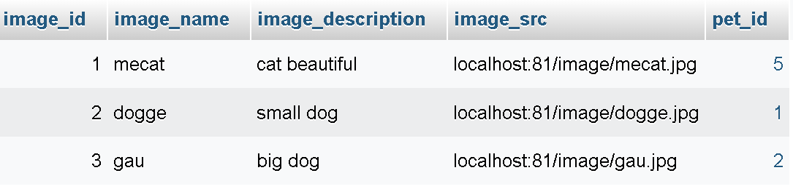

## Dumping data for table `progress`

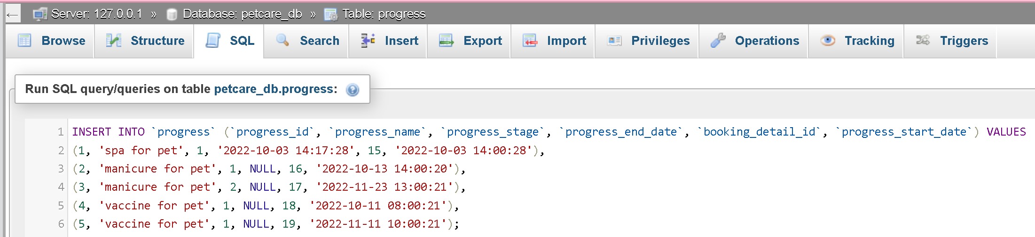



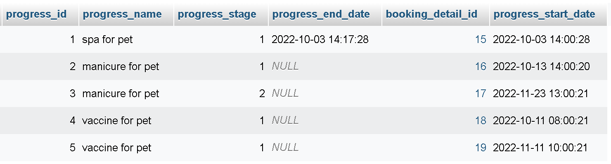

## Dumping data for table `receipt`

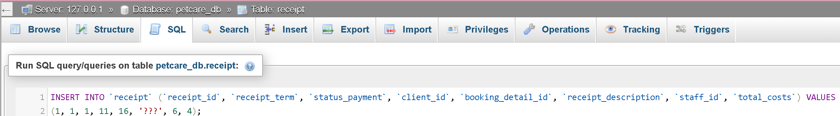





## Dumping data for table `request`

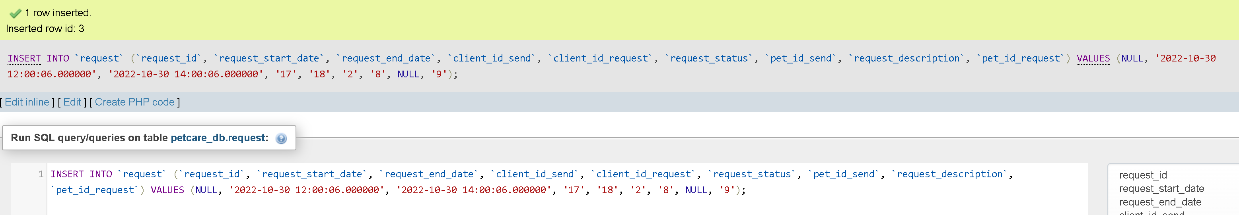

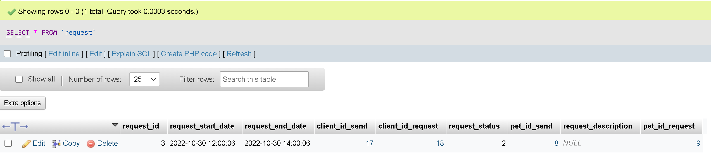

# Task 5 – Enhancements (15 marks):

We will have 3 enhancements propose for the client in use

## Add Indexes to the database

The use of indexes to assist with massive blocks of my data has a significant impact on reducing the query execution. Non-indexed tables are just like a unordered lists; The SQL engine must search data from start to end. This may affect the search time for large tables.

tôi sẽ đánh toàn bộ các index mà có foreign key

không đánh index các hệ cơ sở dữ liệu ví dụ như oracle có vấn đề

## Add Views to the database

The benefits of adding views to the database is automatically secure for the hidden data. Restrict access to viewers and have control over someone sees what.

The engineer of the operation team sometimes needs to inquire about the customer’s data, but some of the information cannot be queried by the staff, such as staff type. Therefore, we will create a view to extract the data that client needs (client id, client name, client phone number and client address) to avoid leakage of confidential information.

## Add Permission to the database

The advantage of adding permission to different users. Each user can be granted permission to access, update, remove or insert data. User roles can be defined in the database to give users permission based on their needs.

Client creates account, add he/she necessary information, like address and phone number. Then they need to add 1 or more than pets that they have by adding information. Client also needs to add some photos which relate to their pets. Client can be able to book services and request date for breeding their pet to another client.

The admin manager can do everything, including create accounts for a manager and employees in different departments, and the employer from these departments are able to manage the process, data, and create account for each department that they manage.

The employee will work with their right position from their department, such as caretaking department, where they must notify and perform the pet take care process for clients. The cashier employees can collect the money and create receipt for clients after finishing process for taking care of clients’ pets

# Task 6 – SQL reports (10 marks)

## Query 1

Rationale for query – Various receipts can be provided by different clients; this query is to list out the receipts that each of them can be provided.

The following below is the script and result of query 1.

**select** c**.**client_id **as** "Client ID"**,** c**.**client_name **as** "Client name"**,** c**.**client_phone **as** "Client phone number"**,** pt**.**pet_name **as** "Pet name"**,** s**.**service_name **as** "Service name"**,** s**.**price **as** "Price"**,** **IF(**r**.**status_payment **=** 0**,** "Not yet"**,** "OK"**)** **as** "Payment status"**,** p**.**progress_end_date **as** "Date time finish"

**from** booking_detail **as** bd

**right** **join** booking **as** b

**on** bd**.**booking_id **=** b**.**booking_id

**right** **join** client **as** c

**on** c**.**client_id **=** b**.**client_id

**right** **join** service **as** s

**on** s**.**service_id **=** bd**.**service_id

**right** **join** receipt **as** r

**on** r**.**booking_detail_id **=** bd**.**booking_detail_id

**right** **join** progress **as** p

**on** p**.**booking_detail_id **=** bd**.**booking_detail_id

**right** **join** pet **as** pt

**on** pt**.**client_id **=** c**.**client_id

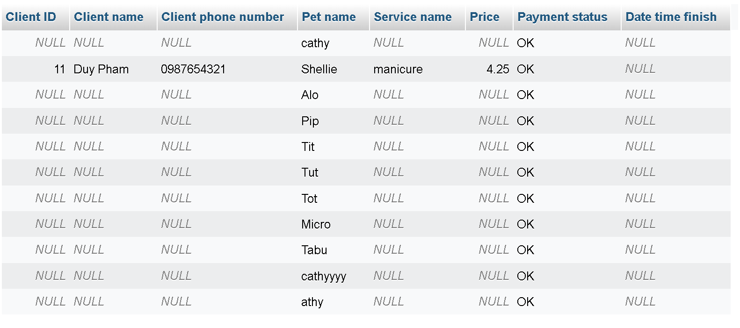

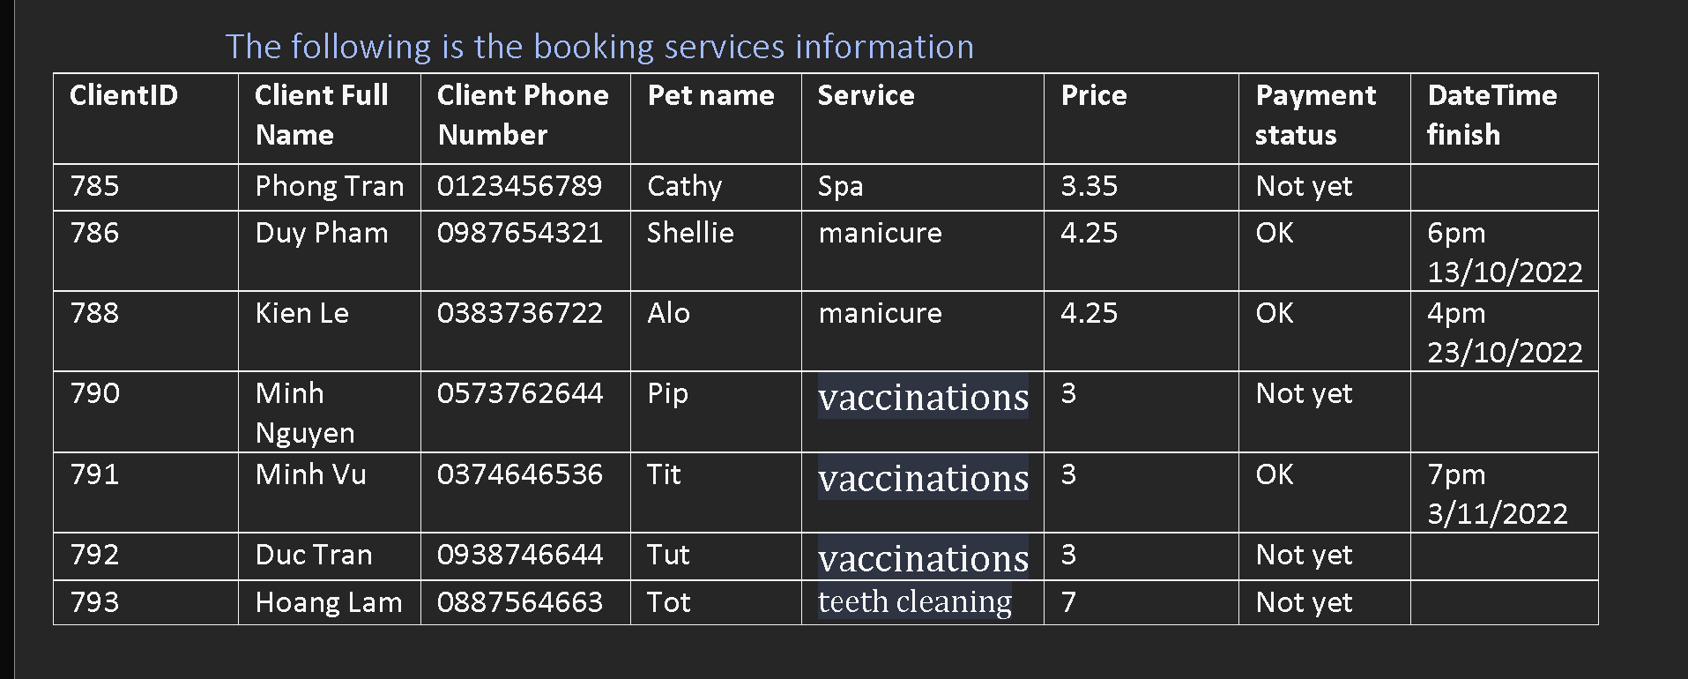

## Query 2

Rationale for query – Various service implementation can be provided by different caretaker staffs, this query is to list out the pet services that each of them can be provided.

The following below is the script and result of query 2.

**select** s**.**service_name **as** "Service name"**,** c**.**client_name **as** "Client name"**,** c**.**client_address **as** "client address"**,** c**.**client_phone **as** "Client Phone number"**,** st**.**staff_name **as** "Staff name"**,** **IF(**bd**.**exchange_status **=** 0**,** " "**,** "OK"**),** p**.**pet_name **as** "Pet name"**,** sp**.**species_name **as** "Species name"**,** pr**.**progress_start_date "Date time implementation"

**from** booking_detail **as** bd

**right** **join** service **as** s

**on** bd**.**service_id **=** s**.**service_id

**right** **join** booking **as** b

**on** b**.**booking_id **=** bd**.**booking_id

**right** **join** client **as** c

**on** c**.**client_id **=** b**.**client_id

**right** **join** pet **as** p

**on** p**.**client_id **=** c**.**client_id

**right** **join** species **as** sp

**on** sp**.**species_id **=** p**.**species_id

**right** **join** progress **as** pr

**on** pr**.**booking_detail_id **=** bd**.**booking_detail_id

**right** **join** staff **as** st

**on** st**.**staff_id **=** bd**.**staff_id

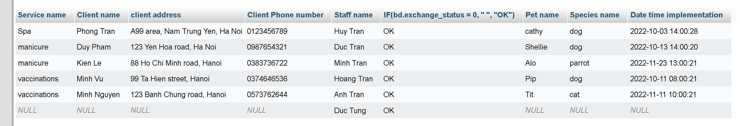

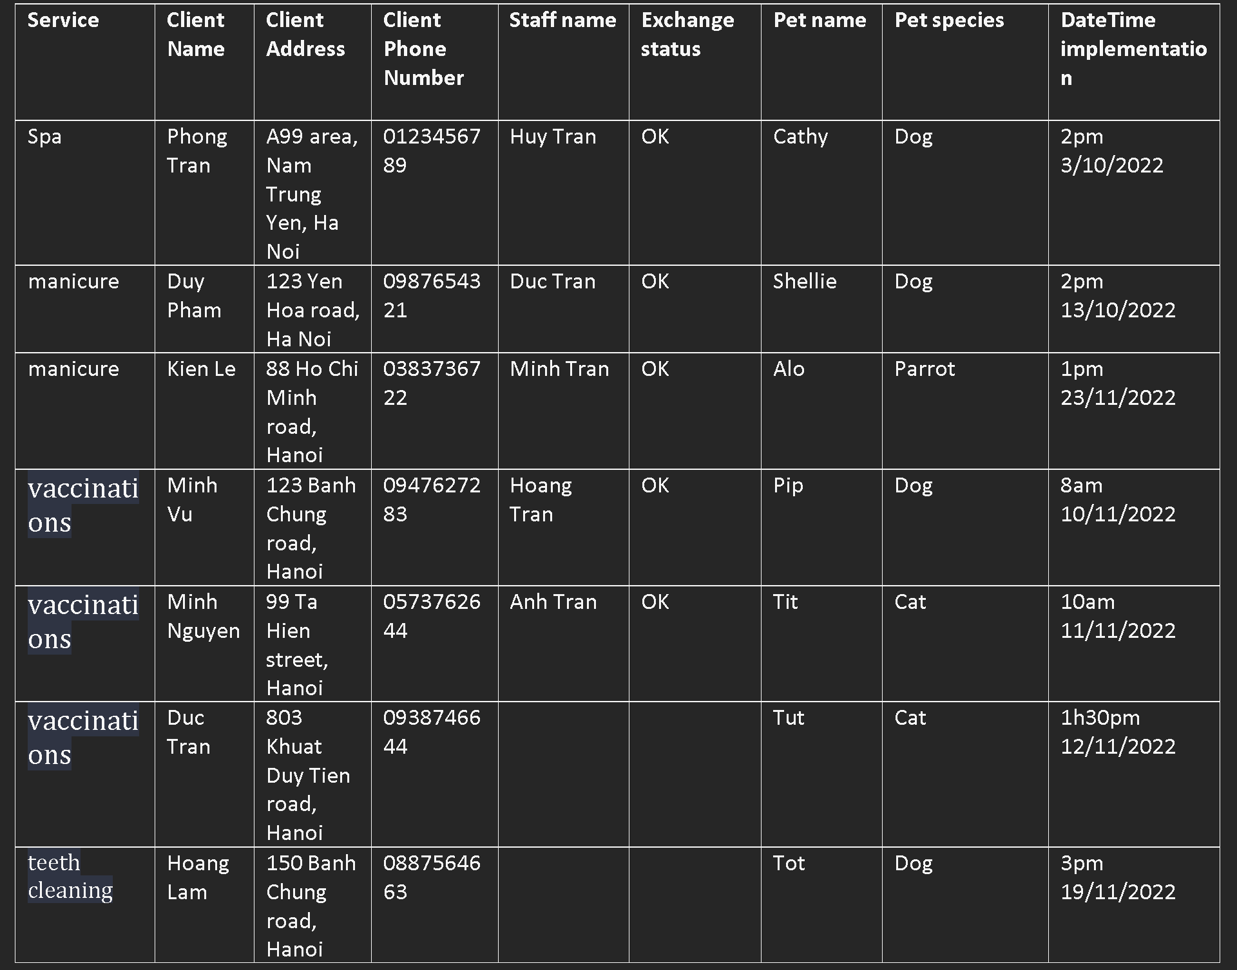

## Query 3

Rationale for query – Various requests can be provided by different clients; this query is to list out the requests that each of them can be provided.

The following below is the script and result of query 3.

**select** c**.**client_name **as** "Client name send"**,** c**.**client_address **as** "Client address"**,** c**.**client_phone "Client phone number"**,** p**.**pet_name **as** "Pet send name"**,** s**.**species_name **as** "Species send name"**,** cr**.**client_name **as** "Client name request"**,** cr**.**client_address **as** "Client address request"**,** cr**.**client_phone "Client phone number request"**,** pr**.**pet_name **as** "Pet send name request"**,** s**.**species_name **as** "Species send name request"**,** r**.**request_start_date "Date time started"**,** r**.**request_end_date **as** "Date time ended"

**from** request **as** r

**right** **join** client **as** c

**on** r**.**client_id_send **=** c**.**client_id

**right** **join** client **as** cr

**on** r**.**client_id_request **=** cr**.**client_id

**right** **join** pet **as** p

**on** p**.**pet_id **=** r**.**pet_id_send

**right** **join** pet **as** pr

**on** pr**.**pet_id **=** r**.**pet_id_request

**right** **join** species **as** s

**on** s**.**species_id **=** p**.**species_id**;**



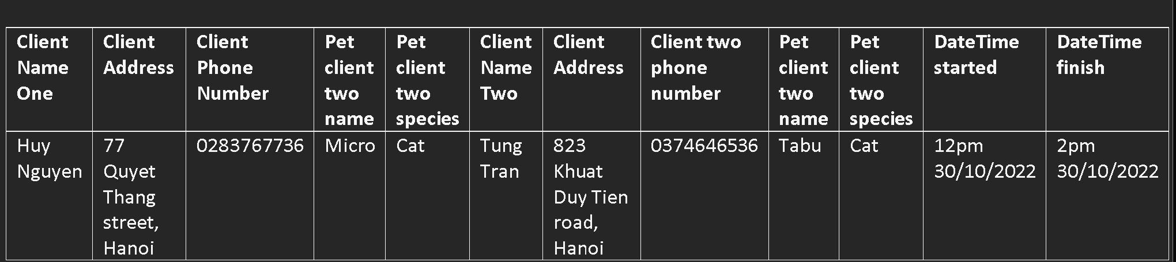

# Task 7 – Distributed Database Option (10 marks)

Giga Pet will expand its business to all around Vietnam soon, and Hanoi will become its headquarters. All clients in different places in our country will be connected to each other to improve the number of species or book some services for clients’ pets to make their pets feel comfortable like humans.

Considering the above reasons, I would suggest that they split the database into fragments, and each of them is stored on local computers under the control of separate DBMS.

Distributed database has the following benefits, including

1. Data sharing

The site of clients, pets, and staff are connected to each other, then they can see their information, the clients will see pet booking’s progress from staff to track, also staff can able to manage clients’ pets, including necessary information and pet images.

1. Local Autonomy

Giga Pet business in all different places in our country will have independent teams with different roles to manage the database system, distributed database able to retain a degree of control over data stored locally.

1. Reliability and Availability

If the database fails in one of the areas, other areas can still function without being affected

1. Modular growth

As the future, Giga Pet may increase the development in other parts of Vietnam, the benefits of database distribution is able to add a new computer(site) to the network without any challenge

1. Speed up Query Processing

In most cases, clients only need to query their own data, including booking, pets, and request breeding, so the data store in local machine can be faster than querying data.

Finally combing the above benefits, database distribution is very suitable for Giga Pet, but has some drawbacks that they may need to pay attention to, including

1. Complexity

A distributed database is more complicated to set up and maintain compared to a central database.

1. Security

There is less security as data is set to different locations in our country, and weak protection like password can become an advantage for crimes to break password easily. As a result, they will take more sensitive information from the business, which can be detrimental for the company’s reputation.

1. Database design and more complex

The design of a distributed database has to fragmentation/replication of data to specific roles and sites.

1. Higher cost

More extensive infrastructure means higher costs.

1. Lack of experience

Distributed database require an experienced people on proper practices.

# Task 8 – Reflective Practice (10 marks)

## What?

The purpose of this assignment was to design for clients, pets, and staff. First and foremost, understanding the background of the pet care business and daily operations is the top priority that I must do. I tried to establish successfully in the MySQL environment, before conducting some tests to try to insert, update and delete some data from the database. I encountered some problems on the test, like receipt after finishing the process for clients’ pets, and I think it need to be used trigger to prevent the process for pets’ booking has not been completed yet. From this matter, I think there will be more problems with the database design like the complexity and some processes.

## So What?

After that, I learned some knowledge of database development from the class. Before establishing the database, we must carry out some procedures, such as drawing ERD, creating data dictionary and database normalization. I learned some vital things, especially database normalization, which can eliminate the possibility of data anomalies such as update anomalies, insertion anomalies, and delete anomalies. I suppose that by drawing ERD, making data dictionary and database normalization, these help me to understand a clear relationship between entity and attributes. The knowledge learned will be indispensable for me to improve my database design in the future.

## Now What?

By finishing this assignment, I had learnt more about a more advanced way to comprehend a database, including how to design ERD and how to use it, database normalization and prepare data dictionary. Moreover, I have learned how to use MySQL Server to create, delete, and update database.

I feel that these things will help me a lot in database in the future, and there will be no more database anomalies caused by poor database design.